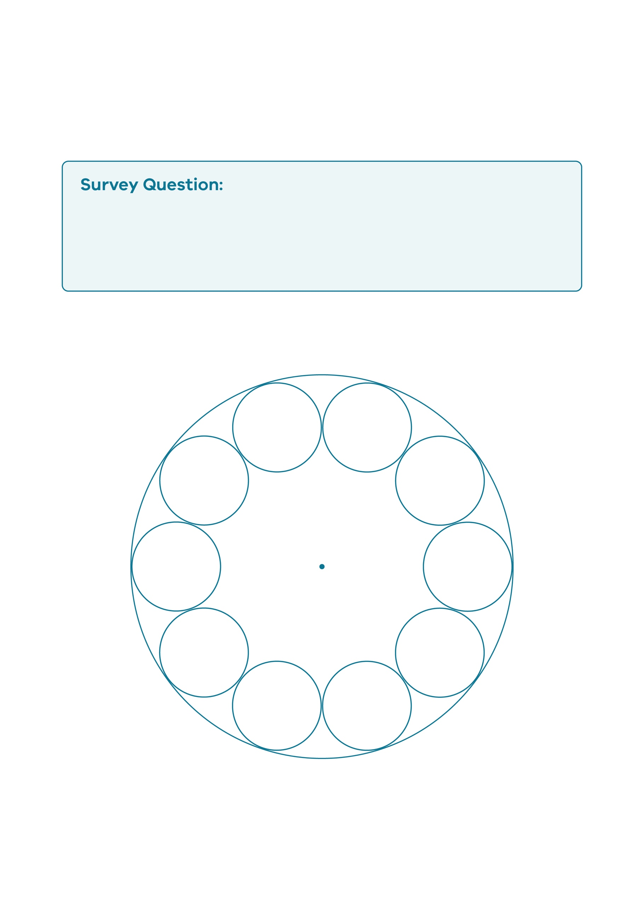
What does our village look like?
10 Person Circle

© Department of Education and Training CC BY 4.0

