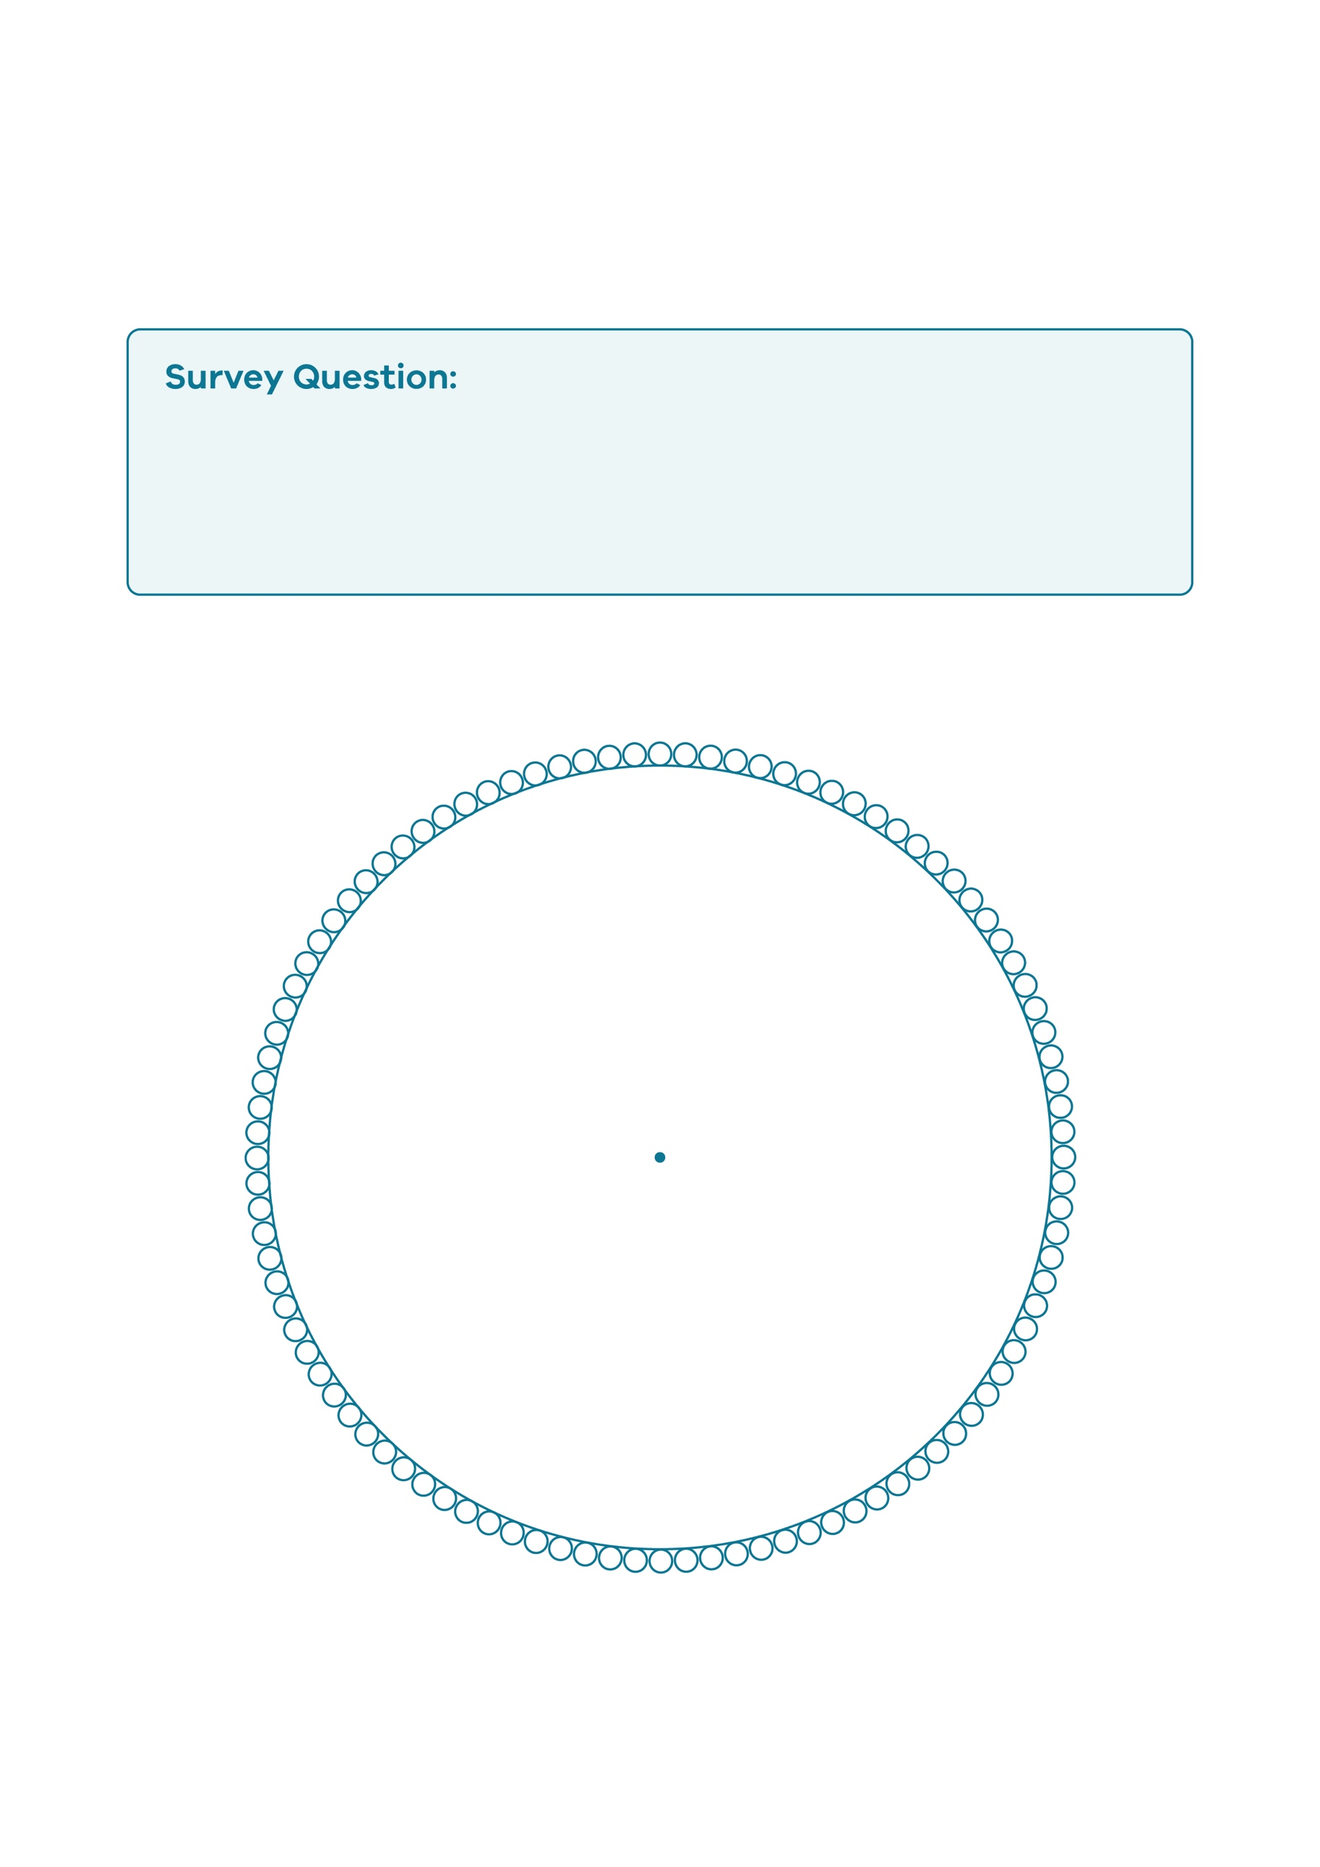
What does our village look like?
100 Person Pie Chart

© Department of Education and Training CC BY 4.0

