The X Factor

Garden Beds – Recording and Reflecting
- Once you’ve seen how the garden beds are designed, use the blocks to make designs of different sizes. In the space below, record the outcomes of your different designs.

- How many tiles do you think would be needed if there were 100 plants in the garden bed? Explain your thinking clearly below.

- Write an explanation that would be used to work out the number of tiles for any size garden bed. Write this in different ways (for example, in full sentences, and also using mathematical symbols and operators).

- Think of another way of explaining how many tiles would be needed for any size garden bed, and write it here. You may like to work with someone else in the class.

- Complete these two tables of values by working out how many tiles are needed for a certain number of plants, and how many plants were planted for a certain number of tiles. Show your working or explanation for at least one of the entries in each table.
No. of plants | 23 | 48 | 82 | 129 | 2,148
No. of tiles

No. of plants
No. of tiles | 42 | 60 | 128 | 644 | 3,782

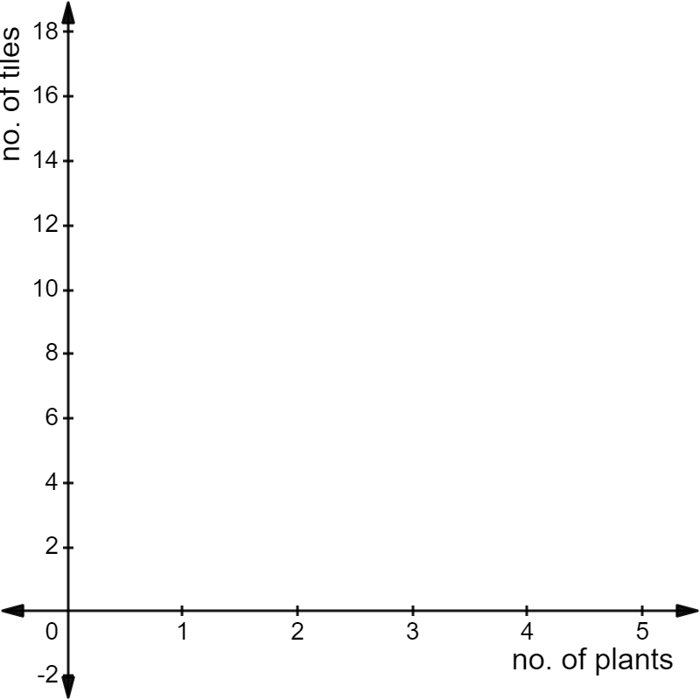
- Represent the relationship between the number of plants and the number of tiles on this set of axes.

In which direction do the plotted points go? Why is this?

Do the points follow a pattern? Why is this the case?

Are you able to extend the points in either ‘direction’? Why or why not?

What does your rule, and the graph, suggest the value of $T$ should be when $p=0$? Does this make sense?

© Department of Education and Training CC BY 4.0

