The X Factor

Chocolate Boxes – Initial Problem
Penny, Tom and Matthew were each given a box of chocolates in a hexagonal box:

Penny ate 10 chocolates to begin with. She looked at the box and quickly worked out there must have been 61 chocolates in the box to begin with.

Tom ate 20 chocolates to begin with. He looked at the box and quickly worked out there must have been 61 chocolates in the box to begin with.

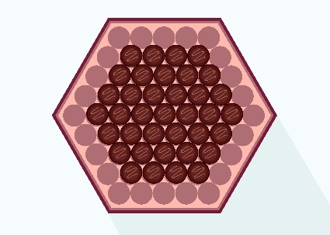
Matthew ate 24 chocolates to begin with. He looked at the box and quickly worked out there must have been 61 chocolates in the box to begin with.

What strategies do you think each of them used to work out how many chocolates were in the box to begin with?

© Department of Education and Training CC BY 4.0

