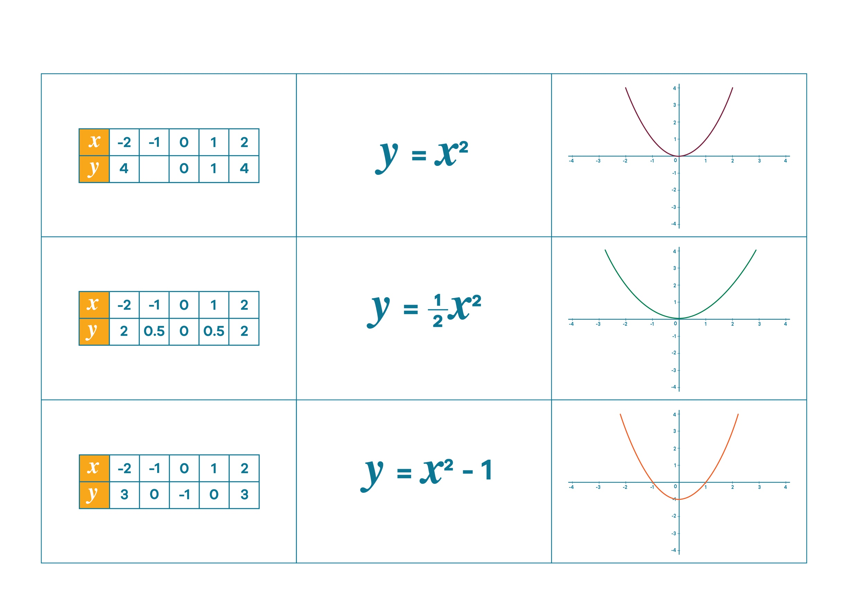
Find my triplet - Worksheet 3

© Department of Education and Training CC BY 4.0

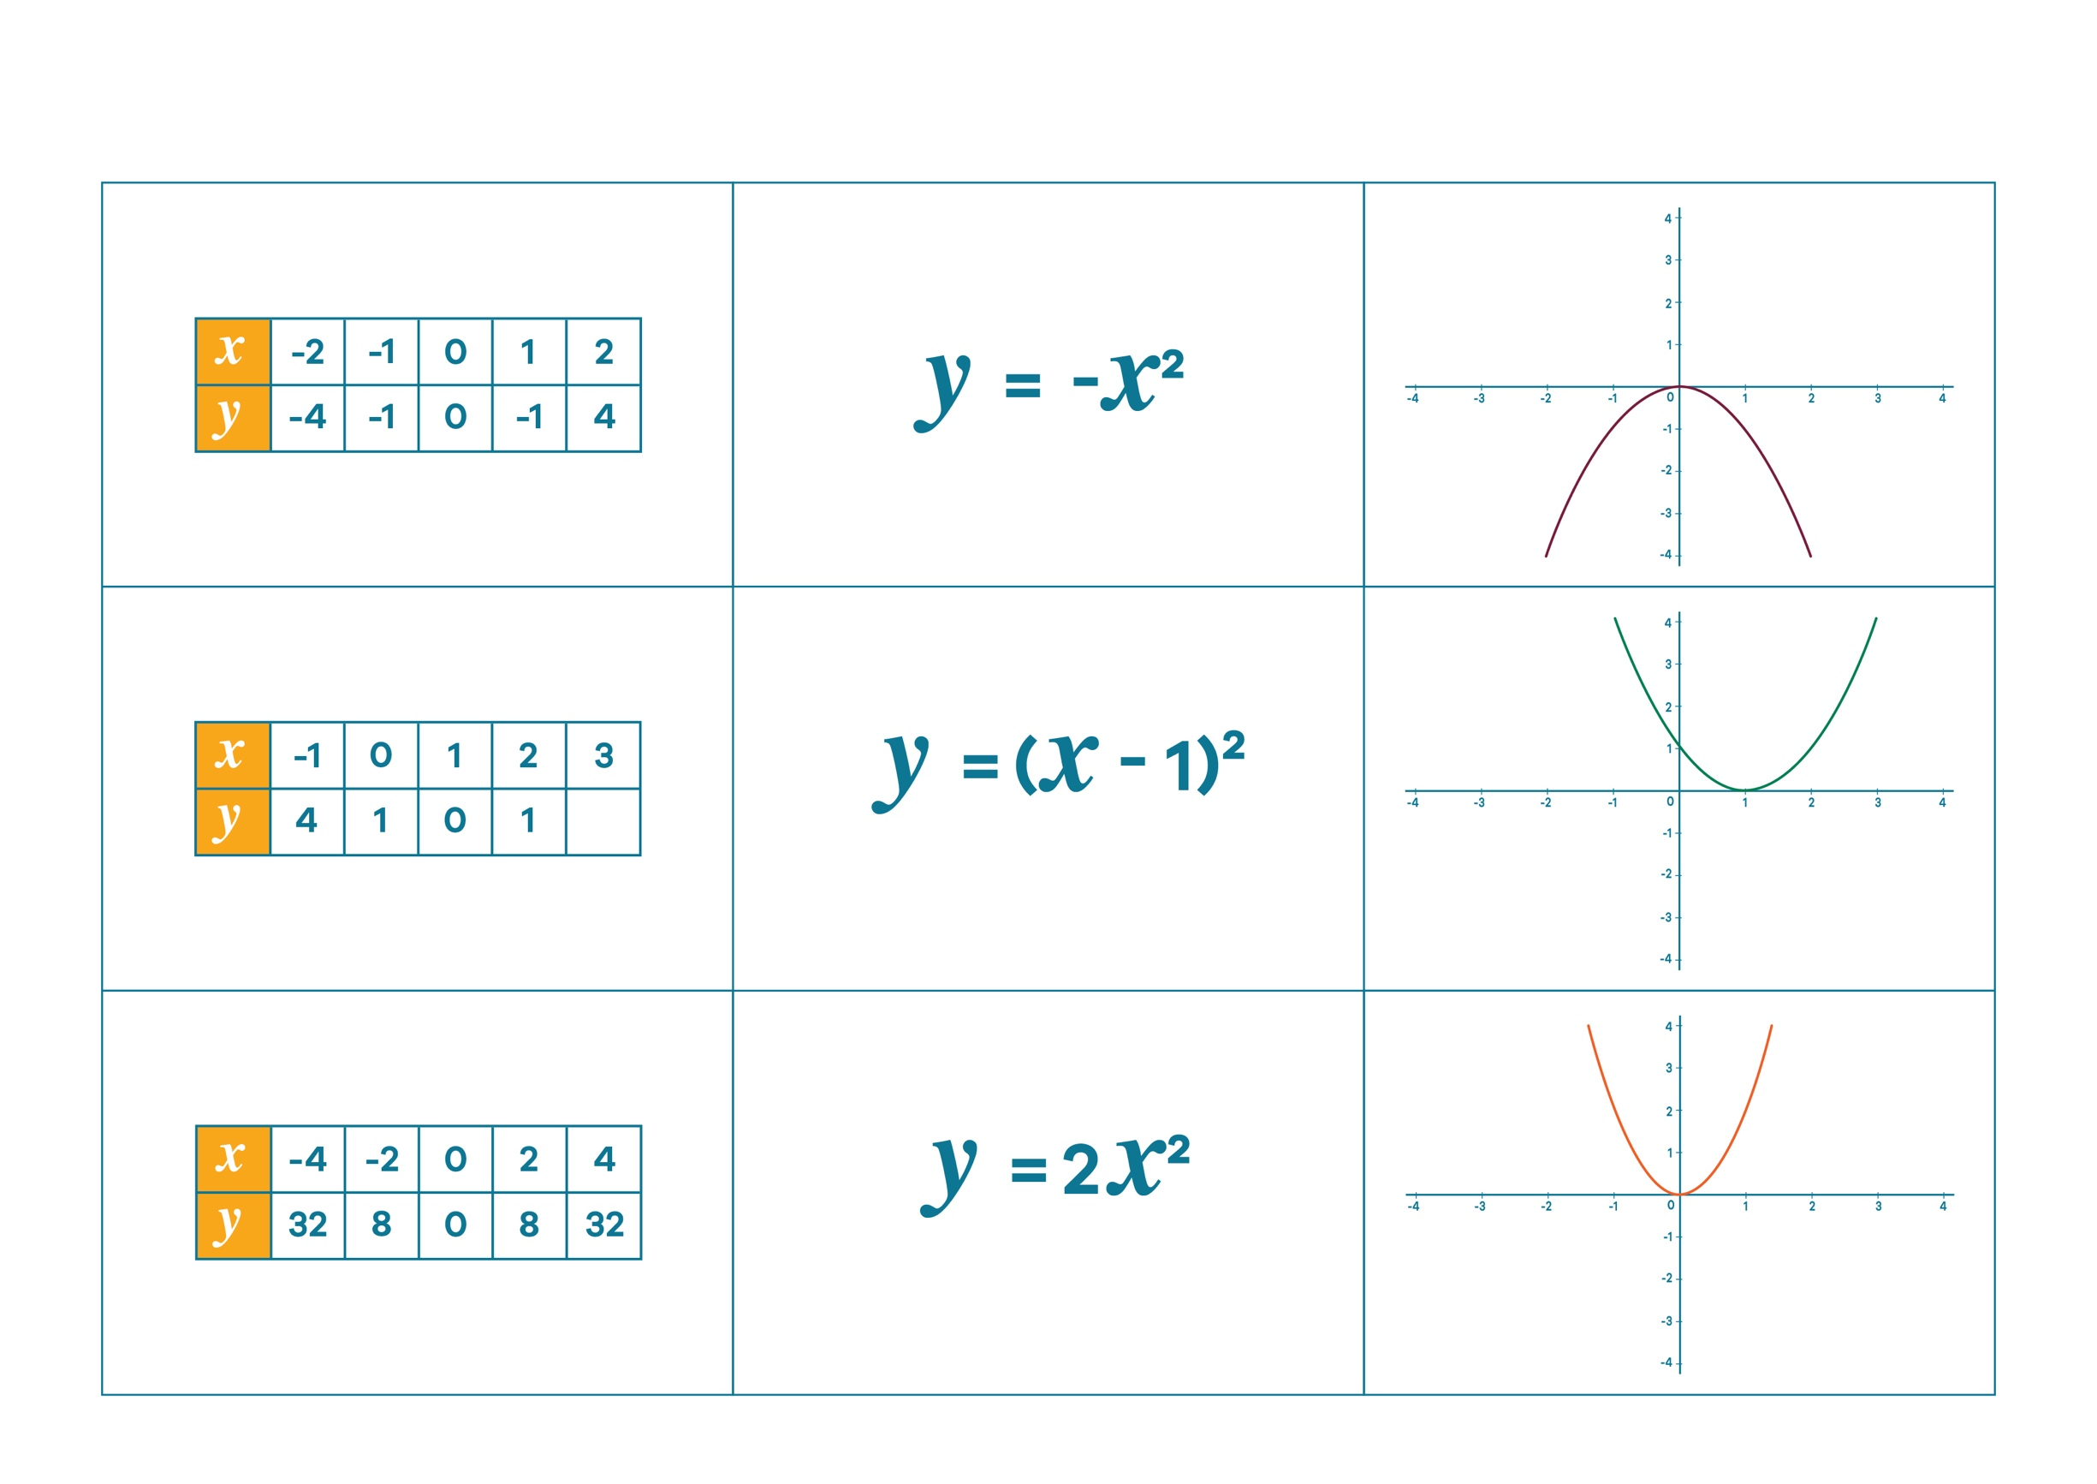
Find my triplet - Worksheet 3

Department of Education and Training CC BY 4.0
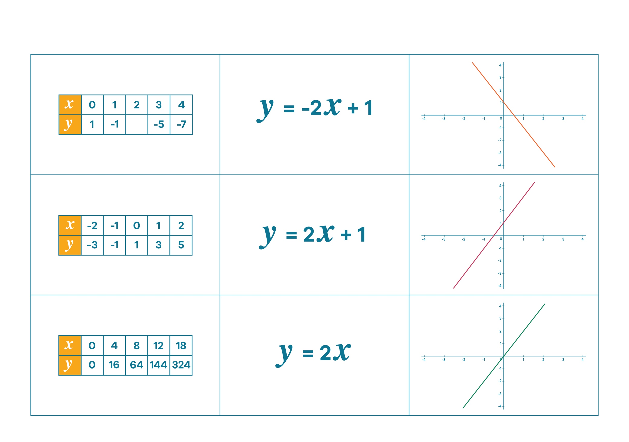
Find my triplet - Worksheet 3

© Department of Education and Training CC BY 4.0
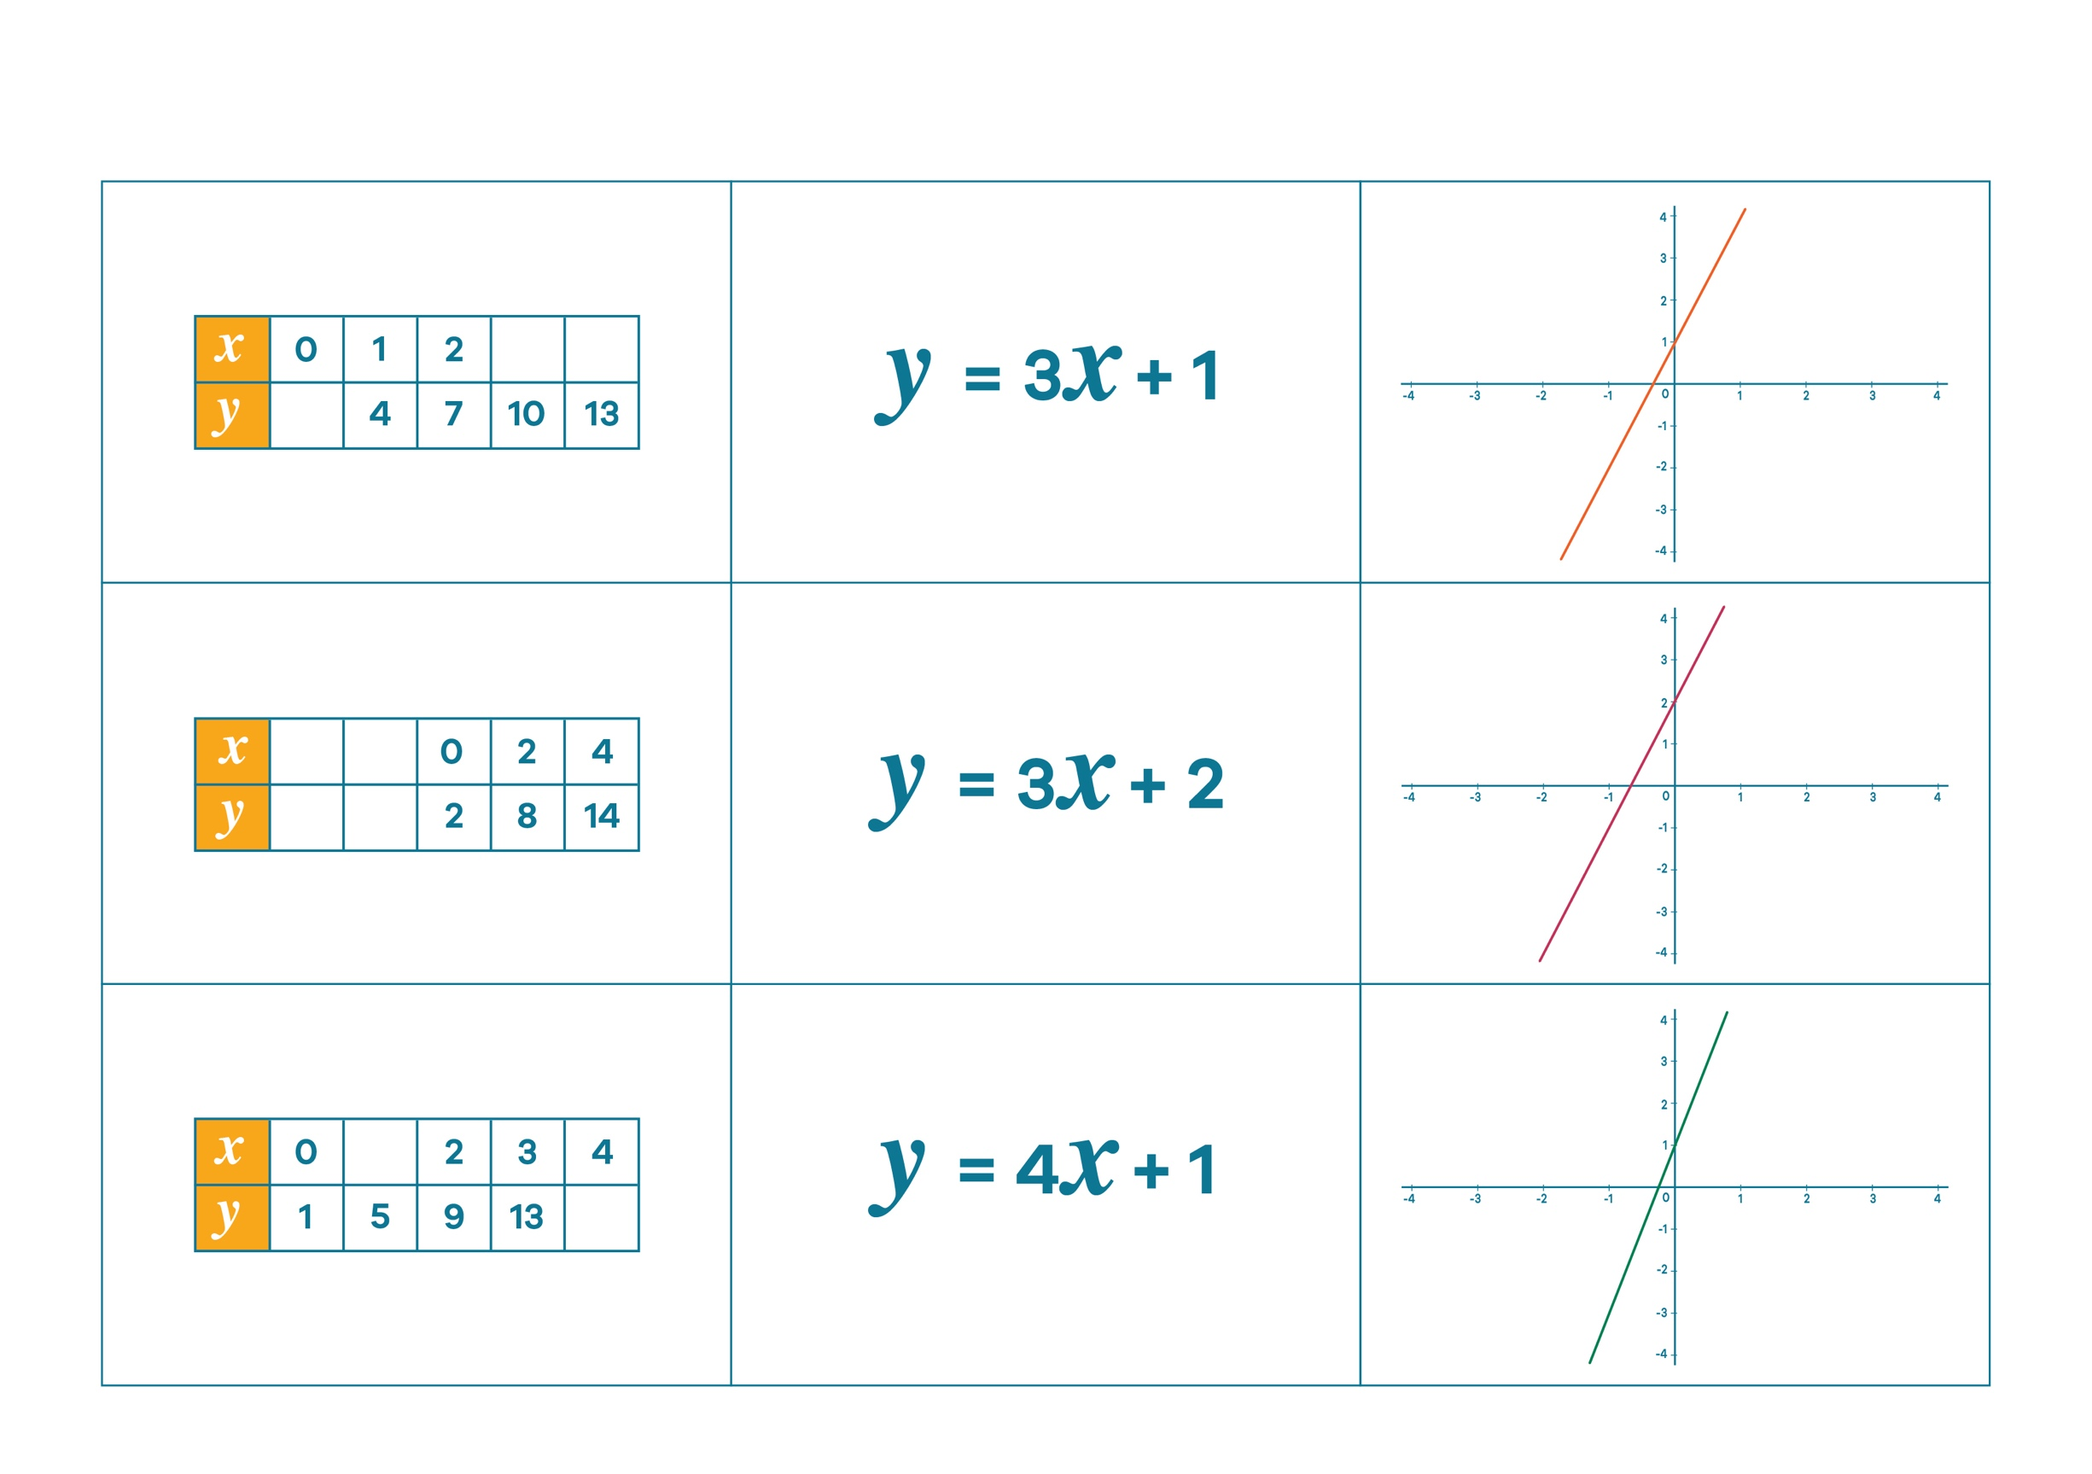
Who is right? - Worksheet 3

© Department of Education and Training CC BY 4.0
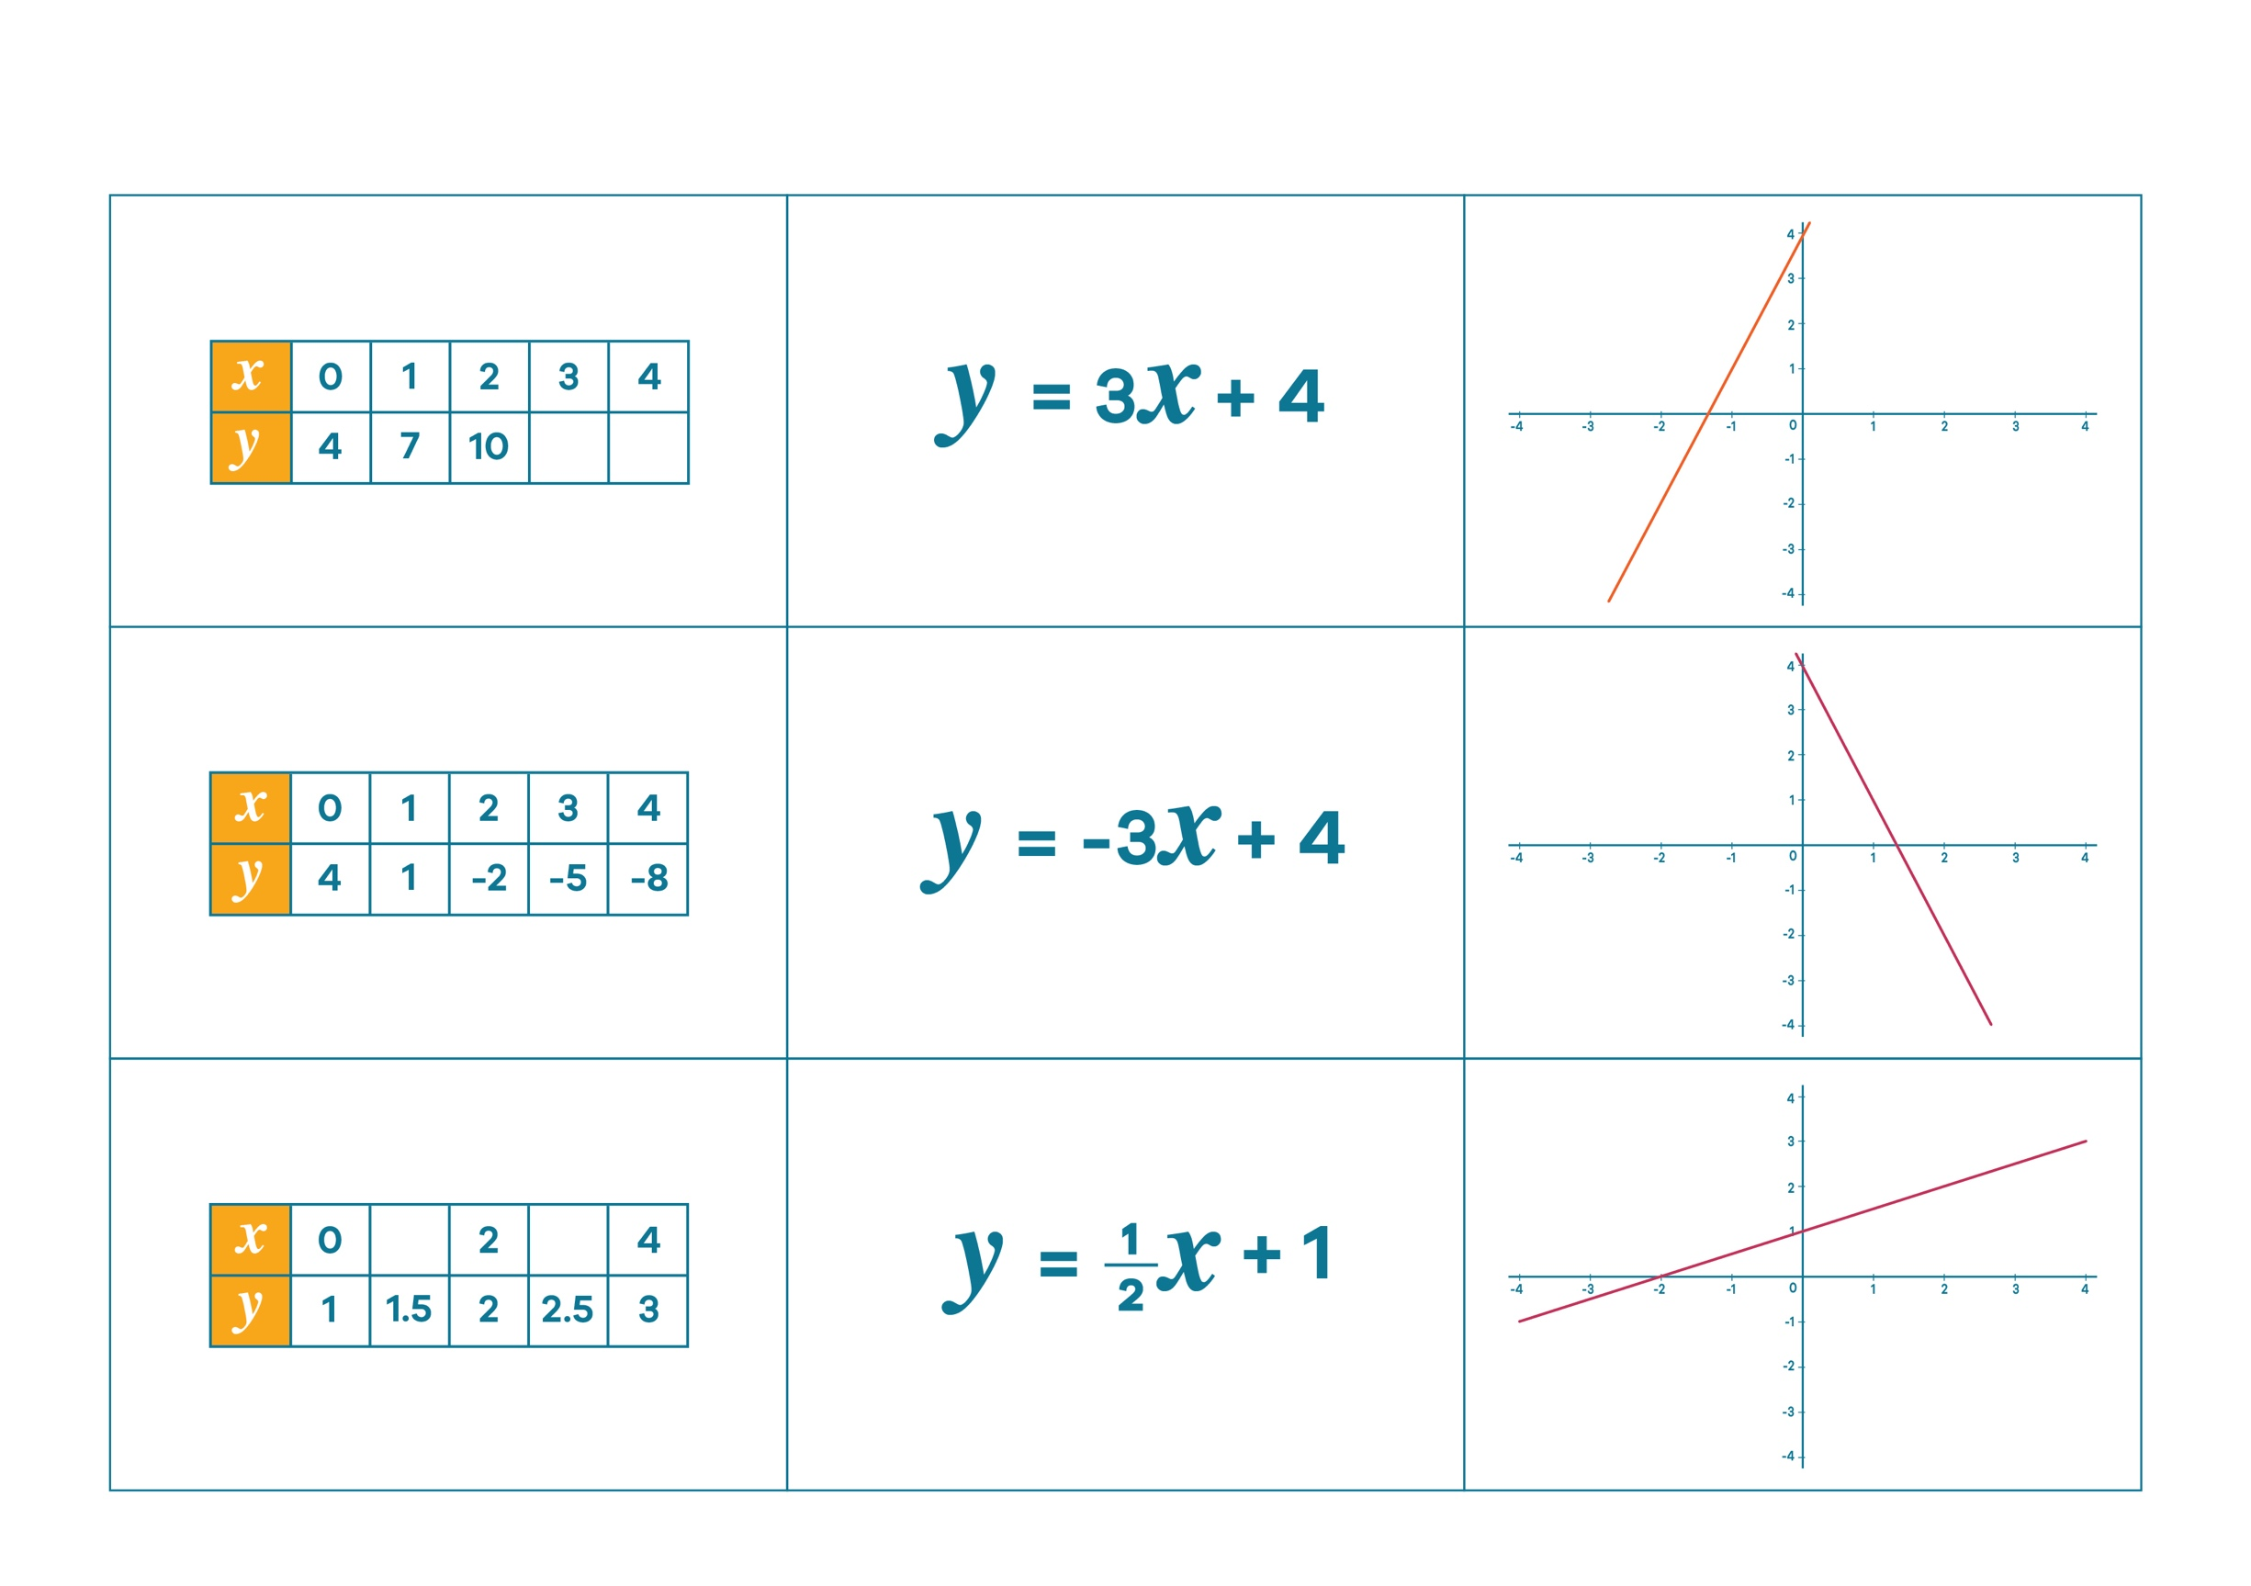
Who is right? - Worksheet 3

© Department of Education and Training CC BY 4.0

