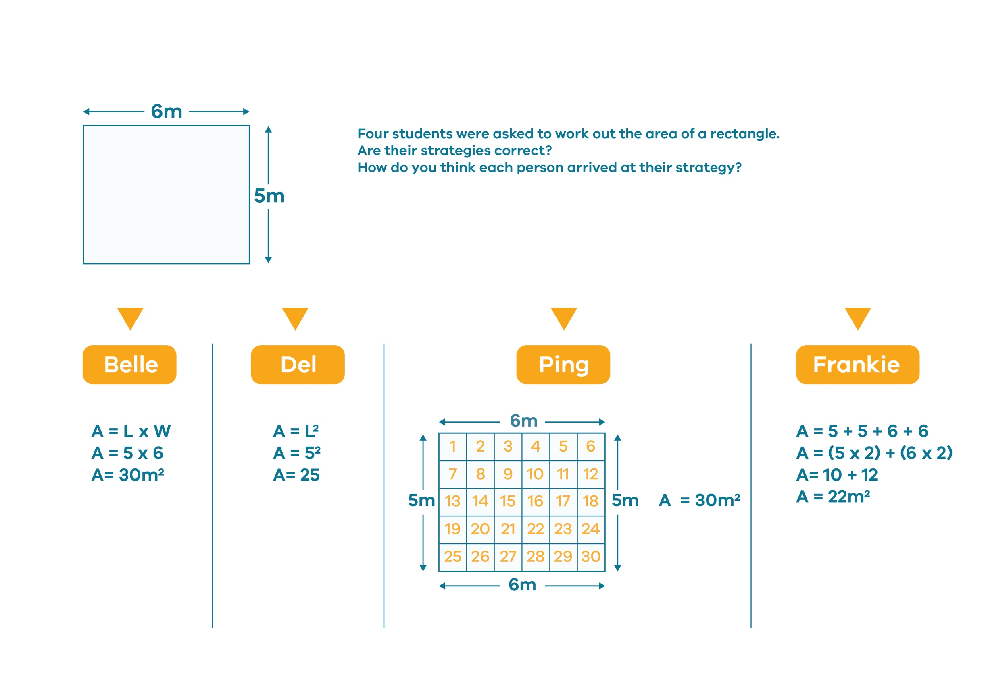
Who is right? - Worksheet 1

© Department of Education and Training CC BY 4.0

