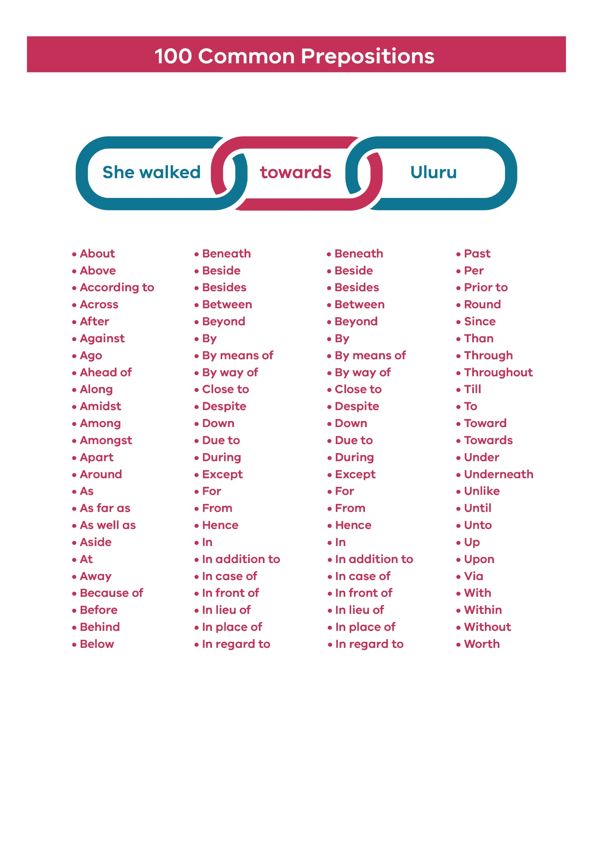
Prepositions are helpful words that show a relationship between a noun and another word. They are generally words that locate things in space or time.
For example, we can relate the two nouns book and puppy by using various prepositions depending on what we are trying to communicate.
The book could be about the puppy, beside the puppy or behind the puppy. The puppy could be in the book, near the book or in front of the book.

