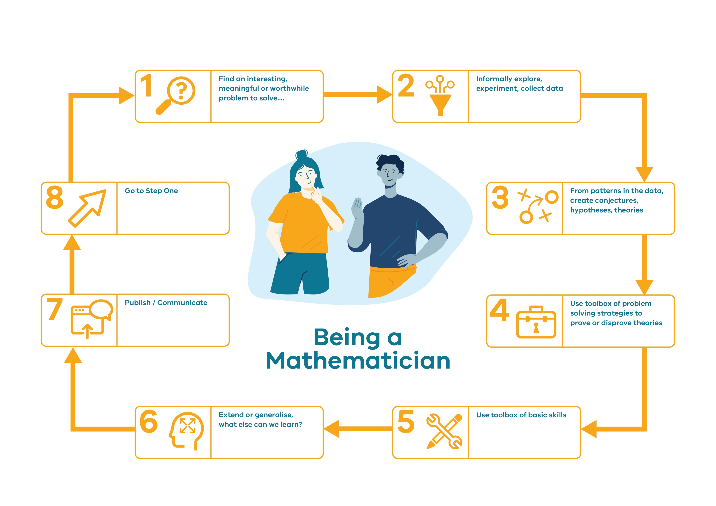
Being a Mathematician ‘adapted from Lovitt and Clarke (2011)’

© Department of Education and Training CC BY 4.0

