MAKE YOUR OWN LIST POEM!
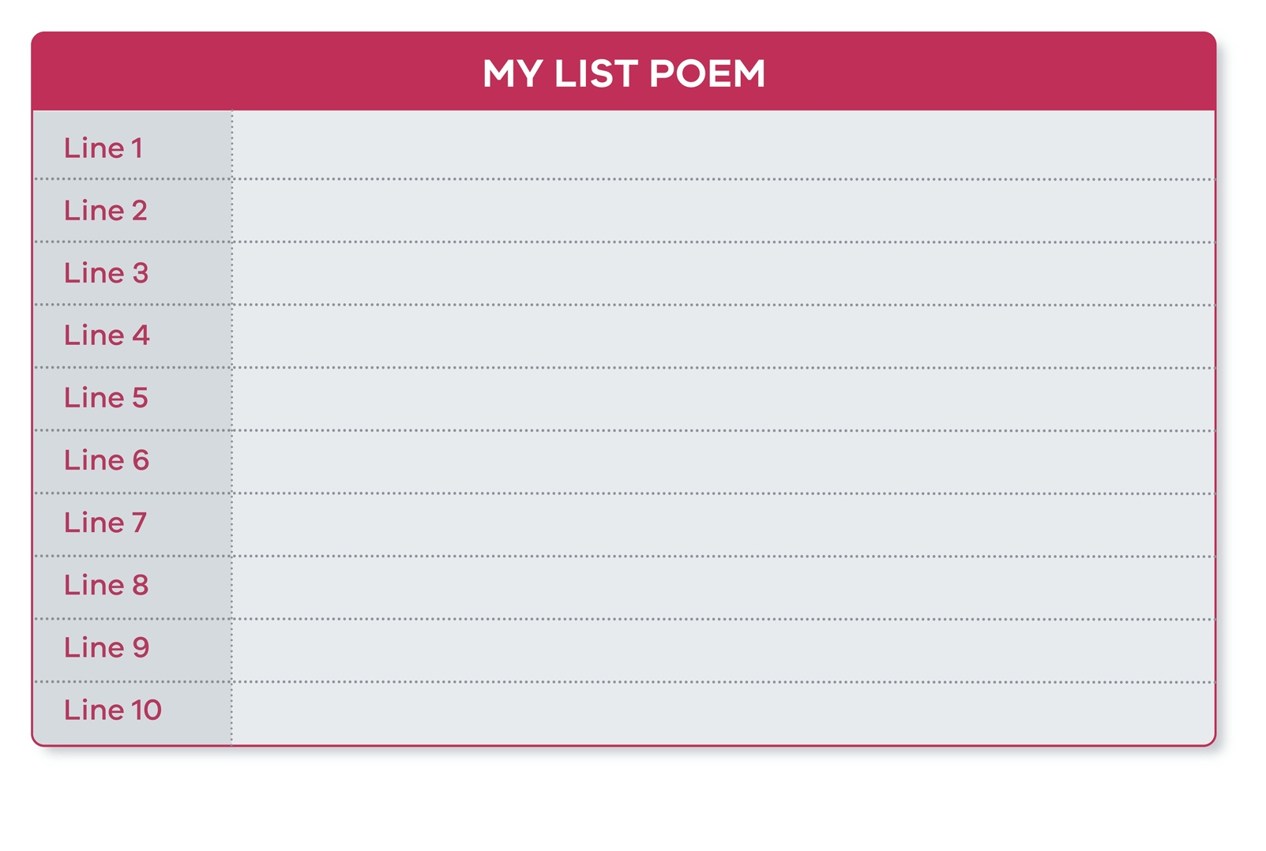
Brainstorm some ideas. Will your list be about something you like? Something you don’t like? A band you adore? A family member? A season? It can be about anything at all!

