Through whose eyes?: aboriginal and european perspectives in literature: RESOURCES

visual stimulus
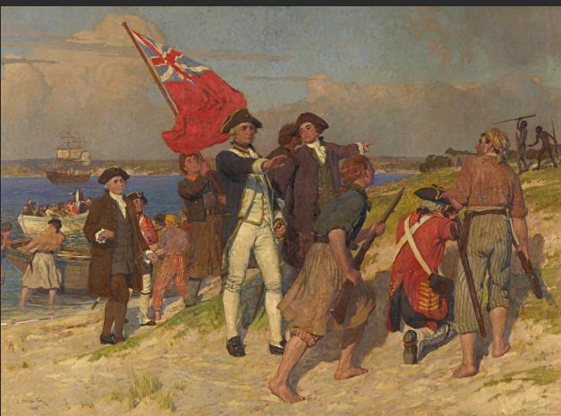

Landing of Captain Cook at Botany Bay, www.ngv.vic.gov.au/explore/collection/work/5576/
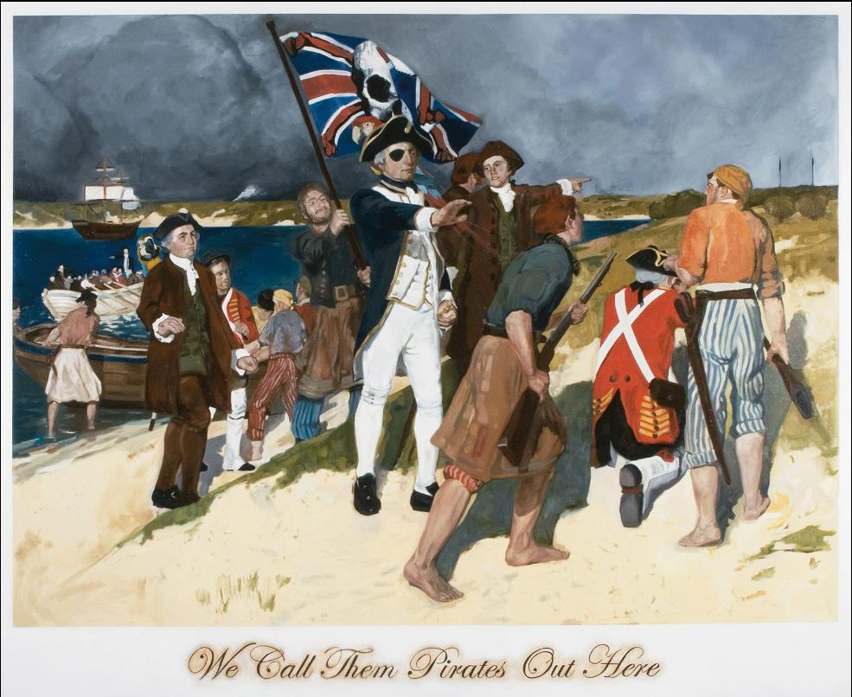
Daniel
Boyd, We Call them Pirates Out Here, 2006. Oil on canvas, www.mca.com.au/about-us/mcastory/first-contact-contemporary-aboriginal-perspective/
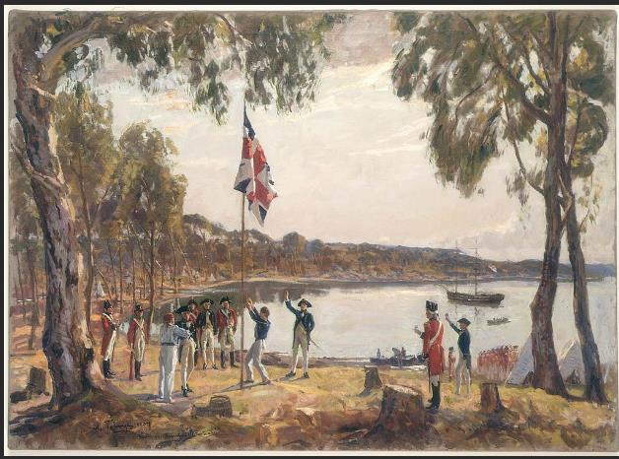
The Founding of Australia by Captain Arthur Phillip RN Sydney Cove, Jan 26th, 1788, Algernon
Talmarge RA https://www.sl.nsw.gov.au/collection-items/founding-australia-capt-arthur-phillip-rnsydney-cove-jan-26th-1788
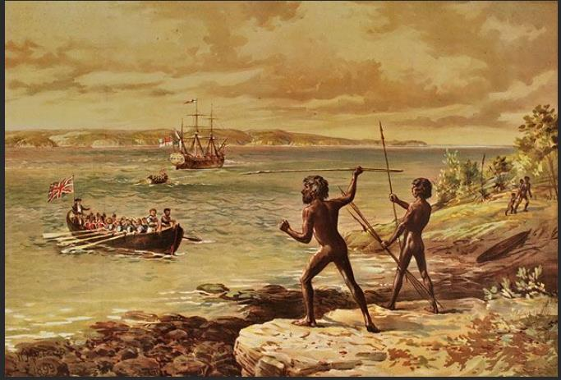
Cooman and another Gweagal warrior confronting Lt James Cook, William MacLeod, 1899,
https://www.abc.net.au/news/2016-11-02/cooman-confronting-cook/7986888

