Persuasion & Influence: RESOURCES

Brigitte Bardot letter
ABC News, Brigitte Bardot condemns Environment Minister Greg Hunt's plan to cull 2 million feral cats,
www.abc.net.au/news/2015-07-22/brigitte-bardot-condemns-greg-hunt-for-feral-cut-cull-plan/6640846,
(viewed 30/10/2019)
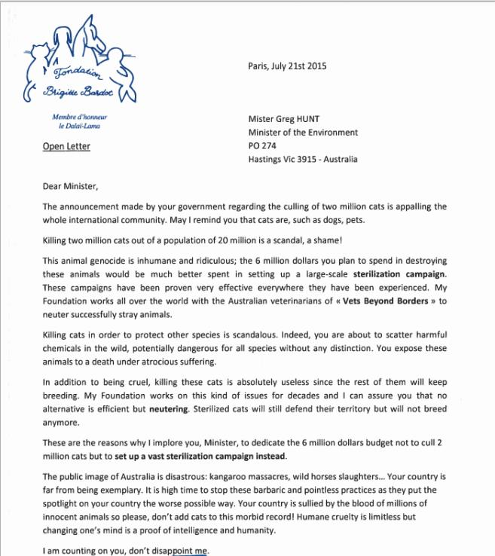
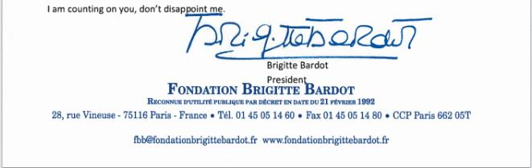

© Department of Education and Training CC BY 4.0

