my life as an alphabet: exploring narrative

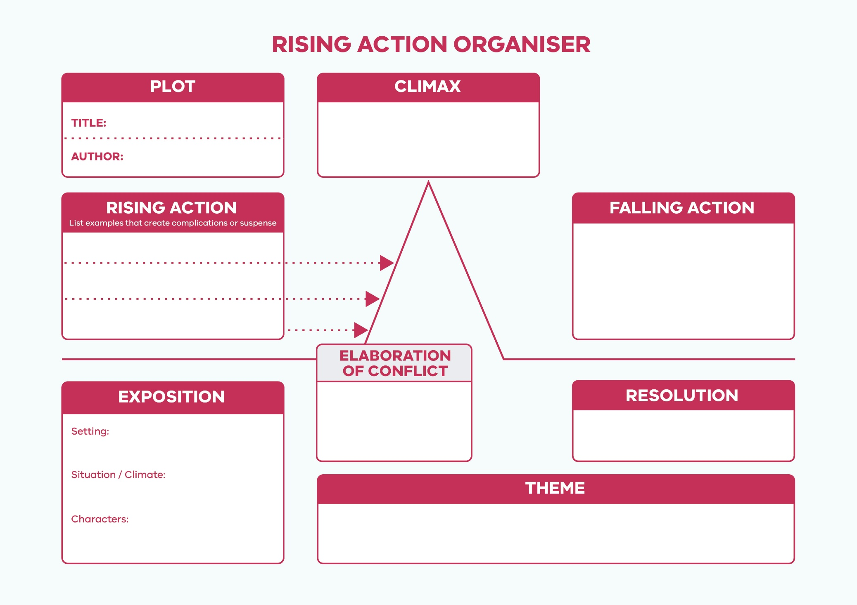
Rising Action Planner
Source: https://thinklivebepositive.files.wordpress.com/2014/08/plotdiagram.jpg

© Department of Education and Training CC BY 4.0

