my life as an alphabet: exploring narrative

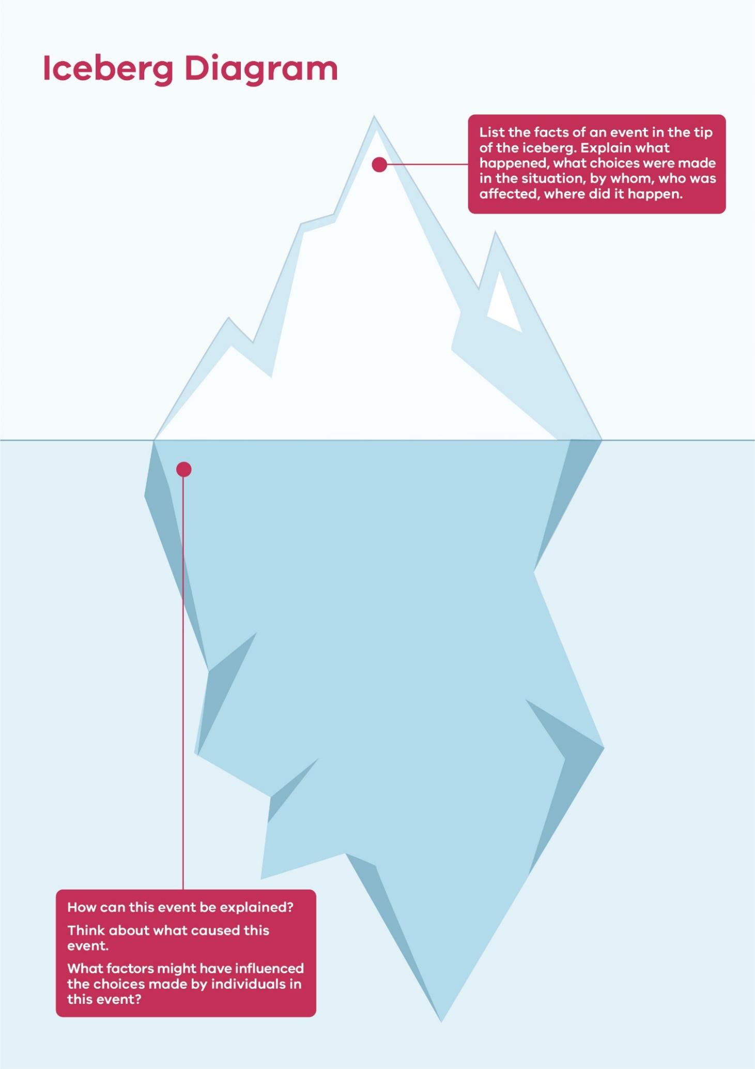
iceberg Diagram
© Department of Education and Training CC BY 4.0

