Let’s Experiment: Discovering Area and Volume Formulas

Comparing Kites and Rectangles
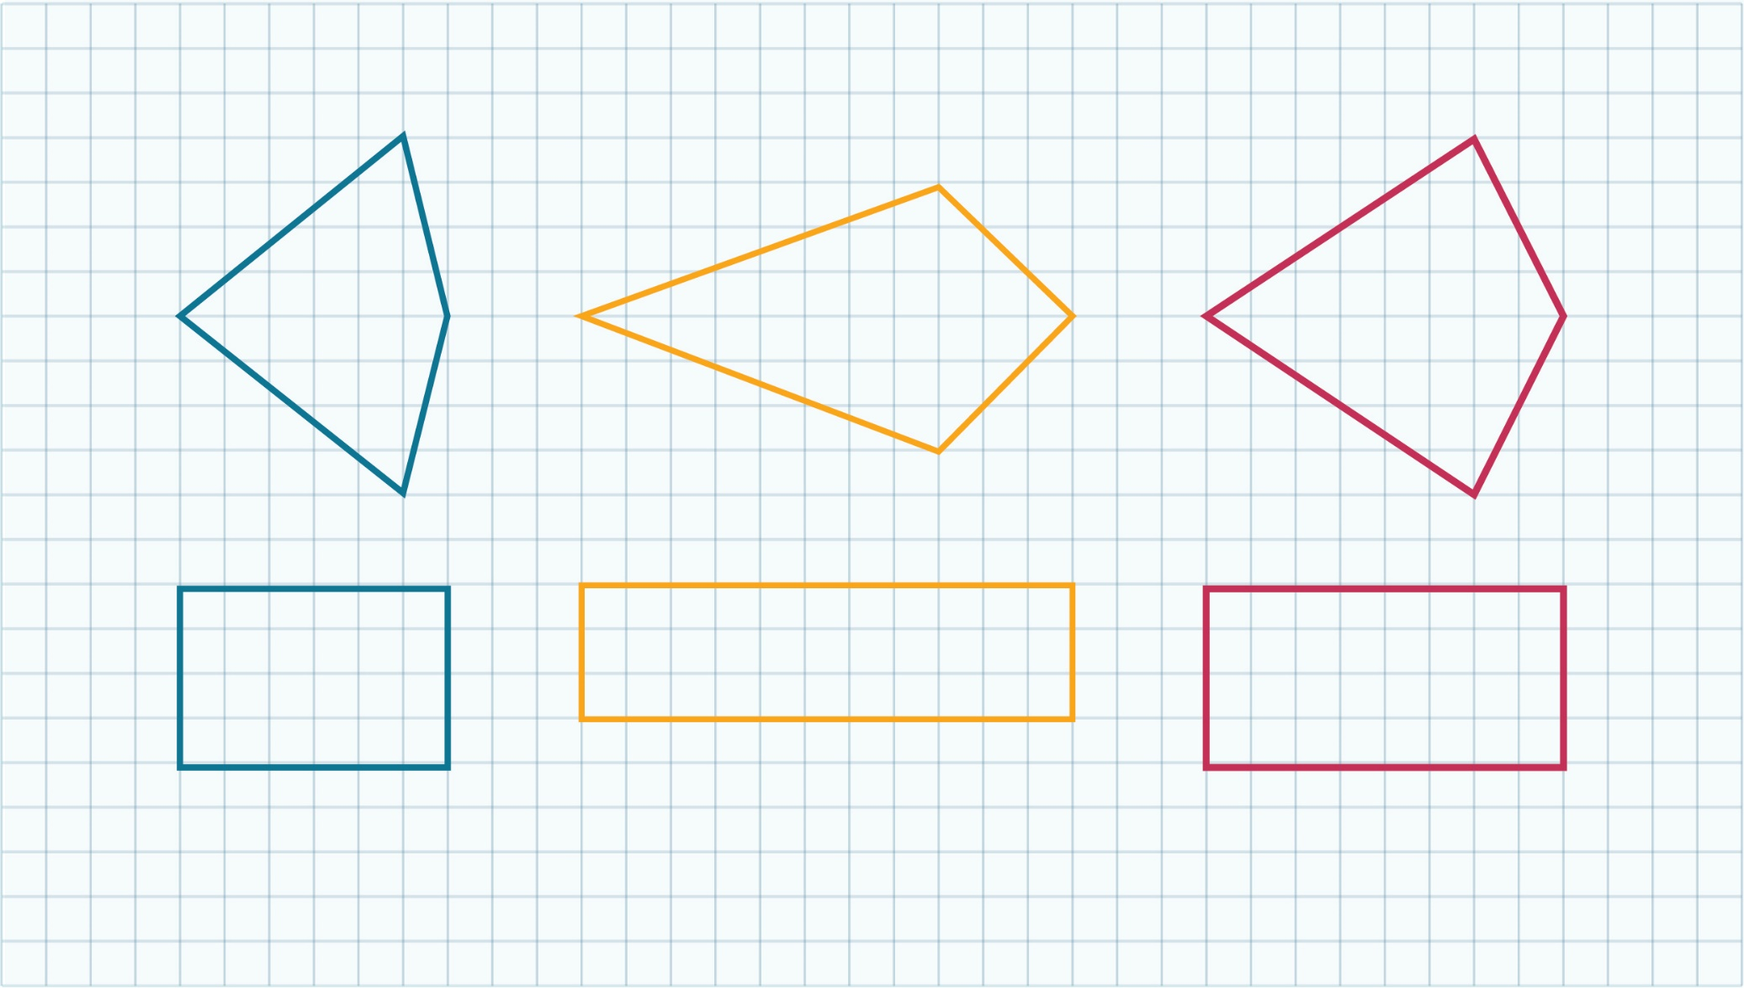

© Department of Education and Training CC BY 4.0

