Exploring multimodal texts: Resources

Exploring modes: Persuasive texts
SunSmart campaign (Slip, slop, slap…)
Students can compare how the following modes persuade:
- Original television advertisement: the Slip, Slop Slap video from 1980.
- Written text from the Cancer Council: 'The job’s not done until we’re all safe in the sun'
- Promotional poster from Skin Cancer Action Week (below)
Reproduced with permission from the Cancer Council.
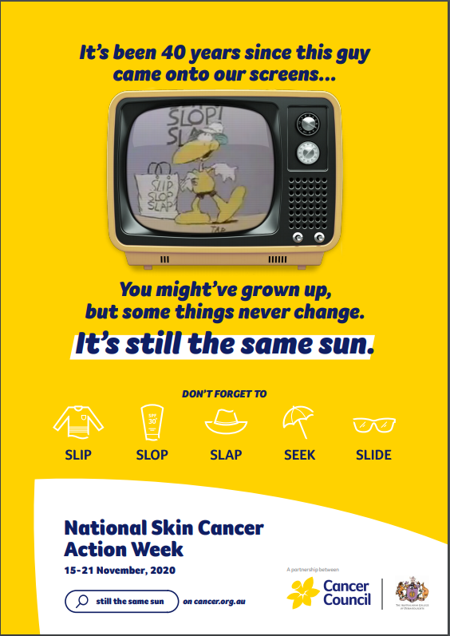
References

Cancer Council Victoria (2010) Slip! Slop! Slap! - The Original Sid the Seagull Video. Available at: https://www.youtube.com/watch?v=b7nocIenCYg (Accessed: 4 April 2022).
Cancer Council (2020) It’s still the same sun. [Poster].
Cancer Council (2021) National Skin Cancer Action Week | The job’s not done until we’re all safe in the sun. Available at: https://www.cancer.org.au/cancer-information/causes-and-prevention/sun-safety/campaigns-and-events/national-skin-cancer-action-week (Accessed: 4 April 2022).

© Department of Education and Training CC BY 4.0

