Through Whose Eyes?: Aboriginal and european perspectives in literature: RESOURCES

T Chart
Partner interview: Take turns interviewing your partner. Ask questions to develop the thoughts, feelings and perspectives on the events described in the text from the point of view of the indigenous animals and the rabbits. Record the responses below.
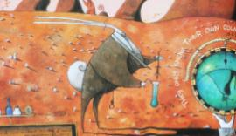
The Indigenous Animals | 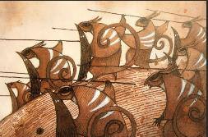 | The Rabbits

© Department of Education and Training CC BY 4.0

