through whose eyes?: aborignal and european perspectives in literature: RESOURCES

Assessment
Complete the following organiser to develop the perspectives of each group from the text. Use dot points and provide examples and evidence from the text
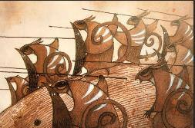 | 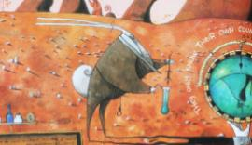
What did each group want?
What might they have been thinking and feeling about their setting and their actions?
How might they have thought and felt about the other group?
How do these themes and events relate to historical events in the past?
© Department of Education and Training CC BY 4.0

