# The bone sparrow: a novel study: RESOURCES

Exploring different perspectives

**Visual Prompts**

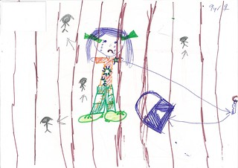

[**Figure 1:**](https://www.flickr.com/photos/23930202@N06/14903081513/in/album-72157645938124048/)AHRC National Inquiry into Children in Immigration Detention 2014

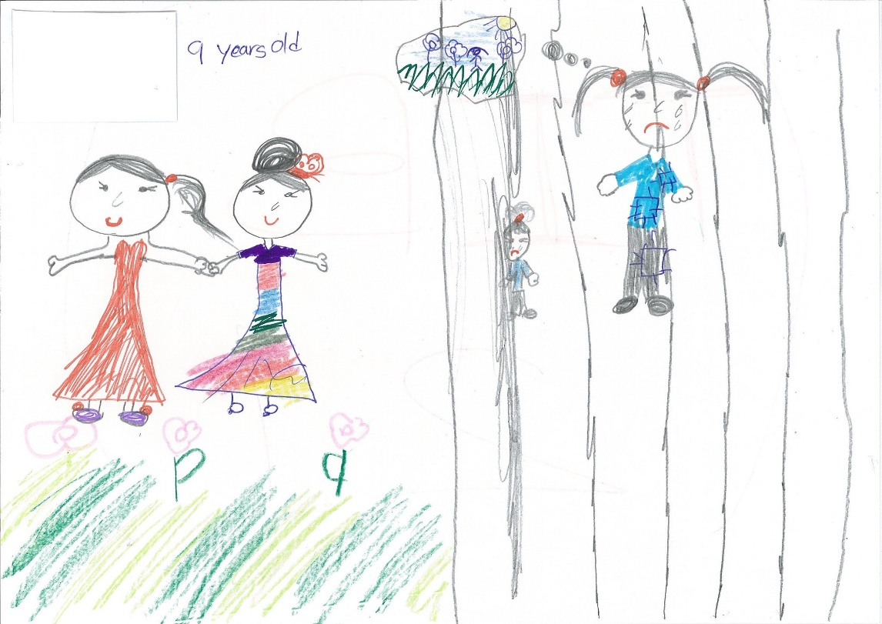

[Figure 2:](https://www.flickr.com/photos/23930202@N06/14696565589/in/album-72157645938124048/) AHRC National Inquiry into Children in Immigration Detention 2014

© Department of Education and Training [CC BY 4.0](https://creativecommons.org/licenses/by/4.0/)