every word has a story: RESOURCe

Aesop’s Fable: The Wolf and THe Lamb
Below is an Aesop’s Fable, printed in 1484 by William Caxton. Read it carefully and note any words that are the same as we would use today. Underline words that are similar and words you do not recognise.
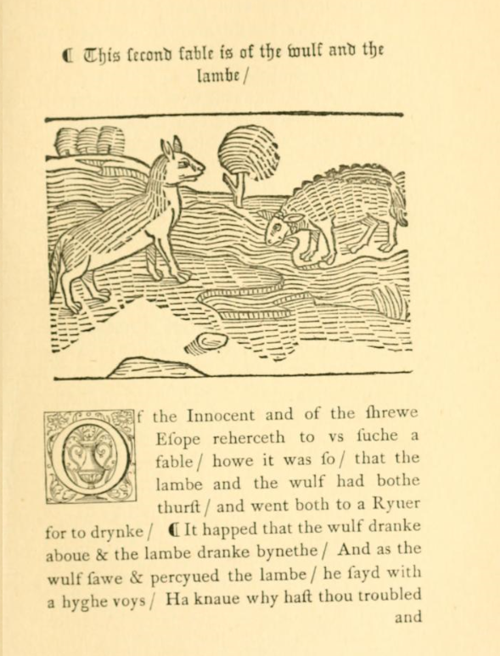

Source: https://archive.org/details/fablesofaesopasf02aesouoft/page/4/mode/2up?q=wolfe+and+the+lambe

Aesop’s Fable: The Wolf and the lamB
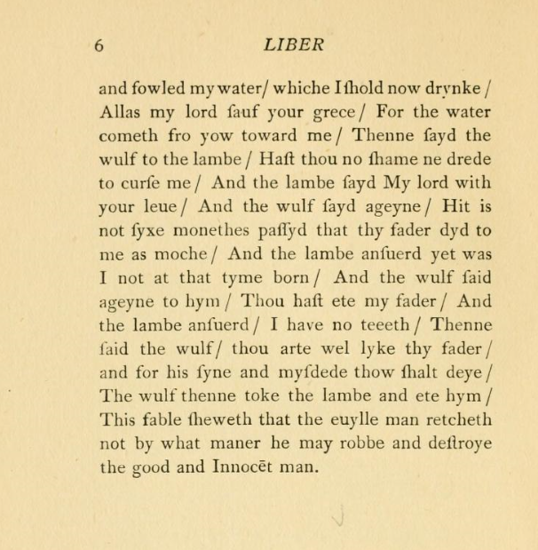

Words that are the same as today | Words that are easily recognisable
Words that I can guess using the context of the story and sentence | Words that I do not recognise
Re-read the fable and list words under each of the following categories:
© Department of Education and Training CC BY 4.0

