every word has a story: RESOURCe

Word spoke chart
Select a prefix, base or suffix to record in the middle of your word spoke chart. Include a brief definition.
Think of other words that share your selected prefix, base or suffix to record in the spokes of your word chart. Include a brief definition of each word.
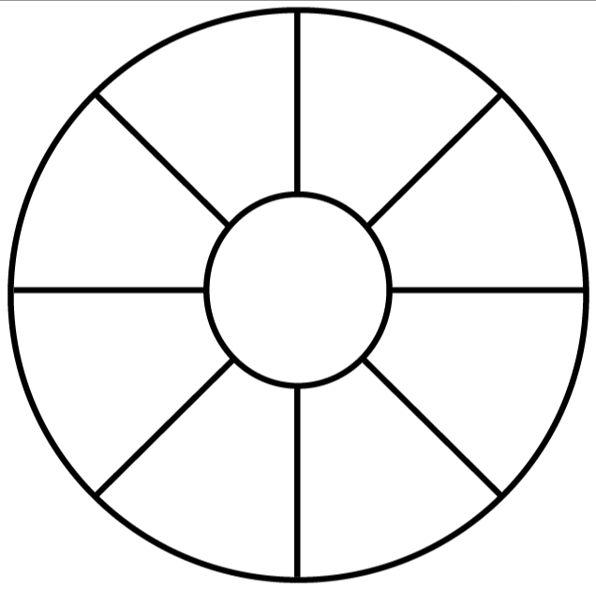
Use illustrations to support the word definitions.

© Department of Education and Training CC BY 4.0

