Ur a poet and u didn’t know it

Magnetic Poem Sample and Sample Annotation

Magnetic poem draft: how might word choice affect meaning?

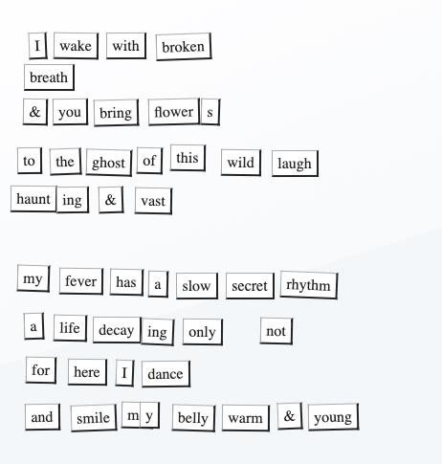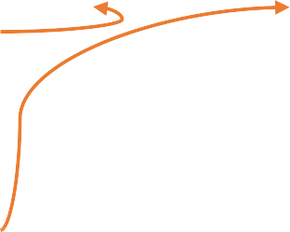

The adverb ‘not’ is spaced out on its own to add emphasis; to contradict the idea that a life is decaying. Guides the reader towards focusing on the contradiction. Implies hope.

The use of the word ‘wild’

implies freedom or joy.

Contrasts to ‘broken breath’ and

the bringing of flowers. Emphasises the loss of the laugh.

Choice of the words ‘belly’,

‘warm’ and ‘young’ creates an image of youth and vitality, an indicator that perhaps the person will recover from whatever has caused them to have ‘broken breath’ after all.

Decaying is an evocative word and creates powerful imagery. More effective than words

like ‘going’ or leaving’.

Enjambment used to place emphasis on the word at the end of the line, ‘dance’.

Dancing implies a different rhythm to the ‘slow’ fever and may symbolise hope.

Use of descriptive language (‘slow’, & ‘secret’) to create a

sense of motion and time, and a lack of control by the person suffering. The fever behaves in a “secret” way and moves at its own pace.

Though ‘full stops’ are not available in Magnetic Poetry kits, this line is end-stopped: it has a complete idea or sentence on one line. Used for rhythmic effect and slows the reader down to encourage them to focus on a complete idea.

Break in stanza to indicate a move into a new focus or element of the poem. Breaks

the ideas or ‘story’ up.

The use of the

word ‘vast’ implies something fathomless. Has a more evocative meaning than a

word like ‘big’.

Suffix ‘ing’ found in magnetic poem kit and added to

‘haunt’ to create an adjective for descriptive purposes.

Personification suggests that laughter has gone or died, but it still lingers or haunts. Laughter dying could be symbolic of illness, death or sadness.

The idea of someone bringing of ‘flowers’

adds to the theme of illness or bereavement.

‘Breath’ placed on its own on a line to force the reader to linger or pause for emphasis; perhaps even to think about their own breath.

Use of enjambment. ‘Broken’ placed at the end

of the line for emphasis.

Choice of word ‘broken’ in relation to ‘breath’

suggests illness or breathlessness, or even grief.

© Department of Education and Training [CC BY 4.0](https://creativecommons.org/licenses/by/4.0/)