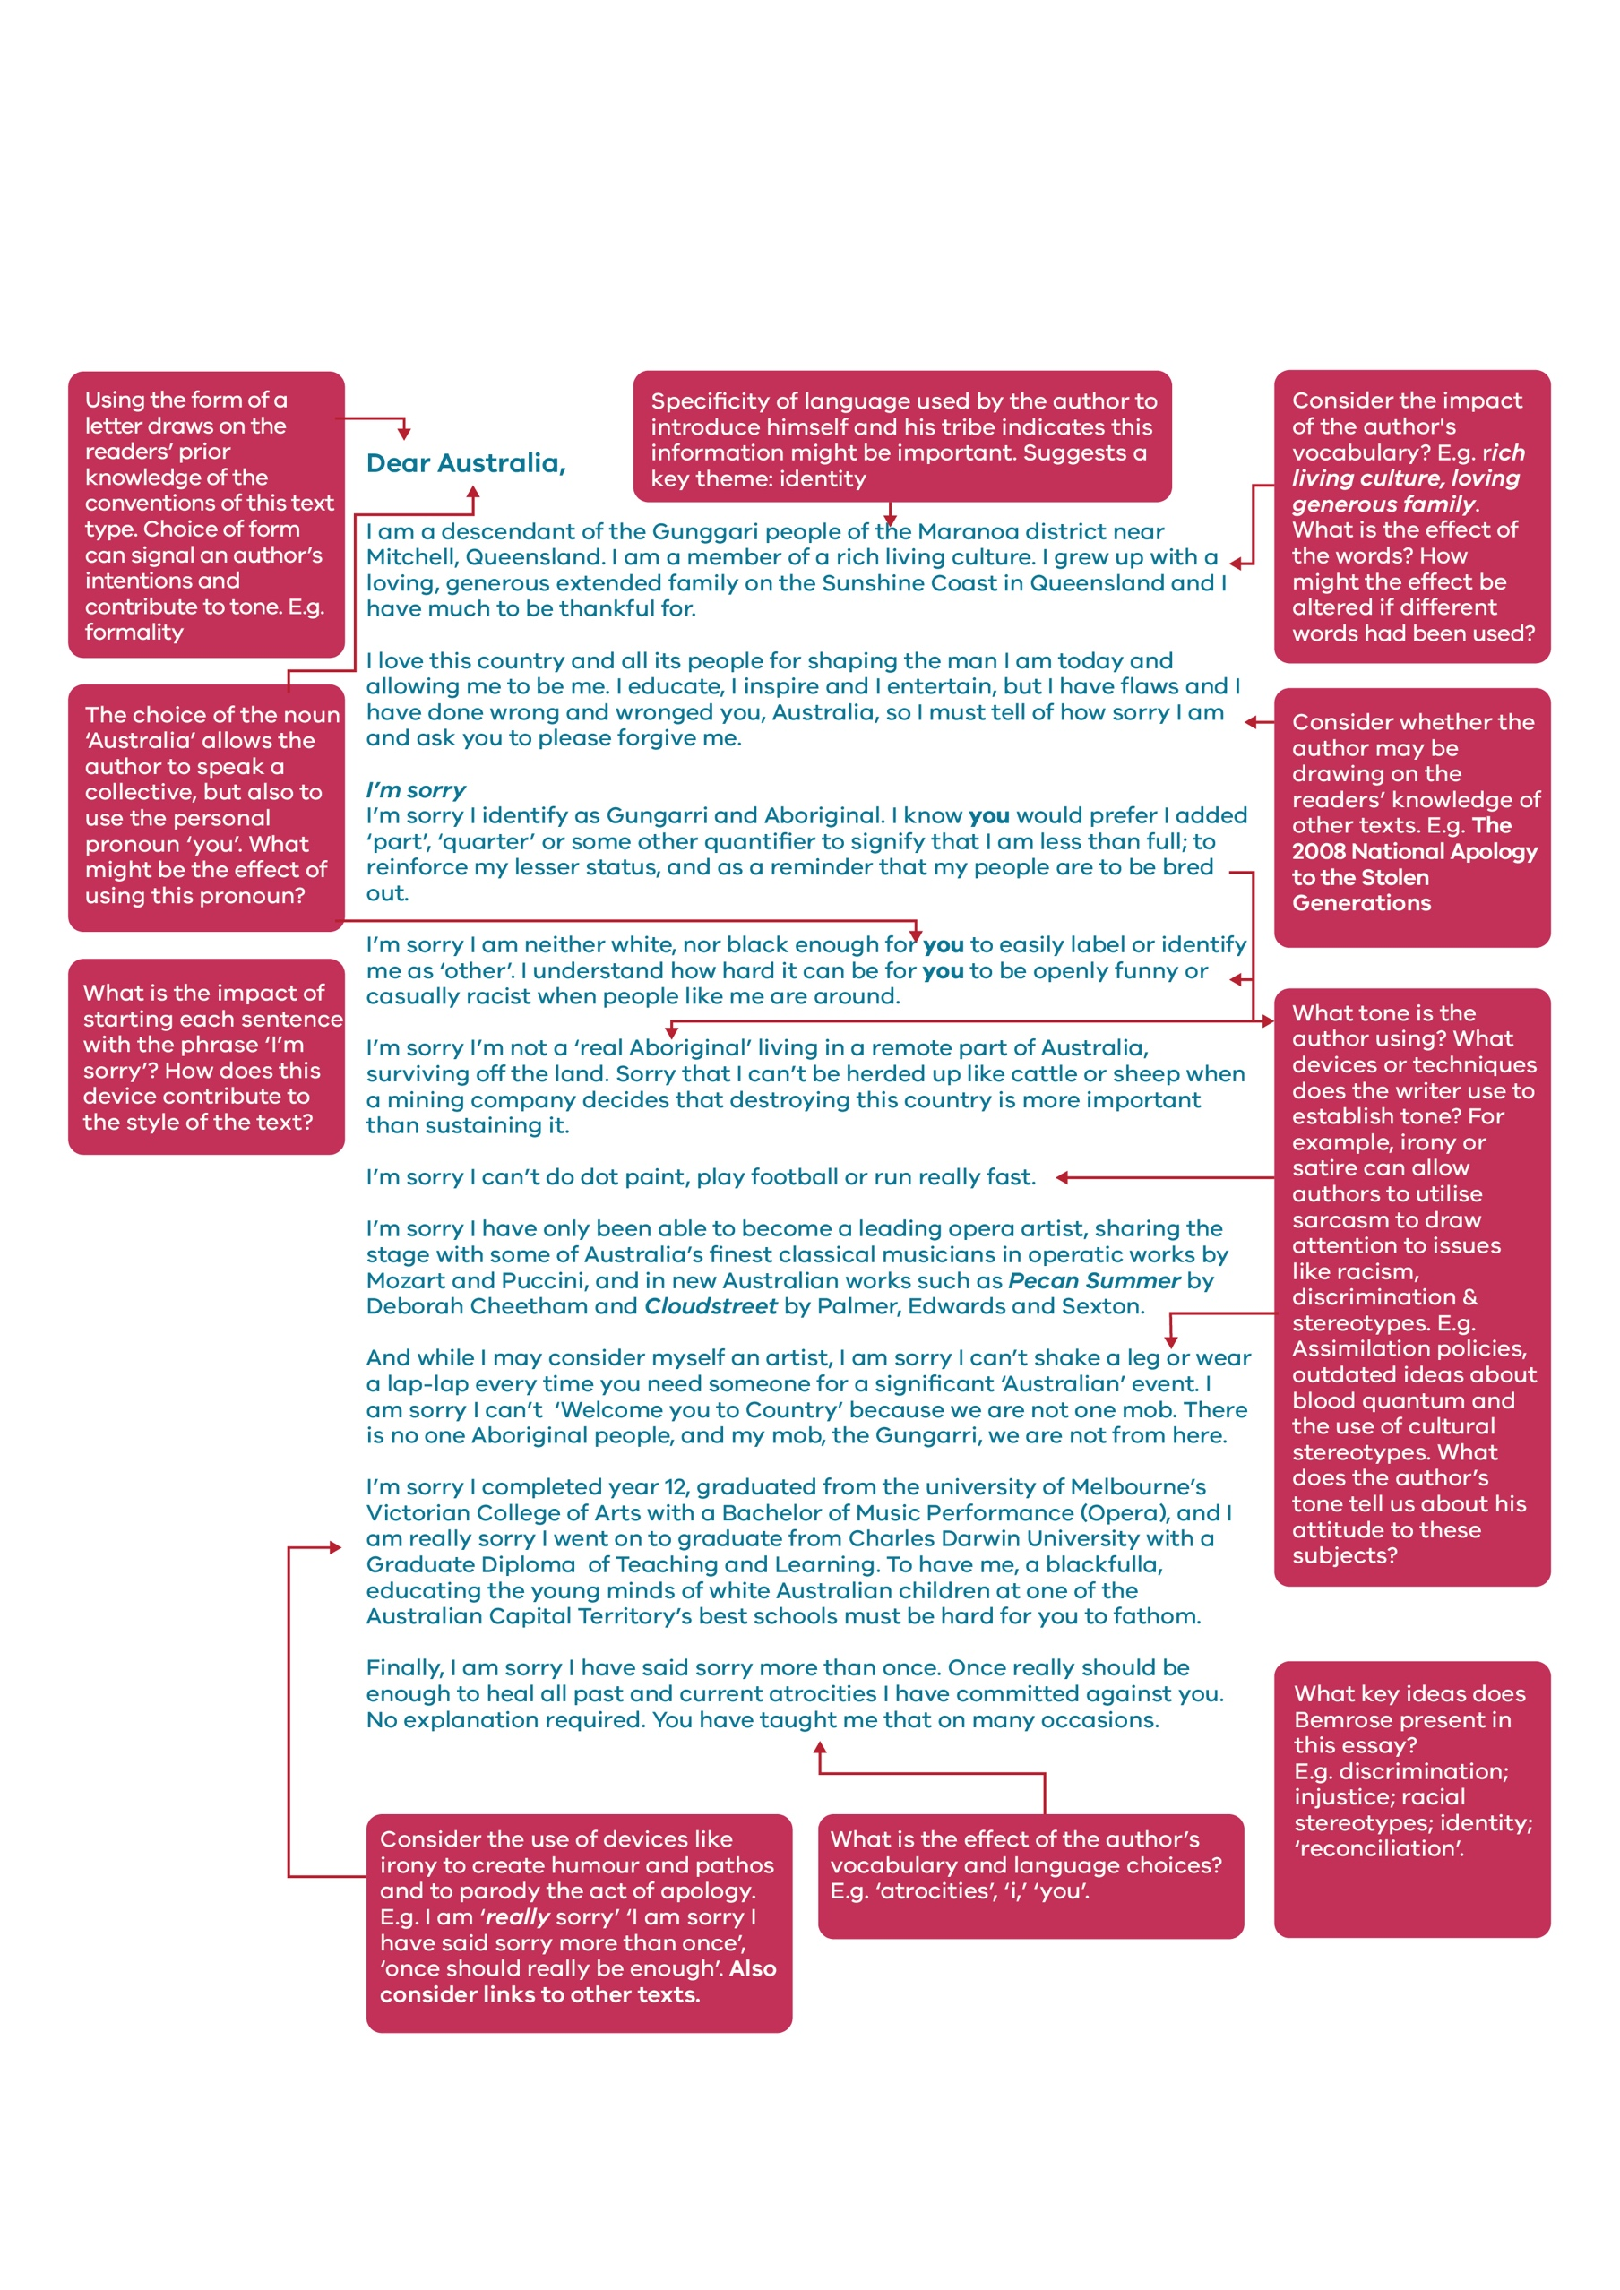
Sample Annotation: Dear Australia – Don Bemrose

© Department of Education and Training CC BY 4.0

