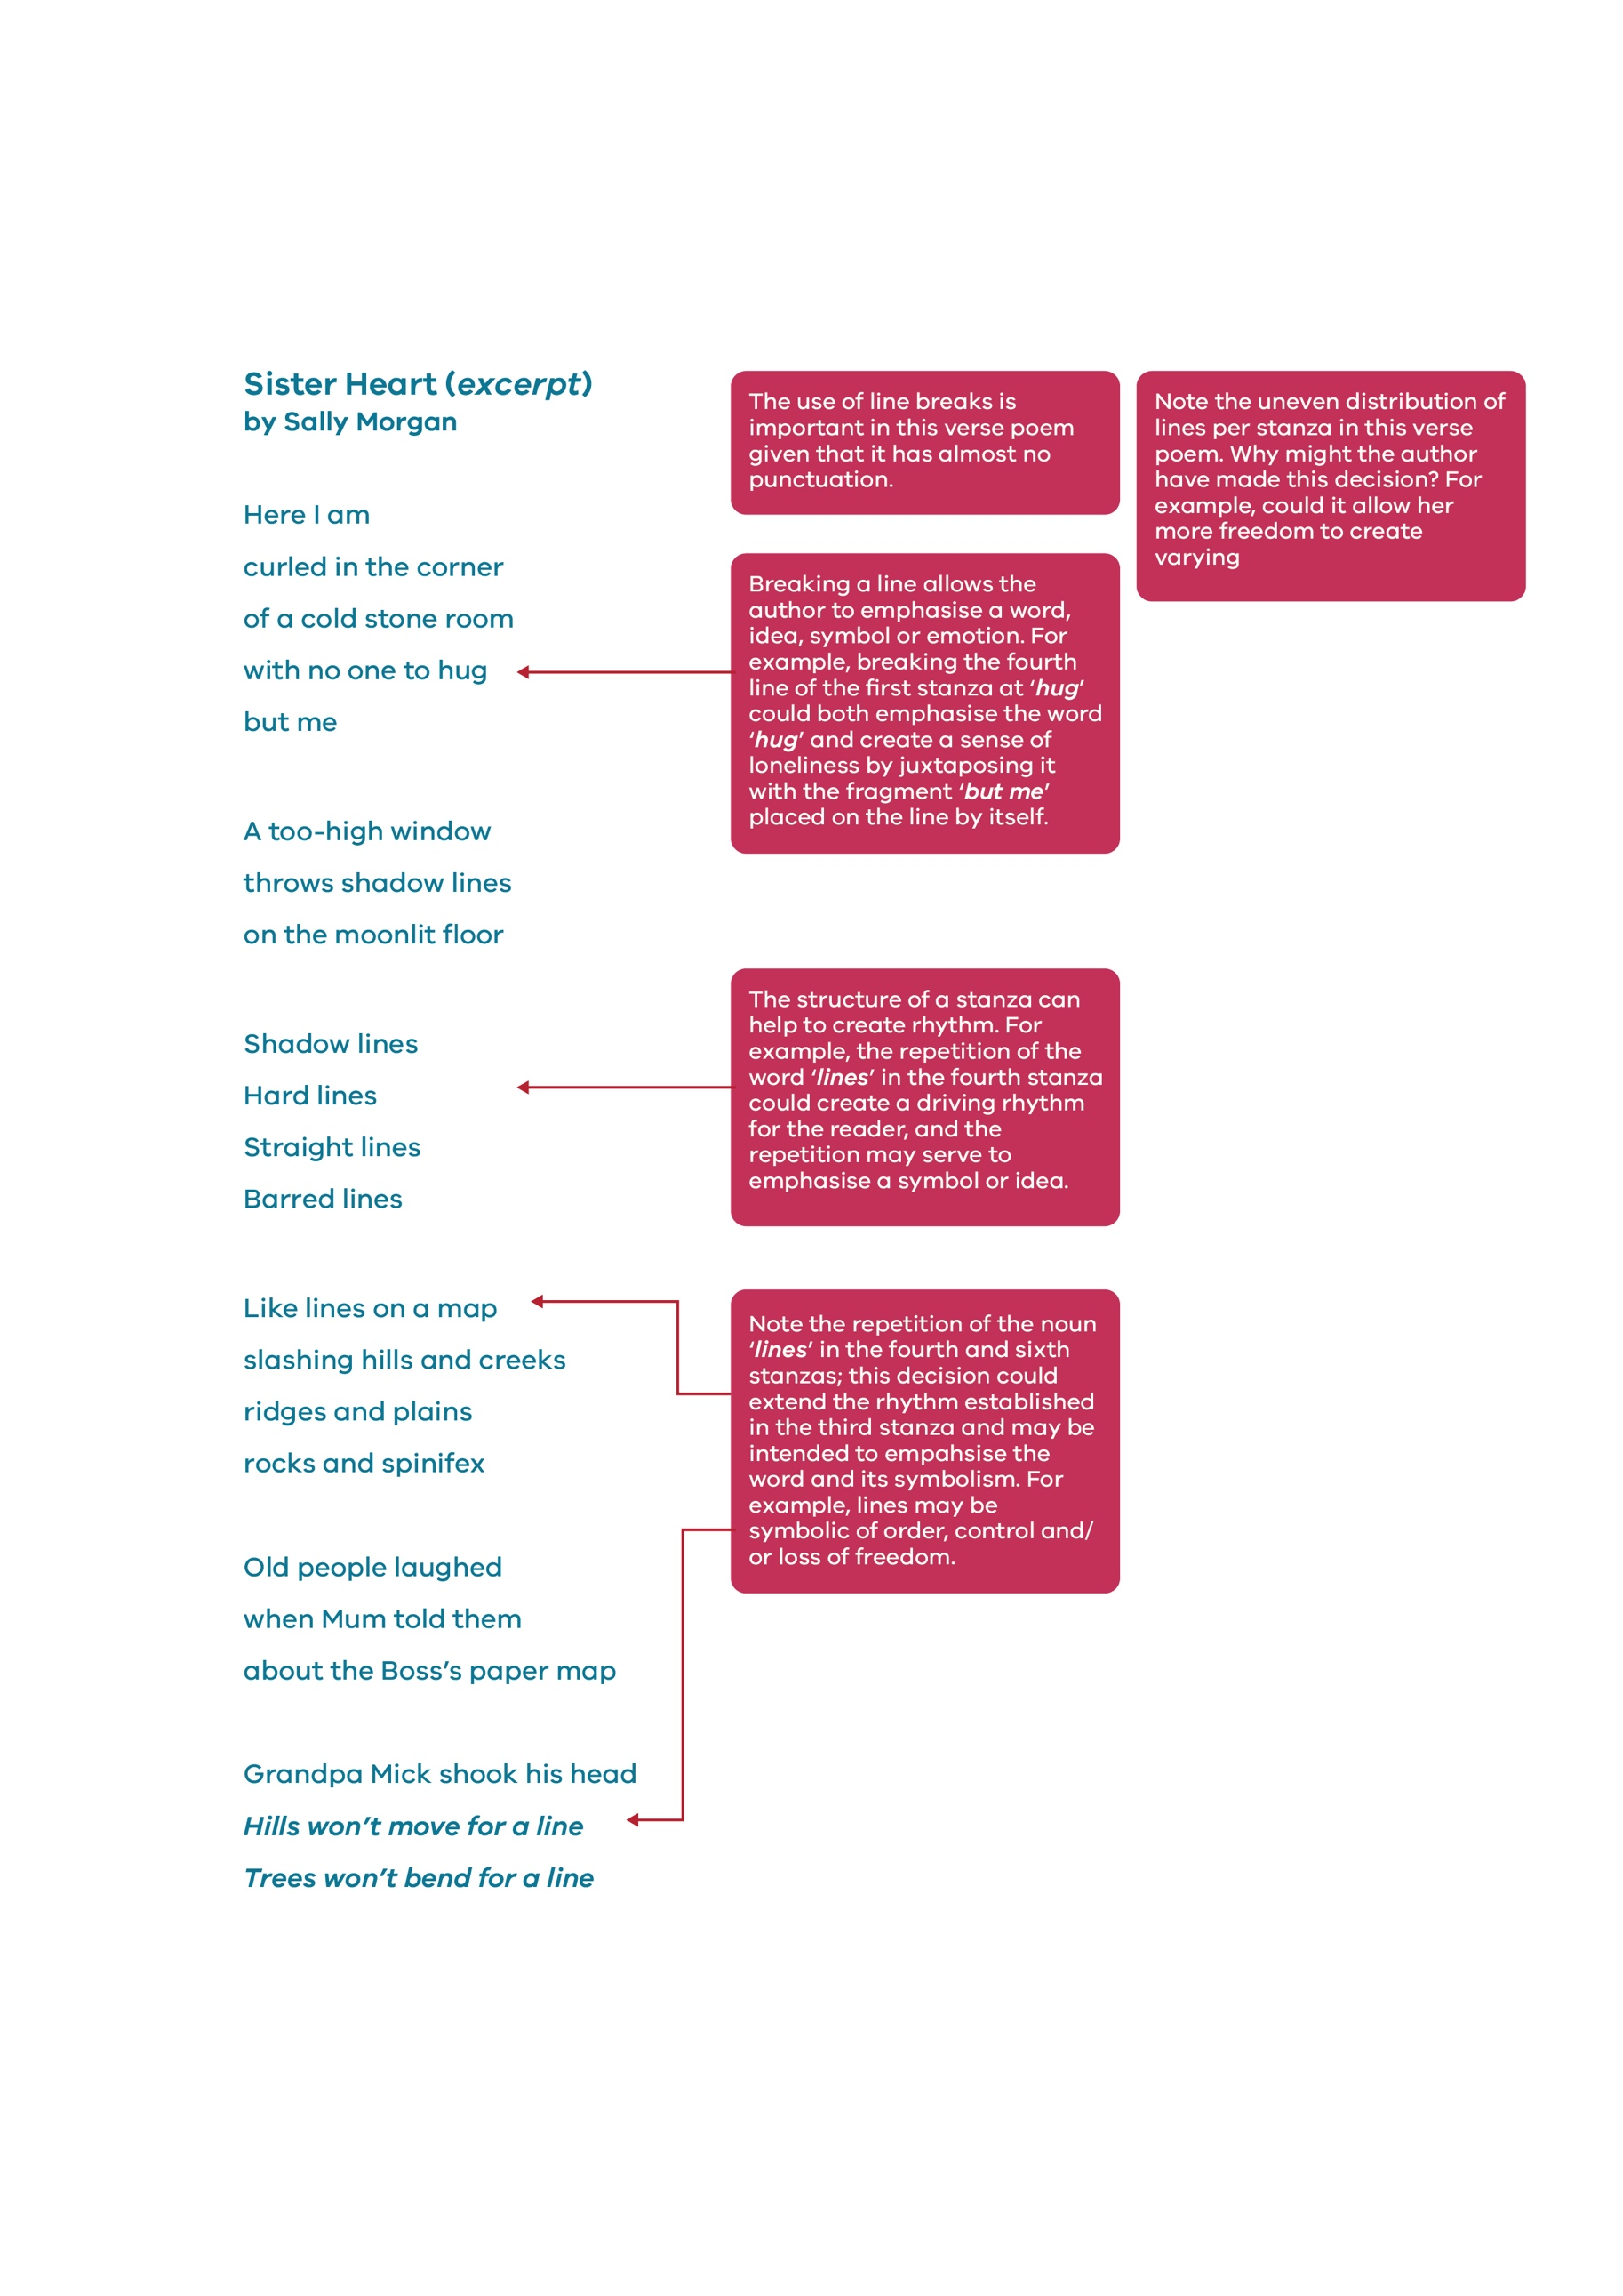

Annotation: Language Structure

© Department of Education and Training CC BY 4.0

Annotation: Language Structure