UR A POET AND U DIDN’T KNOW IT
AVOIDING CLICHÉ LIKE THE PLAGUE
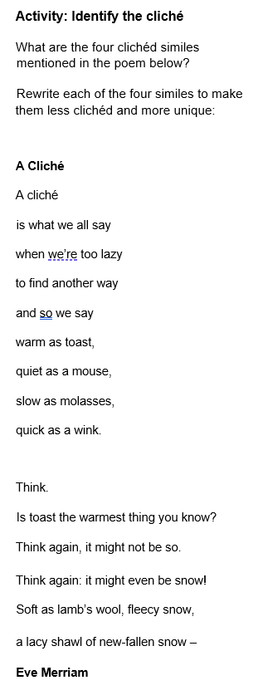
All writing is a campaign against cliché. Not just clichés of the pen but clichés of the mind and clichés of the heart.
- Martin Amis
Clichés are metaphors and turns of phrase that have become tired through overuse.
‘If you love someone set them free’ is a cliché, along with ‘all walks of life’ and ‘don’t cry over spilled milk’.
You could say ‘every cloud has a silver lining’ to describe the positive aspect of a bad situation but coming up with something more creative and original will be more effective.
Clichés often appear in early drafts of your work when you're looking for words to describe an action, event, or person. That's fine, but it's a good reason to do a couple of drafts - no one gets it right the first time.
You should:
- Read through your poem with a critic’s eye – and ask someone else to read it too.
- Delete anything that might resemble a cliché and replace it with words of your own.
- Think about what techniques you could use to express an idea in an original way. For example, using figurative language like imagery, metaphor or simile.
Online resource for those who want to rid their writing of cliché: http://www.westegg.com/cliche

