BRINGING LIFE TO DATA: RESOURCES
THE PET GRAPH

Source: Nrich
The children in the Foundation class have been collected information about all of their pets. They have six different kinds of pets between them.
They made a column graph to show how many of each pet the class has altogether.

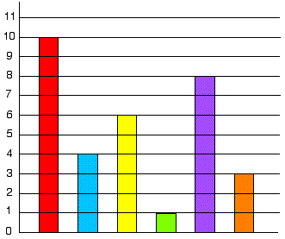

The children have not yet put in the animal names under each column. Can you do this for them using the information below?
- There are two less cats than dogs
- Only one child has a parrot at home
- The number of fish added to the number of rabbits is equal to the number of dogs.
- There are twice as many fish as mice.
- There are half the number of rabbits as there are cats.

© Department of Education and Training CC BY 4.0

