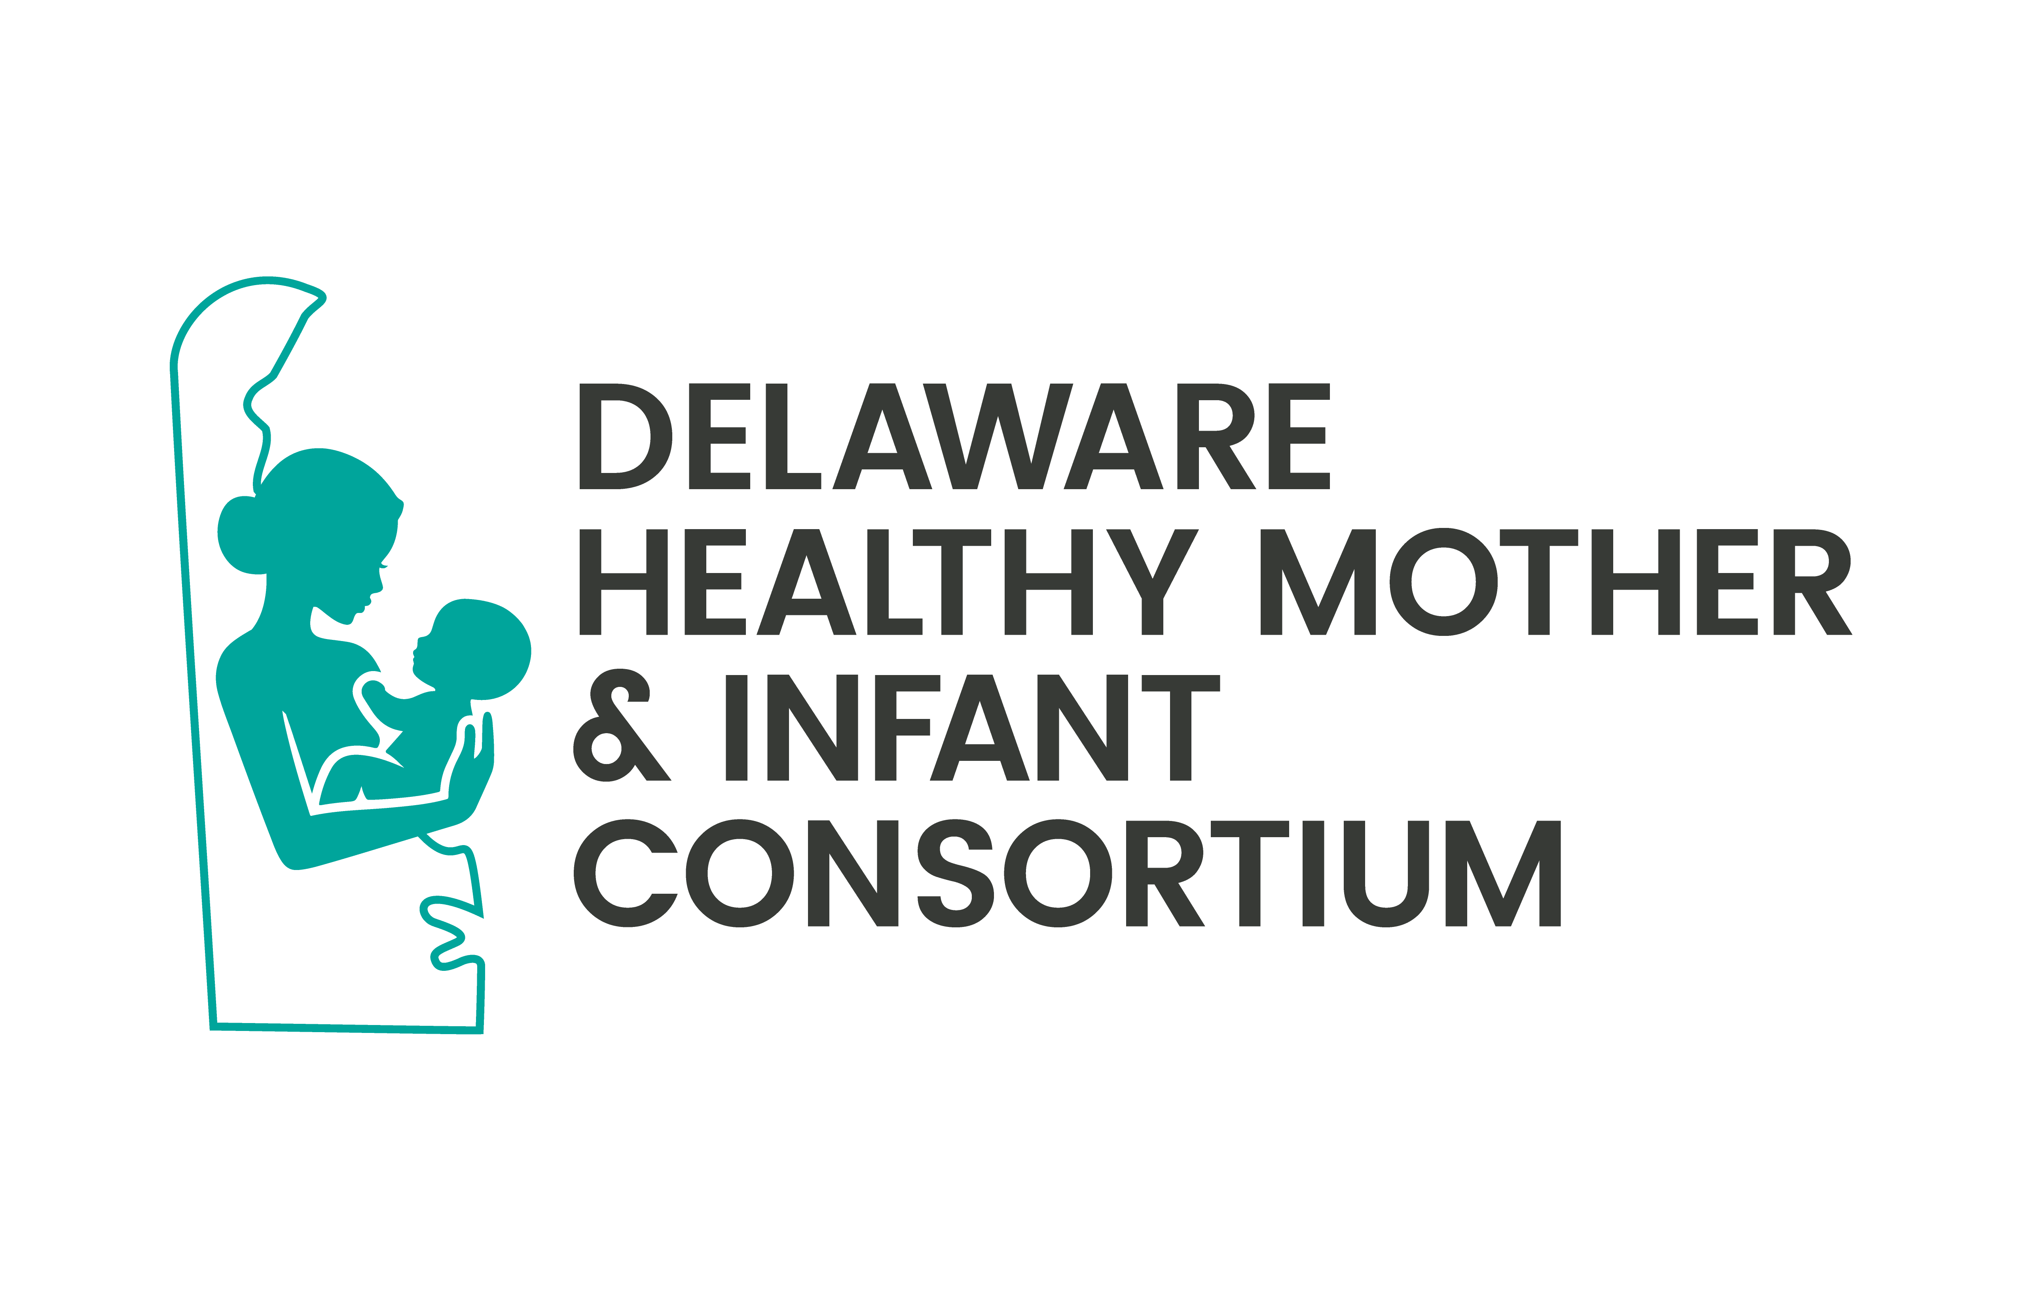


DELAWARE HEALTH
AND SOCIAL SERVICES
Division of Public Health

DELAWARE HEALTHY INFANT AND MOTHER CONSORTIUM (DHMIC) MEETING MINUTES

Well Woman/Black Maternal Health Committee
Wednesday, September 16, 2026 Virtual Zoom Meeting
Anchor Site: 1351 W. North Street, Suite 103 Dover, DE 19904

MEMBERS PRESENT:
Mona Liza Hamlin, Chair Tiffany Chalk, Chair
Erin Rideout
Meena Ramakrishnan
Philinda Mindler
Cynthia Guy
Tracy Harpe
Bridget Buckaloo
Kirsten Olson
Jackie Armstrong

OTHER ATTENDEES:
Tavanya Lockett
Kori Hambric
Peter Thistle
Tiara Jackson
Symone Hopkins
Corie Dalton
Nadia Lazarczyk
Sara
Jacqueline Corbin
Nickee Alexander

DIVISION OF PUBLIC HEALTH PRESENT:
Leah Jones
Dr. Naa Dede Hesse Chelsea Manwiller George Yocher


DRAFT

Number of public members in attendance: 10. Full sign-in list stored with DPH meeting records.

TOPIC | FINDINGS, CONCLUSIONS & RECOMMENDATIONS | PERSON RESPONSIBLE | STATUS | ACTIONS & FOLLOW-  UP
I.  Call to Order | Mona Liza Hamlin called the meeting to order and led the roll call. | Mona Hamlin, Chair | Resolved | No further action required.
II. DHMIC  Member Introductions | Mona Liza Hamlin, Chair, facilitated introductions from DHMIC members, current committee co-chairs and general members, newly appointed members, Representatives from various health organizations and DPH team members.  Seven committee members were present. | Mona Hamlin, Chair | Resolved | No further action required.

1351 W. North street • Dover • Delaware
Mailing address: 1351 W. North Street • Suite 103 • Dover • Delaware • 19904

III.  Approval of Minutes | A motion to approve the November minutes was offered, however, full quorum was not confirmed, so approval of the previous meeting minutes was deferred to the next meeting. | Mona Hamlin, Chair | Resolved | No further action required.
IV. New Business | N/a | N/a | Resolved | No further action required.
V. Committee Updates | Her Story 2.0 Project Update  Project status  • Tiffany Chalk reported that first-draft edits had been received after testimonial recordings were completed in June and late August.  • Short video clips were shared with the committee. The clips centered the experiences and voices of women and families and highlighted pregnancy and postpartum challenges.  • Technical issues affected the quality of portions of the screen-shared video presentation.  Toolkit planning and feedback  • The project team is developing patient- and provider-facing toolkits that may include tip sheets, fact sheets, best practices, guidance for patient-provider conversations, and testimonial videos.  • Leah Jones recommended adding clear calls to action, key statistics through text overlays, and links to DE Thrives or Maternal Health 360 resources.  • Tiffany Chalk will finalize and distribute the video clips and toolkit materials after incorporating committee feedback.  Resource Map Project Update  - The resource map remains under DPH review and approval and is not yet publicly available.  - Once approved, the map is expected to connect to the DE Thrives website through a unique URL.  - The current Excel resource list will remain accessible on SharePoint until the new resource map goes live.  - • Committee members will be reminded to review and verify their organizations’ information on the SharePoint resource list before launch.  Fourth Trimester Education and IPAC Initiative  Overview  • Bridget Buckaloo and Katie Taylor presented an update on the Delaware Perinatal Quality Collaborative’s Improving Postpartum Access to Care initiative.  • The initiative promotes an early maternal health safety visit at 2 to 3 weeks postpartum, in addition to ongoing postpartum care, and reflects the fourth trimester model of care.  • Two collaborative learning sessions were held in June and August with birthing facilities, managed care organizations, and other partners.  Education and patient identification  • The Blue Band Initiative uses blue bands to identify postpartum women and white bands to identify individuals who experienced pregnancy loss.  • Supporting materials are intended to reinforce maternal warning signs, care coordination, and timely connection to services.  • The presentation noted that up to 40% of women do not attend the traditional 6-week postpartum visit and that 50% of postpartum strokes occur within 10 days of discharge.  Implementation considerations and next steps  • The group discussed the need to reach external practices and home visiting providers and to address provider billing and coding concerns for the 2 to 3 week visit.  • Bridget Buckaloo and Katie Taylor will work with Kirsten Olson to arrange an educational session for home visiting providers.  • Bridget Buckaloo and Katie Taylor will collaborate with ACOG on a learning session for members and practice staff, targeted for fall 2026.  • The IPAC team will continue work on billing and coding solutions to support provider reimbursement. | Akiba Daniels  Bridget Buckaloo  Leah Jones  Mona Liza Hamlin  Nickee Alexander  Symone Hopkins  Tiffany Chalk  Bridget Buckaloo and Katie Taylor |  | Ensure the current Excel resource list remains accessible on SharePoint until the new resource map goes live.  Share information about Beebe’s Walk to Remember event on October 4, 2026.  Provide feedback on the Her Story 2.0 videos, including clear calls to action and potential links to DE Thrives or Maternal Health 360 resources.  Remind committee members to review their organizations’ details on the SharePoint resource list before the map goes live.  Share registration information for Delaware First Health’s community baby shower on October 15, 2026.  Share Impact Life’s admissions line contact information for referral purposes.  Finalize and distribute Her Story 2.0 video clips and toolkit items, incorporating feedback on calls to action, text overlays, and resource links.  Work with Kirsten Olson to arrange an educational session for home visiting providers on the IPAC initiative and fourth trimester care.

VI. Public Comment/ Updates and Announcements | - Bridget Buckaloo shared information about Beebe’s Walk to Remember event on October 4, 2026.  - Nickee Alexander shared information about Delaware First Health’s community baby shower on October 15, 2026.  - Symone Hopkins shared information about Impact Life services and agreed to provide the admissions line contact information for referrals.  - Members also referenced the Maternal and Child Death Review Commission meeting, the Community Health Worker Summit, and support programs for pregnant and postpartum individuals. | Various | Resolved | No further action required.

VII.  Adjournment | The meeting concluded following public comment and final announcements.  Meeting adjourned at 11:58 AM |  | Resolved | No further action  required.

Minutes prepared by: Akiba Daniels
Minutes reviewed by:
Minutes reviewed and submitted by:
Minutes approved by: Pending next quarterly meeting

2026 Meetings
All Meetings held virtually

• Thursday, March 5th from 11 am – noon​
• Wednesday, June 3rd from 11 am – noon​
• Wednesday, September 16th from 11 am – noon​
• Wednesday, November 4th from 11 am – noon

