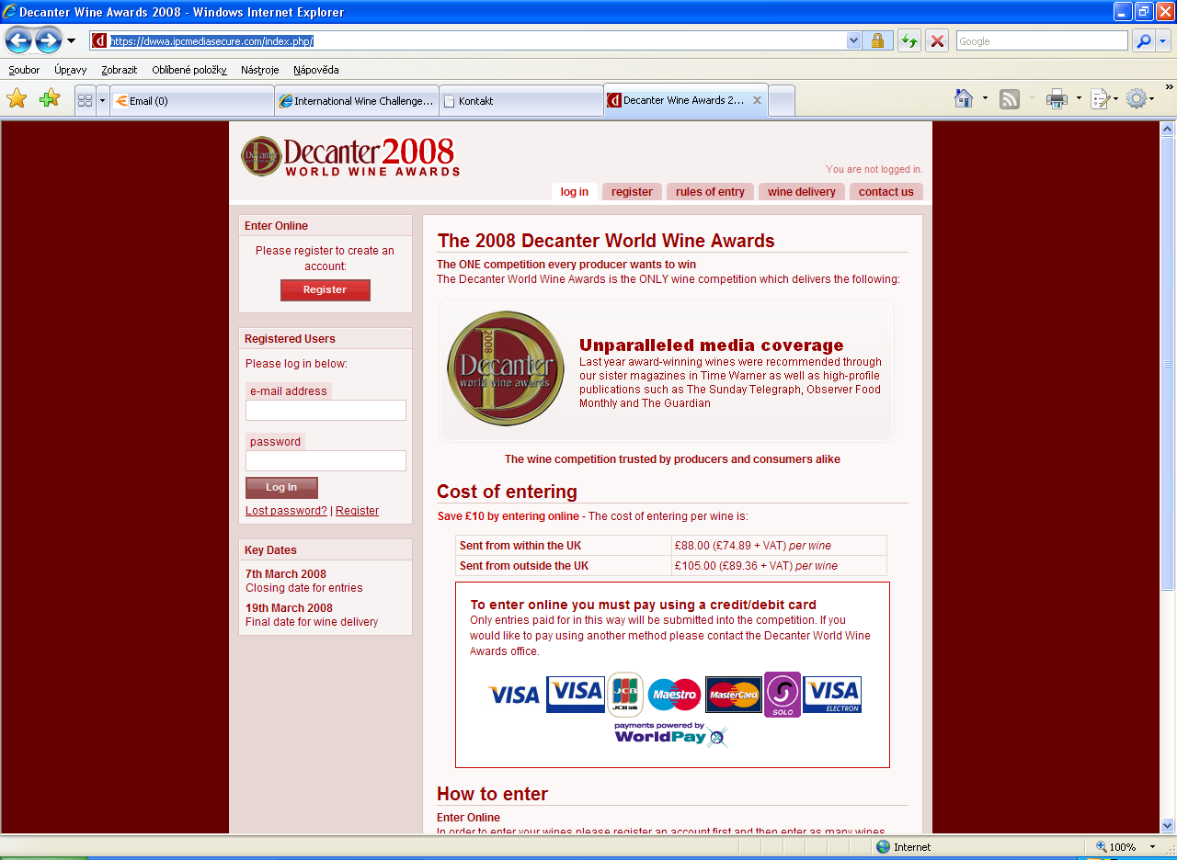

Registered Users
Please log in below:
Začátek formuláře
e-mail address narodni@vinarskecentrum.cz
password nvcvaltice
Log In Lost password? | Register

Potvrdíte: Log in
Otevře se vám stránka: my wines

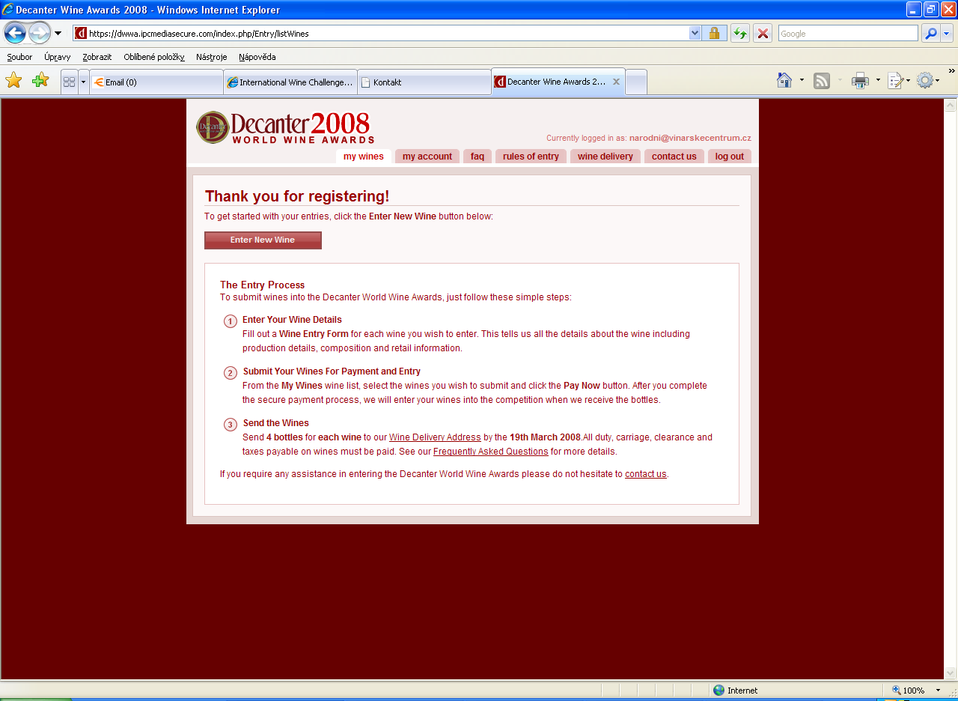

Thank you for registering!
To get started with your entries, click the Enter New Wine button below:
Enter New Wine - Potvrdíte

Decanter World Wine Awards 2008
Začátek formuláře

Wine Entry
Please enter the details for this wine and then click the Submit button at the end of this form.
Producer Wine Name

Wine Production Location
Country of Production Enter country name add country Region of Production Enter region name add region Official Subregion of Production Enter subregion name add subregion

Vintage, Style and Classification
Vintage ročník
Classification
Wine Colour barva vína
Wine Style typ vína

Primary Grape Varieties
Please select up to three grape varieties that make up the wine and the percentage for each.
Principal Grape Variety hlavní odrůda

Percentage %
Second Grape Variety

Percentage (2nd) %
Grape Variety Three

Percentage (3rd) %

Wine Composition and Closure Type
Bottle Size This must be 75cl unless sweet or fortified. Type of Closure objem lahve musí být 0,75 l mimo sladká a fortifikovaná vína
typ uzávěru
Alcohol Level % Alkohol

Oak Ageing

Please provide oaking details for this wine
Oaked/Unoaked zrání v sudu

Retail Barcode & Number of Bottles Produced
Wine's Barcode (if applicable) Is the number of bottles produced over 2,400? (Sweet wine 600)

UK Retail Information
Is the wine available in the UK?

UK Retail Suggested Price band

US Retail Information
Is the wine available in the US?

Ex-cellar Price
If you do not know the UK or US suggested retail price of your wine, please enter the ex-cellar price per bottle and choose the appropriate currency
Ex Cellar Price Per Bottle cena za láhev
Currency

potvrdit
Konec formuláře

