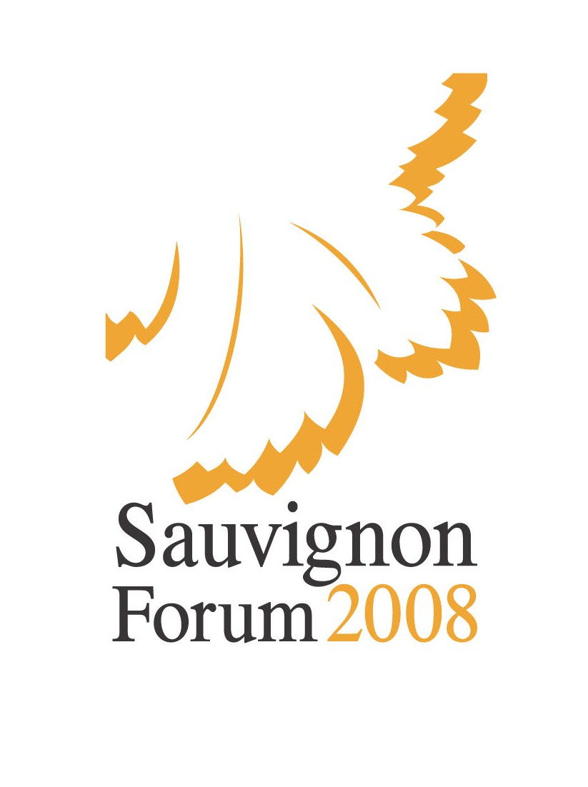

THE STATUTE
of the
Sauvignon Forum 2008
international wine fair

Mikulov, Brno – the Czech Republic

I. The mission and goal
The 4th year of the “Sauvignon Forum 2008” international wine fair will follow on from the forums held in 1998, 2000 and 2004 and it will focus on raising the significance of some of the most cultivated grape vine species; Sauvignon Blanc and Cabernet Sauvignon.
The uniqueness and the high quality of these varieties (especially Sauvignon Blanc) grown in the original conditions of South Moravia have led us to organise this unique international competition, where Moravian wines come together with leading wines from Europe and abroad.
This competition provides a unique opportunity to compare Sauvignon Blanc and Cabernet Sauvignon wines from various areas of the world marked by differing climatic and soil conditions, but also to compare wines which are often produced using diametrically different technologies.

II. The dates and the venue
12th – 14th November 2008 – the wine judging, Hotel Galant, Mikulov
December 2008 – the official results, a wine presentation, the awarding of the medals and prizes, an auction of the best wines

III. The organiser
- VINSELEKT MICHLOVSKÝ a. s.
The organizer of the event agreed that his representative will not be a member of any of the evaluative committees. In addition, the organizer pledges not to put his own wine samples into the competition organized by himself. (This rules have been used for the first time in the history of such an important event and we believe that also other organizers-producers will follow this example)

IV. Participation
All producers, importers and traders of Sauvignon Blanc and Cabernet Sauvignon wines from throughout the world are invited to participate at the international wine fair. All of the wine samples must conform to the standard legislative framework of the given countries or the O.I.V. guidelines. Wines originating from the Czech Republic and registered in the competition must also conform to Viniculture and Wine Making Act no. 321/2004 Coll., as amended, and to implementing regulation no. 323/2004 Coll., as amended.

V. Applications
Exhibitors send in the wine samples together with their application for registration. The registration application for each wine must include the following information: the name of the producer and the applicant, the address, the country, the grape variety, the category, the quality classification, the year, the sugar content, the titratable acid content, the total SO2 content, the alcohol content, the batch number and the number of bottles in the batch.
The application and the samples must be delivered to the organiser by 24th October 2008.
The organiser is entitled to reject an application, if the nature and quality of the sample does not conform to the intentions and level of the competition or if there are any inaccuracies in the application – inspected using the Wine Scan system.

The submission of samples
Each wine sample consists of 6 bottles with a volume of 0.75 l; in the case of 0.50 l bottles, the sample consists of 9 bottles or it will contain 12 bottles in the case of 0.375l bottles. The competition samples will become the property of the organiser.
Please deliver the labelled wine samples together with the registration application to the organiser’s address:
VINSELEKT MICHLOVSKÝ, a. s., Luční 858, CZ – 691 03 Rakvice
tel. (+420) 519 349 870; fax (+420) 519 360 889; e-mail: michlovsky@michlovsky.com
Contact person: Radmila Richterova

Further collection points:
- Havelská 25, Prague 1, postal code: 110 00 – the commercial office of Vinselekt Michlovský a.s., Prague, the 3rd floor of the U Závoje House of Wine,
contact person: Vaclav Cervenka (+420) 777 569 608
- Víno Matyšák Pezinok, Glejovka 10/A, 902 01, Pezinok, contact person: Danka Miklovicova tel: (+421)905 167 212

The registration fee
Applicants pay 1000 CZK (participants from the Czech Republic) or 40 EUR (others) for each sample.
The fee can be paid in person when submitting the samples or by direct credit to account no. 164765915/0600 at GE CAPITAL BANK (for applicants from abroad: IBAN CZ78 0600 0000 0001 6476 5915 SWIFT CODE: AGBACZPP). The organiser will be authorised to eliminate a sample from the competition, if the fee is not paid on time.

VI. The competition categories
The exhibition will include wines with a content of at least 85% of the Sauvignon Blanc or Cabernet Sauvignon varieties (with the exception of category F) and in the following categories:
A – Sauvignon Blanc – (max. 9 g/l residual sugar – see the valid Viniculture Act) i.e. wines with residual sugar of up to 4g or up to 9g, provided the total acid content calculated as tartaric acid is at least 2 grams less than the value of the residual sugar content
B – Sauvignon Blanc – with residual sugar of more than 9 g/l and up to 45g/l
C – Sauvignon Blanc – with residual sugar of more than 45 g/l
D – Cabernet Sauvignon – (max. 9 g/l residual sugar – see the valid Viniculture Act) i.e. wines with residual sugar of up to 4g or up to 9g, provided the total acid content calculated as tartaric acid is at least 2 grams less than the value of the residual sugar content
E – Cabernet Sauvignon – with residual sugar of more than 9 g/l
F – Cabernet Sauvignon – min. 50% in the cuvee with residual sugar of up to 9g/l i.e. wines with residual sugar of up to 4g or up to 9g, provided the total acid content calculated as tartaric acid is at least 2 grams less than the value of the residual sugar content
If a small number of samples are submitted for a given category, the organiser may merge the given category with the nearest closest category, in which the prizes will be awarded for both (all) of the merged categories together. The organiser may do this at its discretion. If there are not at least 12 wines corresponding to the competition’s statue competing in a single category, the organiser will merge this category with another, as long as this is logically possible

VII. The judging committee
The wine will be judged by a committee of five or seven members consisting of significant wine experts from the Czech Republic and the entire world.

VIII. The judging
The wine will be judged using the modified method of the one-hundred-point system of the International Union of Oenologists.

IX. The prizes and awards
The following medals and diplomas will be awarded according to the number of points which the individual wines acquire:

The awards
The grand gold medal, the gold medal, the silver medal, the bronze medal

The champion
Only Sauvignon Blanc (A) and Cabernet Sauvignon (D) variety wines which have received the highest number of points may become the champion. If several wines have achieved the same number of points in these categories, a new sub-committee appointed by the competition president will judge the wines in question again. Only a wine which has received a gold medal may be declared the champion.

The category winner
The category winner (B, C, E and F) will receive the winner’s cup and an honorary diploma.

The organising committee hereby pledges not to award more than 30% of the medals in each category from the total number of competing wines.

Any further particulars: WWW.SAUVIGNONFORUM.COM

Doc. Ing. Miloš Michlovský, DrSc. Miroslav Majer
President Director
Sauvignon Forum 2008

