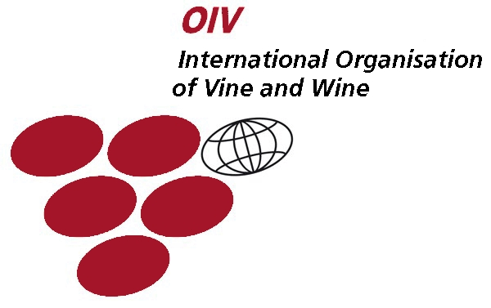 | CHISINAU WINES & SPIRITS CONTEST’ 2011  XX International Wines & Spirits Contest  12-13.02.2011  Chişinău, Republic of Мoldova | 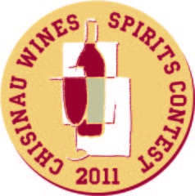 | 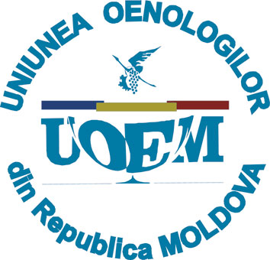

CONDITIONS OF PARTICIPATION

Any company producing and trading the wines and spirits is entitled to take part in the Contest.
The samples presented for the Wine Contest:

Category №1. Still white wines: blended wines, varietals wines, high quality (aged and collection wines).
Category №2. Still rose and red wines: blended wines, varietals wines, high quality (aged and collection wines).
Category №3. Sparkling white, rose and red wines: carbonated wines, pearly (fizzy) wines, sparkling wines – natural and classical technology.
Category № 4. Fortified and aromatized wines: wines from non-aromatic varieties, wines from aromatic varieties, aromatized wines.
Category № 5. Spirits: brandy, divin type cognac, vodka, balsam, liqueur, etc.

Each sample should be accompanied with Sample Attestation Report and Certificate of Conformity.
An individual Registration card (see Annex) is filled-in for each sample.

PARTICIPATION COSTS
for Moldovan producers ………………………………………………………84 euro/sample*
for foreign producers …………………………………………………………100 euro/sample*

*3 samples + 1 sample bonus; 6 samples + 2 samples bonus;
9 samples + 3 samples bonus; 12 samples + 4 samples bonus;
15 samples + unlimited number of samples bonus

Participants from abroad can send their samples by express mail.
The Organiser guarantees participation of the samples in the Contest without attendance of the company representative.

COMPETITION PROCEDURE
- The evaluation of the wine samples quality is made according to O.I.V. methods, by 100 point scale. The basic criteria are a full anonymity of samples submitted to the Jury.
- Due to the results of the evaluation, it would be accorded the following awards: Grand Prix - wines, Grand Prix - spirits; Great Gold medal - for each category, medals - gold, silver, bronze, and also special prizes - Special Diplomas. The total number of medals is awarded to 30% participating samples.
- The Winners Award will be held on the 16th of February, 2011.

Samples are to be submitted in the amount of 6 bottles (all types of wines), 3 bottles (3 l.) – spirits.
Since the moment they reach the Organizer, the samples become the Organizer’s property and can not be changed.

Deadline for applications: 25 January 2011.
Samples should reach the Organiser not later than 1 February 2011.

“Poliproject Exhibitions” SRL | Tel/Fax: 373 22/ 88-58-30, 22-20-70, 69122901
 | info@poliproject.md; www.vinmoldova.md
Manager: Lana Melniciuc | lana@poliproject.md

