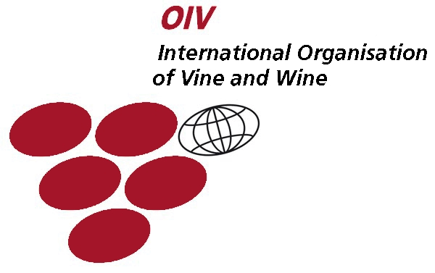 | CHISINAU WINES & SPIRITS CONTEST’ 2011  The XXth International Wine & Spirits Competition  February 12-13, 2011  Chisinau, Republic of Moldova | 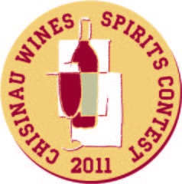 | 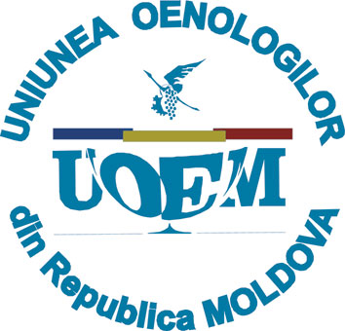

DEAR SIRS!
«POLIPROJECT EXHIBITIONS» S.R.L. Company invites you to participate in the
XXth International Wine & Spirits Competition
«CHISINAU WINES & SPIRITS CONTEST».

The International Wine & Spirits Competition «CHISINAU WINES & SPIRITS CONTEST» - is the first wine tasting contest in the CIS, which is carried out according to the International Organization of Vine and Wine (O.I.V.) Regulations.

The positive trend of contest development, the involvement of highly qualified experts, the attention of trade organizations representatives makes it possible for «CHISINAU WINES & SPIRITS CONTEST» to become one of the most reputable wine tasting competitions of the Black Sea region and Eastern Europe countries.

According to the requirements of O.I.V. Regulations, 70% of the members of tasting committees are international experts. The members of «CHISINAU WINES & SPIRITS CONTEST' 2010» were: Federico Castellucci, Director General of the O.I.V. (Italy), Reiner Wittkowski, Honorary President of the O.I.V. (Germany), Roger Liégeois, wine broker (Belgium), Brigitte Leloup, Vice President of the European Sommelier Association (France), Valeriu Cotea, President of the National Vineyard Growers and Wine Producers Association (Romania), Alexander Panasyuk, Deputy Director of Russia Research Institute of Beer Brewing, Soft Drink and Wine-Making Industry (Russia), wine tasters with a worldwide reputation from Georgia, Ukraine, Cyprus, Czech Republic, Slovakia, Hungary, Greece, Spain and Moldova.

In 2010, 11 countries participated in the competition: Romania, Ukraine, Georgia, Czech Republic, Slovakia, Cyprus, France, Hungary, Portugal, Azerbaijan and Moldova; the number of foreign samples represented 50% of the total number of samples submitted for the contest.

We are confident that the XXth International Wine & Spirits Competition «CHISINAU WINES&SPIRITS CONTEST' 2011» will improve not only the quantitative indicators of the past years, but will increase the prestige of the awards to a new level.

Yours sincerely,
А. Andronic,
Director General
Poliproject Exhibitions S.R.L.

Manager of the competition: Lana Melniciuc
www.vinmoldova.md, tel/fax: +373 22/ 22-20-70, 88-58-30
e-mail: lana@poliproject.md
mob. +373/69122901

