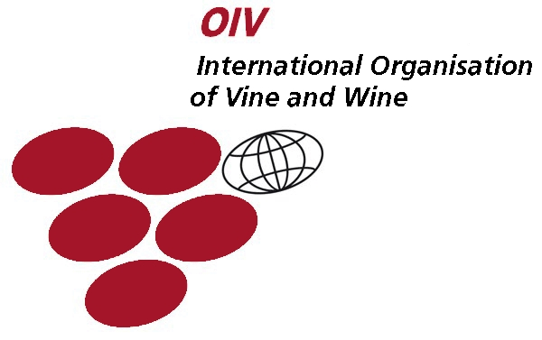 | CHISINAU WINES & SPIRITS CONTEST’ 2011  XX International Wines & Spirits Contest  12-13.02.2011  Chişinău, Republic of Мoldova | 
AGREEMENT Nr. CWSC ___
For participation in: “CHISINAU WINES & SPIRITS CONTEST’ 2011” 12-13.02.2011
Company Name:
Contact Name:

Address:
Address: | Phone: | Fax:
Please register our company as a participant of CHISINAU WINES&SPIRITS CONTEST’ 2011.

№ | Wine name | Vintage year | Grape variety | Wine category

We have read, understood and agreed to be bound by the Terms and Conditions of Participation in Contest.
.

Poliproject Exhibitions Participant:

Adresa: Moldova, or. Chişinău, MD-2012,  str. М.Eminescu 41/1, of. 2 | Address:
Correspondent bank: COMMERZBANK AG, FRANKFURT AM MAIN, GERMANY
SWIFT CODE: COBA DE FF
Beneficiary’s bank: JSCB “EXIMBANK-Gruppo Veneto Banca” S.A. fil. N20 Chisinau, Moldova
SWIFT CODE: EXMM MD 22477
Beneficiary’s account: 222451884
l.ş. l.ş.

General Director: A. Andronic Director:

