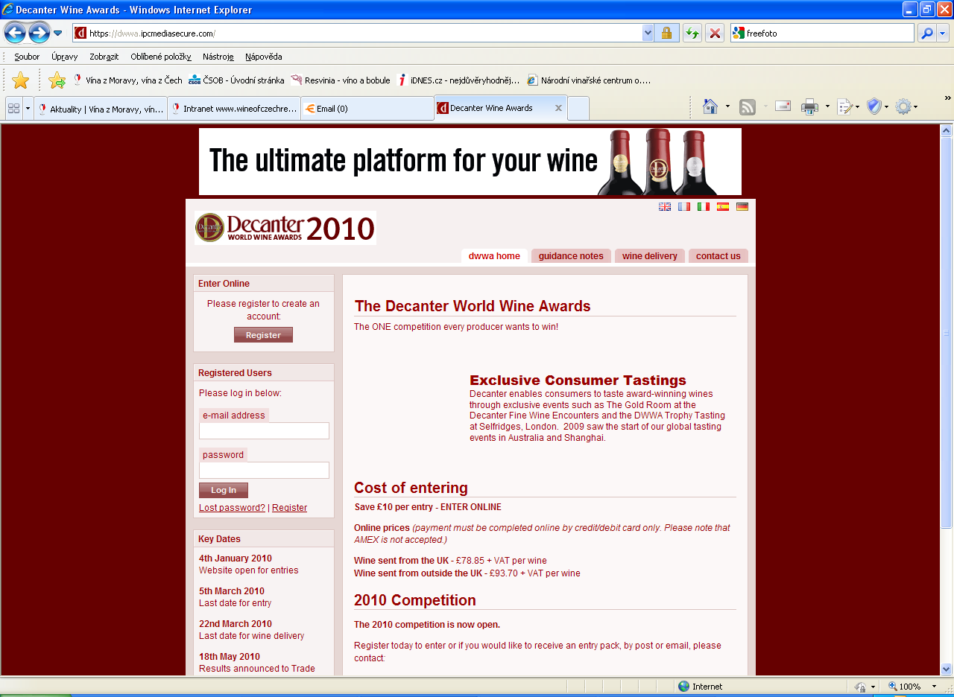
webová adresa: https://dwwa.ipcmediasecure.com/
Registered Users
Please log in below:
Začátek formuláře
e-mail address narodni@vinarskecentrum.cz
heslo/password nvcvaltice
Log In Lost password? | Register

Potvrdíte: Log in
Otevře se vám stránka: my wines

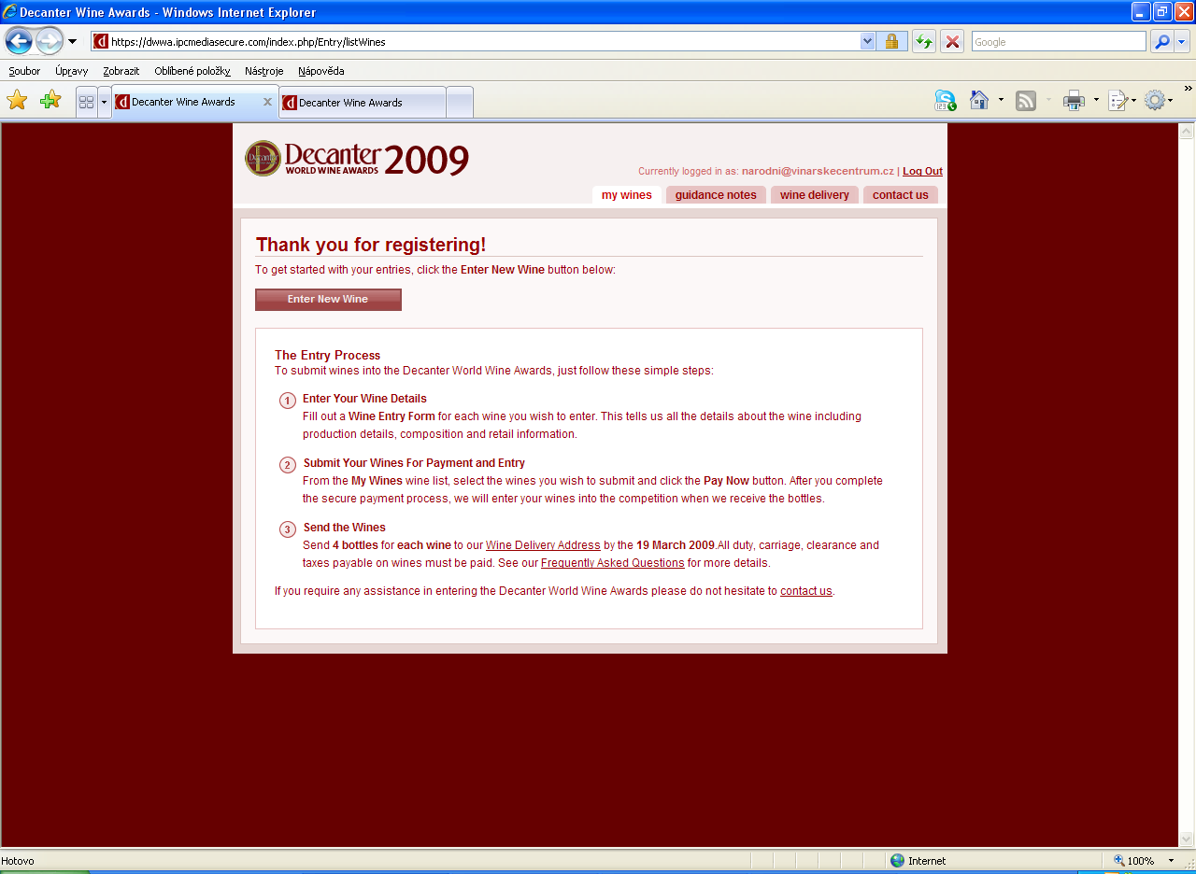

Thank you for registering!
To get started with your entries, click the Enter New Wine button below:
Enter New Wine - Potvrdíte

Začátek formuláře

Wine Entry
Please enter the details for this wine and then click the Submit button at the end of this form.
Podklady vyplňujte bez diakritiky (např. Národní správně Narodni)
Producer Wine Name

Wine Production Location
Country of Production Enter country name add country
Region of Production oblast
Enter region name add region
Classification
Official Subregion of Production Enter subregion name add subregion

Vintage, Style and Classification
Vintage ročník
Wine Colour barva vína
Wine Style typ vína
Organic Sustainable Biodynamic způsob výroby vína

Primary Grape Varieties
Please select up to three grape varieties that make up the wine and the percentage for each.
Principal Grape Variety hlavní odrůda

Percentage %
Second Grape Variety popř. další odrůdy

Percentage (2nd) %
Grape Variety Three

Percentage (3rd) %

Wine Composition and Closure Type
Bottle Size This must be 75cl unless sweet or fortified.
objem lahve musí být 0,75 l mimo sladká a fortifikovaná vína

Type of Closure typ uzávěru
Alcohol Level % alkohol (např. 12.5) použijte tečku
Residual Sugar Level (g/l) g/l zbytkový cukr
Sweet Wine Acidity Level (g/100ml) g/100ml

O označení pro sekty

Oak Ageing
Please provide oaking details for this wine
Oaked/Unoaked zrání v sudu

Retail Barcode & Number of Bottles Produced
Wine's Barcode (if applicable)
Is the number of bottles produced over 2,400? (Sweet wine 600)
Je počet lahví šarže větší než 2 400? (Sladká vína 600)

UK Retail Information
Is the wine available in the UK?
Je víno dostupné na trhu v Anglii?
UK Suggested Retail Price Per Bottle (incl. VAT) £

UK Retail Suggested Price band

Retail Information

Is the wine available in the US?
Je víno dostupné na trhu v USA?

US Suggested Retail Price Per Bottle (incl. tax) $

Ex-cellar Price
If you do not know the UK or US suggested retail price of your wine, please enter the ex-cellar price per bottle and choose the appropriate currency
Ex Cellar Price Per Bottle cena za láhev
Currency

potvrdit
Konec formuláře

