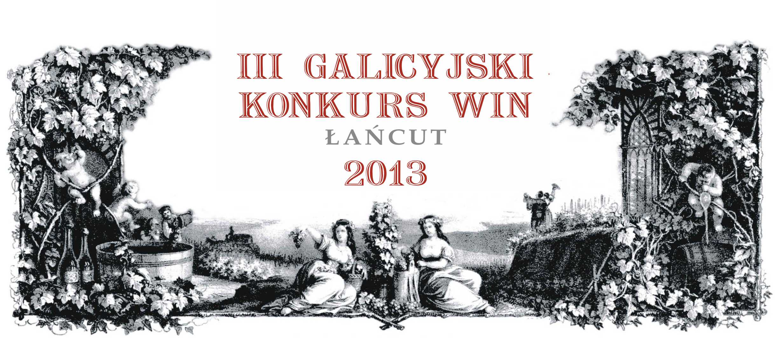
LETTER OF INVITATION

Dear Madam / Dear Sir

We would like to invite you to present your best wines in our contest – III. Galician Wine Competition, which will be held on 20-21 June 2013 at the Castle in Łańcut (South-Eastern Poland).

Kindly welcome all wine producers and distributors to submit their wines to the contest. Current edition of the Galician Wine Competition will run in the new international formula: wines will be judged by international team of judges from Hungary, Czech Republic, Slovakia and Poland. Participation in the contest is free of charge. Each sample of wine submitted for evaluation should consist of three bottles. The last date of delivery of wine samples will pass June 10. Detailed information about the competition can be found also at: www.galicjavitis.pl

Please find enclosed statute of the competition and application form. Please send the completed form by email to the address: konkurs@galicjavitis.pl

Don’t hesitate to ask us if you have any question.

With Best Regards,

Roman Myśliwiec
President of the Galician Wine Competition

