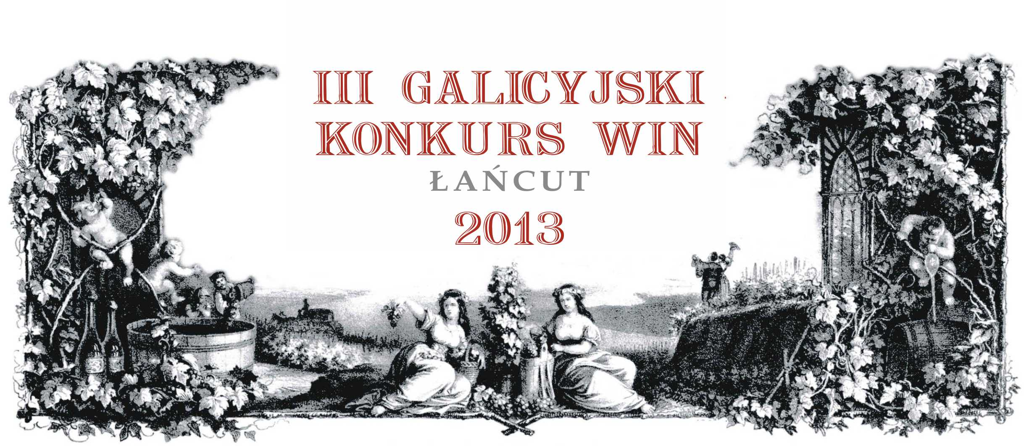

III Galicjan Wine Competition
Łańcut 2013

1. Aim of the Competition
The idea of Galician Wine Competition is to cultivate historical Galician traditions and tighten friendly relations with Slovakia, Czech Republic, Hungary and Austria. The direct goal of the Competition is to compare the quality of wines from Central Europe with those from the rest of the world and to promote culture of wine even in non-producing regions.

2. Competition Organisers
Executive Organiser of the Competition: Subcarpathia Organisation of Wine Producers - http://winiarzepodkarpacia.pl
Coordinator of the Competition: Roman Myśliwiec - http://roman-mysliwiec.pl Content-related Support: Polish Insitute of Vine and Wine (Polski Instytut Winorośli
i Wina) - http://instytutwina.pl Foreign Support:
Národni Vinařske Centrum (Czech Republic) - http://vinarskecentrum.cz
Muzeum Vin (Slovakia) - http://muzeumvin.sk

3. Date and Place of the Competition
The Competition will take place on 20 th and 21 st June, 2013 at The Łańcut Castle – one of the most beautiful aristocratic residences in Poland - http://zamek-lancut.pl

4. Conditions of Participation
The competition is open to all producers and merchants of wine from anywhere in the world that comply with this statute. Only wines, that meet the definition of the O.I.V. International Oenologists Code and were made 100% from grapes grown in the country in which the wine is bottled, can be entered in the competition.
The right to participate in the Competition is gained after fulfilling following conditions:
- correct completion of Wine Information Card attached to Regulations and sending it on thefollowing e-mail: konkurs@galicjavitis.pl, by the deadline date of 10 th June, 2013.
- personal, postal or courier service wine sample delivery should be done utill 10 th June, 2013 on the following address: Wojciech Zięba, 37-100 Łańcut, ul. Zamkowa 1, Poland, tel. +48 692 128 100
- each wine sample entered to the Competition should consist of three bottles 0,375; 0,50; or 0,75 litre (further called “samples”),
- samples should be marked with a label stating the name and wine’s vintage, vineyard, producer’s surname, wine’s category according to the division included in this Statute. The samples incorrectly marked will not be addmitted to the Competition. All samples become the property of the organiser.
- each exhibitor bears expenses connected with delivery of the samples. Package of each sample should be legibly marked „Galicyjski Konkurs Win” (Galician Wine Competition). The samples delivered from abroad should have additional marking “Samples of no commercial value”. For customs purposes please attach to each sample 1,00 euro value proforma-invoice. Participation in III Galician Wine Competition is free of charge.

5. Composition of the Juries
Competing wines will be judged by committees composed of five well-respected foreign and local experts, who possess professional preparation concerning wine assessment. Work of each committee will be supervised by the Presidium of the Competition.

6. Judging
Wines will be marked according to a 100-point system of International Union of Oenologists ( Union Internationale des Oenologues) . The final evaluation of a wine, after the elimination of the highest and lowest scores, will be by the arithmetical average. Should the highest number of points be awarded to more than one competition entry, further criteria relating to the total number of points awarded by all jury members will be taken into consideration.
All samples will be judged anonymously. Individual samples will be served according to variety, vintage and residual-sugar content. Wines will be served blind in covered bottles, displaying only their competition number. The judges will be told only the category and vintage. The evaluation tables with the results will be kept by the organiser for a minimum term of 5 years.

7. Wine categories
Category | Sugar (g/l) | Category symbol
I. White wines
dry | (0-4) | I.1
semi-dry | (4-12) | I.2
semi-sweet | (12-45) | I.3
sweet | (above 45) | I.4
II. Rose Wines
dry | (0-4) | II.5
others | (above 4) | II.6
III. Red Wines
dry | (0-4) | III.7
others | (above 4) | III.8
IV. Sparkling Wines
dry | (0-15) | IV.9
semi-dry | (15-40) | IV.10
semi-sweet | (40-80) | IV.11
sweet | (above 80) | IV.12
V. Liquer Wines
dry | (0-6) | V.13
semi-dry | (6-40) | V.14
semi-sweet | (40-80) | V.15
sweet | (above 80) | V.16

8. Awards and Prizes
The following prizes will be awarded on merit: gold (above 90 points), silver (above 85 points) and bronze (above 80 points). A maximum of 30% of the highest ranked wines in the contest may receive awards. The title of champion will be awarded in each of the following categories: dry white wines (category I.1), globally for other white wines (categories I.2, I.3, I.4), rosé wines (category II), red wines (category III), sparkling wines (category IV) and liqueur wines (category V). A champion award cannot be given in any category should there be fewer than 10 samples in that category. The batch number will always be shown on the diploma. The Judges reserve the right not to award any prizes. Regardless of the diplomas, the Judges may award special prizes. The Judges’ decision is final.

9. Additional Awards
Regardless of the Judges’ official awards, the competition samples will also be independently assessed by the committees comprised of the members of Subcarpathia Wine Organization. The diplomas will be awarded for best wines in particular categories. Such awards do not give the right to place self-adhesive medal labels on particular, awarded bottle. It only gives opportunity to compare the assessments made by expert juries and members of SWO (Subcarpathia Wine Organization) with the taste of Subcarpathia Wine Producers.

10. Special Provisions
The organiser reserves the right to print and distribute medals – self-adhesive labels, bearing the title of Champion, Gold, Silver and Bronze Medals, to applicants. The organiser will print medals or self- adhesive labels upon producer’s request strictly in an amount corresponding to the quantity of the wine made as shown on the entry form at a price of 0.07 EUR per item. Medals – self-adhesive labels referring to an award-winning wine may be used without restriction while stocks of the award-winning wine last. The Competition results will be published on the Competition and SWO’s (Subcarpathia Wine Organization) websites and then will be transferred to trade, local and all-Polish media.
Participation in the Contest indicates that you accept Terms and Conditions of the above Regulations.

