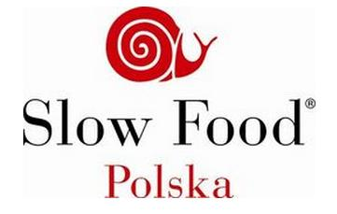

1st St Martin’s Wine Contest / I Konkurs Win Świętomarcińskich

Slow Food Krakow 2014

KARTA ZGŁOSZENIA / APPLICATION FORM
Applicant / zgłaszający: ........................................................................................................................................................
(surname and name or name of company / imię i nazwisko lub nazwa firmy)
Address / adres: ................................................................................................................. Country / kraj: ..........................
Telephone /telefon: ...................................................... E-mail: .....................................................

Wines submitted / zgłaszane wina:
Wine No 1 / Wino nr 1 reference of wine category / symbol kategorii wina*): .........
Name of wine / nazwa wina: .................................................................................................................................................
Producer / producent: ........................................................................................ Country / kraj ............................................
Varieties / odmiany: ...............................................................................................................................................................
Residual sugar /cukier resztkowy (g/l) .............. Alcohol content / zaw. alkoholu (% vol.) ...............
Wine No 2 / Wino nr 2 reference of wine category / symbol kategorii wina*): .........
Name of wine / nazwa wina: .................................................................................................................................................
Producer / producent: ........................................................................................ Country / kraj ............................................
Varieties / odmiany: ...............................................................................................................................................................
Residual sugar /cukier resztkowy(g/l) .............. Alcohol content / zaw. alkoholu (% vol.) ...............
Wine No 3 / Wino nr 3 reference of wine category / symbol kategorii wina*): .........
Name of wine / nazwa wina: .................................................................................................................................................
Producer / producent: ........................................................................................ Country / kraj ............................................
Varieties / odmiany: ...............................................................................................................................................................
Residual sugar /cukier resztkowy (g/l) .............. Alcohol content / zaw. alkoholu (% vol.) ...............
*) reference of wine category / symbol kategorii wina: I – young white wines / młode wina białe; II – young rose wines / młode wina różowe; III – young red wines / młode wina czerwone
Completed Application Form should be sent up to 5th of November 2014 to email address: bosak@winologia.pl / Wypełniony formularz zgłoszenia należy przesłać do dnia 5 listopada 2014 na adres meilowy : bosak@winologia.pl
In case of any questions don't hesitate to contact by e-mail, or call to: 0048 604 930 973 (Wojciech Bosak) / W przypadku jakichkolwiek pytań prosimy o kontakt meilowy lub telefoniczny: 0048 604 930 973 (Wojciech Bosak)

