ARTE VINI spol. s r.o.

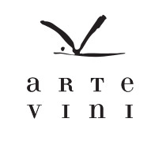
ARTE VINI is a medium seized (app. 90,000 bottles/year) premium producer of dry, elegant and fine food pairing wines in Southern Moravia. The cellar is located in the village Nový Šaldorf in the region of Znojmo near the Austrian border. More than 140 years old vaulted cellar dug into the sandstone massif, several meters under the surface, shows constant temperature and high humidity during the whole year. These conditions are perfect for the slow maturation of our wines, both in stainless steel tanks as well as in barriques.
We are focusing on traditional white and red Moravian varieties, such as Grüner Veltliner, Riesling, Blue Limberger, Zweigeltrebe, the sweet specialty Pálava – a recent Moravian crossing of red Traminer and Müller Thurgau. In addition, we produce dry wines from internationally recognised varieties such as Chardonnay, Sauvignon Blanc, Pinot Gris, Merlot, Pinot Noir and Cabernet Sauvignon because our continental climate provides the wines with typical fruity and elegant Moravian cool climate character.

Contact:
Head Office: ARTE VINI spol. s r.o., Hlavní 195, 253 01 Chýně
Phone: +420 777 777 070
Winery: Nový Šaldorf 29S, CZ-671 81 Nový Šaldorf
Phone: +420 775 044 075
E-mail: vratil@artevini.cz
www.artevini.cz

BOHEMIA SEKT, s.r.o.

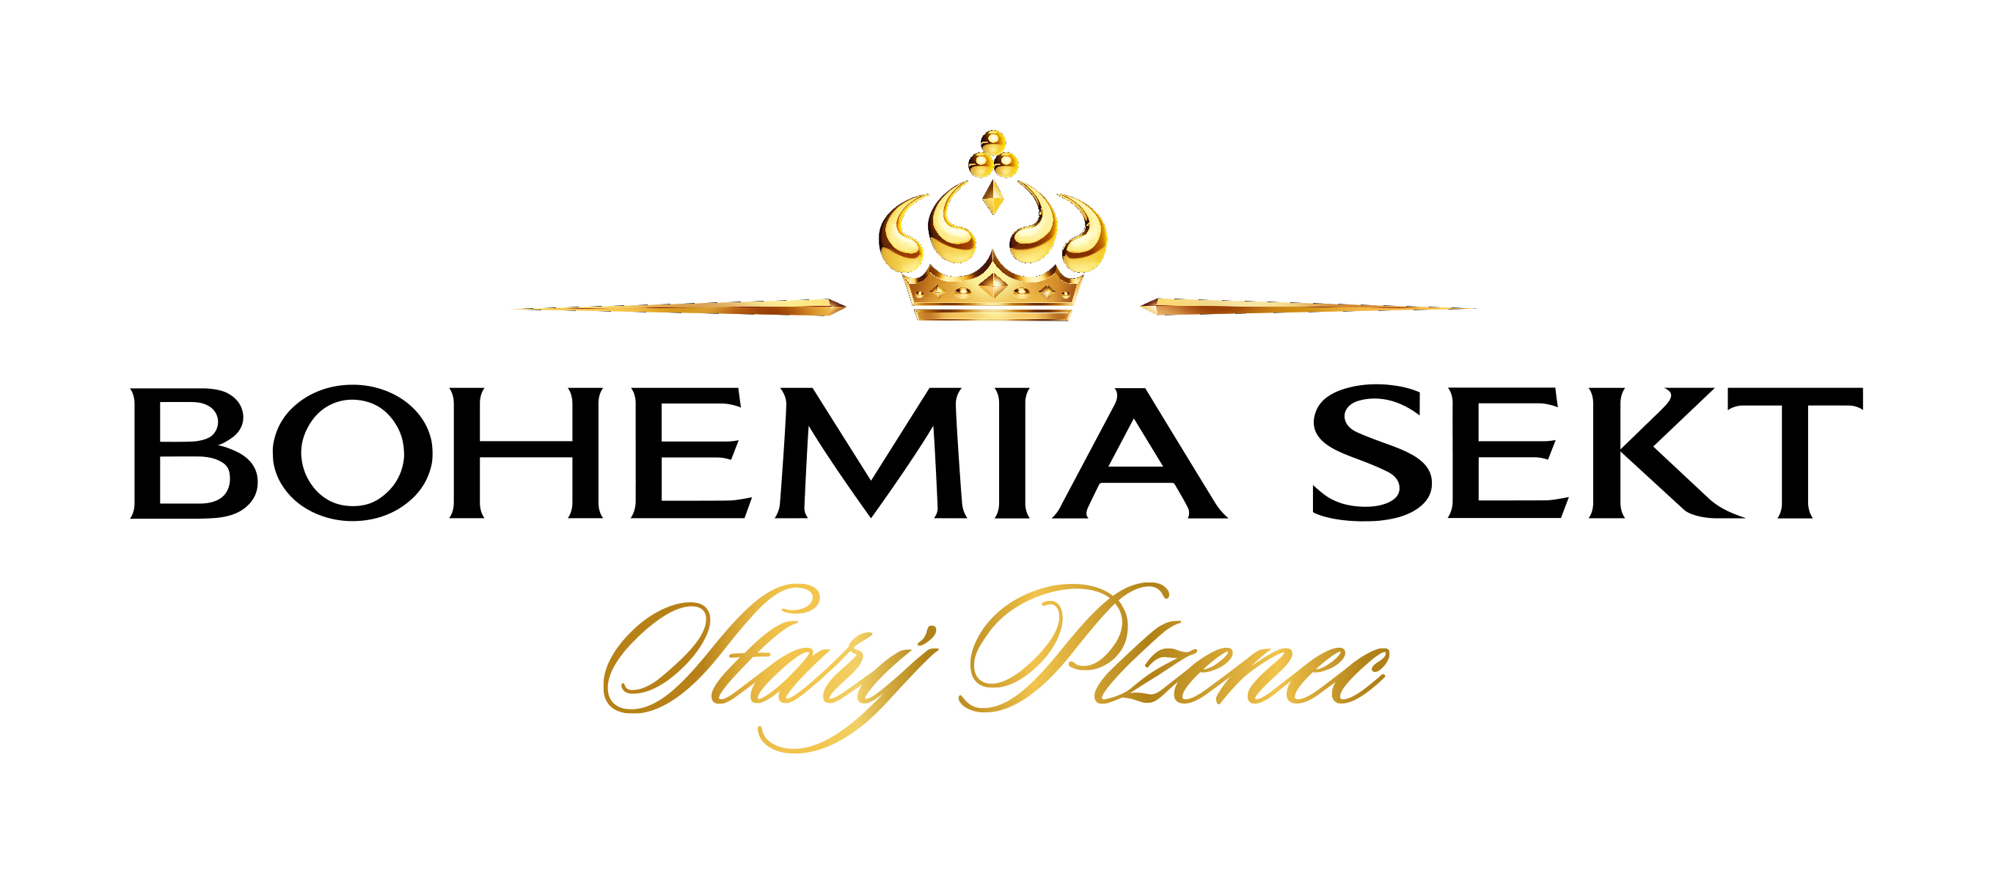
BOHEMIA SEKT is one of the most important producers of sparkling wines, wines and spirits in the Central and Eastern Europe. We sell around 26 million bottles annually. The awards our wines have received at major international wine competitions confirm they are of exceptional quality.
Bohemia Sekt is the largest supplier of sparkling wines in the Czech Republic, controlling as much as 70 per cent of the sparkling wine market. The company also serves customers in another 20 countries with focus on Europe, Asia, Africa and America.

Contact:
BOHEMIA SEKT, s.r.o.
Smetanova 220, CZ-332 02 Starý Plzenec
Ing. Libuše Poskočilová
Foreign Trade Manager
phone: +420 377 197 194 | +420 733 148 194
E-mail: Libuse.Poskocilova@bohemiasekt.cz
www.bohemiasekt.cz

Vinařství Petr Bunža

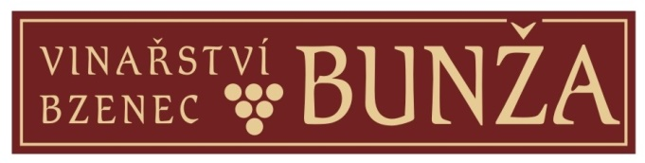
The family business was founded by Mr. Vlastimil Bunža in 1993, when he made use of his father‘s experience in wine making. His son Peter continues with this family tradition. He renewed and planted new vineyards in well known Bzenec wine slopes. In the vineyards we can find Riesling, Chardonnay, Műller-Thurgau, Moravian Muscatel, Sauvignon Blanc, from red wines Dornfelder, Blue Portugieser, Blue Limberger and Pinot Noir. We concentrate on production of attributive wines, such as late harvest wines, wine selections, dessert wines, straw and ice wines.
Our customers enjoy our wines not only for their fullness, aroma and spicy taste, but also for their freshness and balance. Our wines have been awarded prices at many regional and international exhibitions. A new product - grape juice - is 100% natural product and contains a high percentage of antioxidans, which affect our health in a positive way.

Contact:
Vinařství Petr Bunža
J.Baráka 137
696 81 Bzenec
Ing. Marta Petříková
Phone: +420 605 766 945, e-mail: martapetrikova@email.cz
Petr Bunža
Phone: +420 604 258 326, e-mail: bunzoteka@seznam.cz
www.bunza.cz

Nové Vinařství a.s.

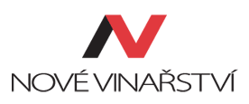
NOVÉ VINAŘSTVÍ, modern and progressive winery, was established in 2005 being the first one using screw caps in the Czech Republic. Only one year later this young winery introduced revolutionary glass stoppers. Consequently NOVÉ VINAŘSTVÍ was awarded „Managerial act of the year in design“ by Design Centre of the Czech Republic in 2007 and also received first medals from prestigious Decanter World Wine Awards London. NOVÉ VINAŘSTVÍ is a founding member of a wine marketing association V8 (www.8V.cz).
Vineyard area: 115 ha (Langewarte, Slunečný vrch, Šibeniční vrch, Pod lomem, Bavorsko).
Wine production in 2014: 150,000 bottles

Contact:
Nové Vinařství, a.s.
Výsluní 613, 691 83 Drnholec, CZE
Export manager: Marek Špalek
Phone: +420 606 647 811
Email: mikulov@novevinarstvi.cz
www.novevinarstvi.cz

Střední odborná škola vinařská a střední odborné učiliště zahradnické Valtice (Wine school Valtice)

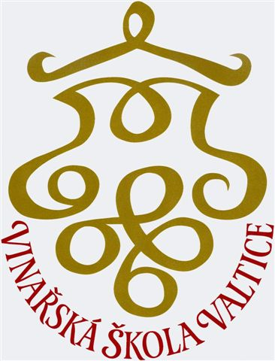
Wine school Valtice was established in 1873 and nowadays it is one of the four oldest wine schools in the former Austro-Hungarian Empire. After 1996, the school went through a complex development and had to fight for its own existence. In the recent years, a prestige of the Wine school has been renewed mainly thanks to its own wine, which is produced in a school farm. Currently the school farm owns 32 hectares of vineyards and the wine is produced only from its own grapes in a modernized cellar named Venerie. A wide range of the varieties of grapes is grown. For many years, Grüner Veltliner and rosé wines are the most successful and awarded wines from the school winery production. Other very important part of the school is a presentation cellar „Pod starou ředitelnou“ where the degustations connected with wine selling take place.

Contact:
Střední odborná škola vinařská a střední odborné učiliště zahradnické Valtice
Sobotní 116
691 42 Valtice
Export manager: Ing. Liběna Štáhlová
Phone: +420 519 352 039 / +420 777 101 847
E-mail: info.venerie@svisv.cz
www.svisv.cz

Spielberg CZ s.r.o.

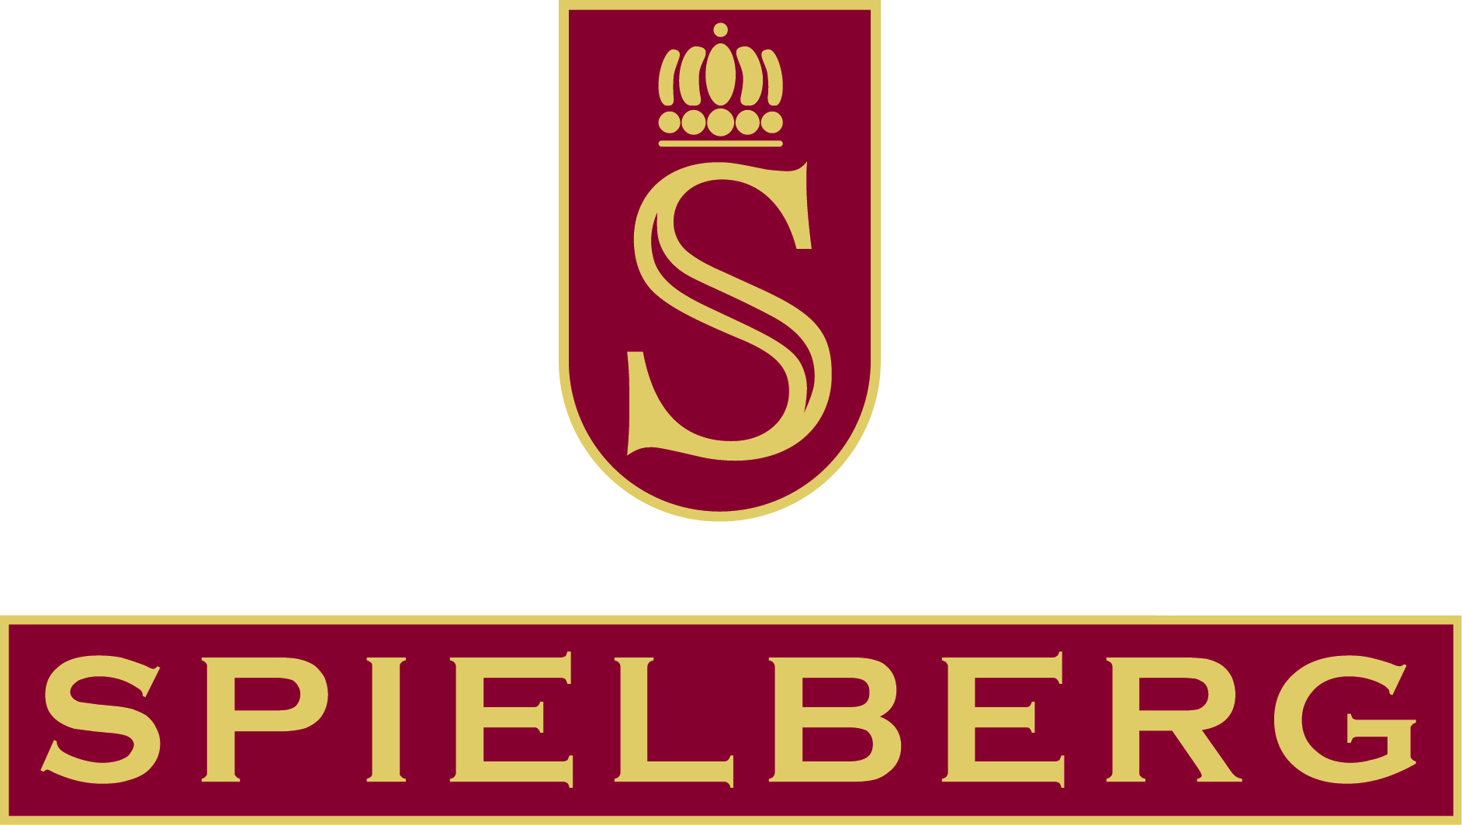
The SPIELBERG winery has entered the traditional wine-growing area on the southern slopes of the Ždánice Forest in the Kyjov region with an ambitious plan to restore the fame of the Žarošice and Archlebov vineyards, and to bring wines from these historical vineyard tracks to the demanding customer of today.
The Company is focused on the production of top-quality wines with attributes and strives to comply with the old winery truth: The most careful treatment of grapes from our 56 ha vineyards is primary, as well as the production of wine of typical cultivar colour, reflecting the specific soil and climate conditions.

Contact:
SPIELBERG CZ, s.r.o.
696 33 Archlebov 406
Mgr. Jana Odstrčilová
Phone: +420 774 288 101
E-mail: marketing@spielberg.cz
www.spielberg.cz

Templářské sklepy Čejkovice, vinařské družstvo (The Templar Wine Cellars)

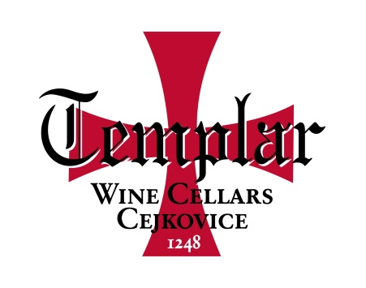
The history of the Templar Wine Cellars in Čejkovice is associated with the arrival of the order of the Templar Knights. They came to Čejkovice in Moravia in 1230s and the first written evidence of the order's activities dates back to 1248. In 1936 the first wine-making syndicate was found and it has been followed by its successor – the Templar Wine Cellars in Čejkovice, wine-making cooperative – since 1992.
Up to these days, Templářské sklepy Čejkovice, still work in the historical wine cellars, where more than 500,000 litres of wine are stored in oak or barrique barrels and archived in bottles. Additional 6,000,000 litres of wine are available in factory buildings located in the Čejkovice village. Traditional but also modern wine making methods and innovations are well balanced.

Contact:
Templářské sklepy Čejkovice
696 15 Čejkovice 945
Pavla Bílková
Phone: +420 602 613 800
E-mail: bilkova@templarske-sklepy.cz
www.templarske-sklepy.cz

Vinařství LAHOFER, a.s.

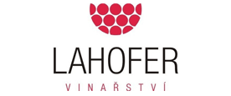
LAHOFER Winery was founded in the Moravian wine town of Znojmo, the Czech Republic, in 2003. By purchasing new vineyards in 2012, we became one of the largest vine grower across the country. LAHOFER Winery owns 410 hectares of vineyards, we produce about 500,000 bottles of predicate wines. All our wines are made primarily from grapes grown in our vineyards. In 2008, we began a reconstruction of a medieval house in the old town of Znojmo. One year later LAHOFER Hotel was opened there. Today, we are proud to say that LAHOFER has become a brand that is the guarantee of stable high quality, original design and superior service.

Contact:
Vinařství LAHOFER, a.s.
Brněnská 523
671 82 Dobšice
Ing. Petr Chaloupecký
phone: +420 725 319 096
Fax: +420 515 242 756
www.lahofer.cz

Vinařství Špalek

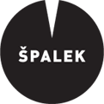
VINAŘSTVÍ ŠPALEK is a small, traditional, family winery with history going back to 1945 (when Špalek family arrived to Nový Šaldorf). New era began in 1992 after the fall of communist regime, when František Špalek and his two sons Marek Špalek and Petr Ilgner founded privately owned wine business. Since 2012, Vinařství Špalek has been transforming into bio (organic) production. The winery’s specialities are the wines made using traditional technologies of 19th century – brand name Edelspitz. The winery is contributing under Grand Cru Šaldorfský Kravák (typical Sauvignon from Kraví hora single vineyard).
Up to 600 years old cellars were ditched in pelagic limestone sediments.
Vineyard area: 10 ha
Wine production in 2014: 30,000 bottles

Contact:
Vinařství Špalek
Nový Šaldorf 143, 671 81 Znojmo, CZE
Export manager: Petr Ilgner
Phone: +420 723 388 882
Email: spalek@saler.cz
www.saler.cz

Vinofol s.r.o.

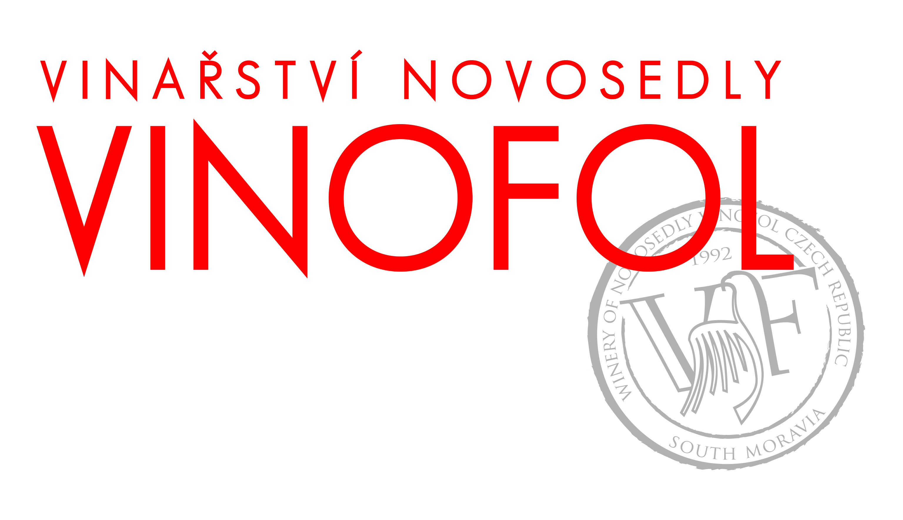
The winery VINOFOL is a family business, headed by brothers Foltyn in the Czech Republic. Since 1992, they have built a modern wine-making business, equipped with all the most up-to-date technology. For production of the highest quality wines, VINOFOL uses grapes from 115 hectares of their own vineyards on the slopes of the Palava hills. The most successful wines from the Pavlov Exclusive, Novosedly Exclusive and Novosedly Selection ranges have been awarded gold and silver medals at great world wine competitions.

Contact:
Vinofol s.r.o.
Koliště 829
602 00 Brno
Export/import Manager: Ing. Zuzana Foltýnová
Phone: +420 776 678 741
E-mail: zuzana@vinofol.cz
www.vinofol.cz

Vinařství Volařík

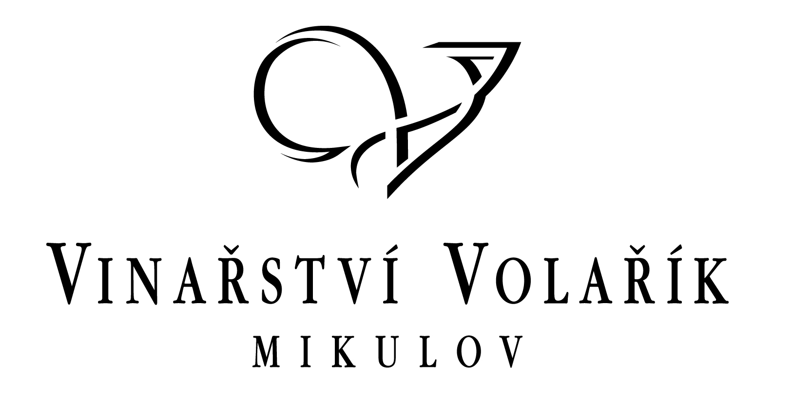
We are a medium sized family winery. We cultivate 80 hectares of our own vineyards located in South Moravian top regions. We put emphasis on environmentally-friendly approach; part of our vineyard is strictly ecological.
We work with wine grape varieties typical for our countryside - Riesling, Welschriesling, Palava, Grüner Veltliner. We emphasize a low-impact treatment of our grapes – low yields per hectare, harvest by hand, and use of the most up-to-date technology. We specialize in high-quality single-vineyard white wines and produce about 200,000 bottles a year.
Diligence, learning, humility and an undying love for wine have allowed the Volařik Winery to earn its place among the best wine makers in the Czech Republic. We earned the title of Winemaker of the Year 2011 and 2014.

Contact:
Vinařství Volařík
Bezručova 30
692 01 Mikulov
PhDr. Martin Procházka
Phone: +420 736 472 073
E-mail: prochazka@vinarstvivolarik.cz
www.volarikwinery.com

Vinařství Piálek & Jäger s. r. o. (Piálek & Jäger Winery)

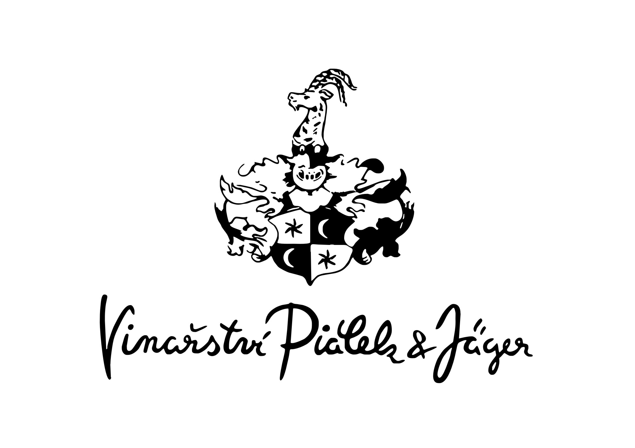
A boutique winery is run by two friends continuing in more than 50 years old family tradition of the wine production.
The Znojmo region, where our vineyards are located and all our wine production comes from, belongs without any doubt to one of the best wine-growing regions in the Czech Republic, neighbouring to the Weinvirtel region in Austria.
We produce wines with VOC original Znojmo certification, these are mainly fruity wines. Our specialty wines are the Grand cru or those produced with oak or acacia aging barrels, which are suitable for fine dining.
We only produce every single batch in around 3,000 bottles every year. You can try and taste our wines in selected wine shops or in the whole range of restaurants, from regional to Michelin-starred ones.

Contact:
Vinařství Piálek & Jäger s. r. o.
Nový Šaldorf 234
671 81 Nový Šaldorf - Sedlešovice
E-mail: info@pialek.cz
www.pialek.cz

V8 – Aliance vinařů V8


The V8 Alliance of Czech winemakers was founded in 2006 with the aim of promoting top quality Moravian wine. All the members of the alliance – the Kolby, Marcinčák, Nové Vinařství, Sonberk, Vinařství Volařík and Krásná Hora wineries - adhere to very strict rules for the production of their wine in order to achieve the highest quality wine possible.
The Alliance arranges for its wines to be regularly assessed by distinguished wine experts who are members of the world-renowned Institute of Masters of Wine, who taste the wines blind and assess both their quality and their potential to compete in international markets. Among those experts are for example Angela Muir or Frank Smulders, and thanks to their positive comments the V8 Alliance began to successfully export its wines.

Contact:
Aliance vinařů V8, o.s.
Zámek č. 1
692 01 Mikulov
E-mail: info@8v.cz
www.8v.cz

