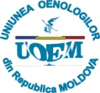
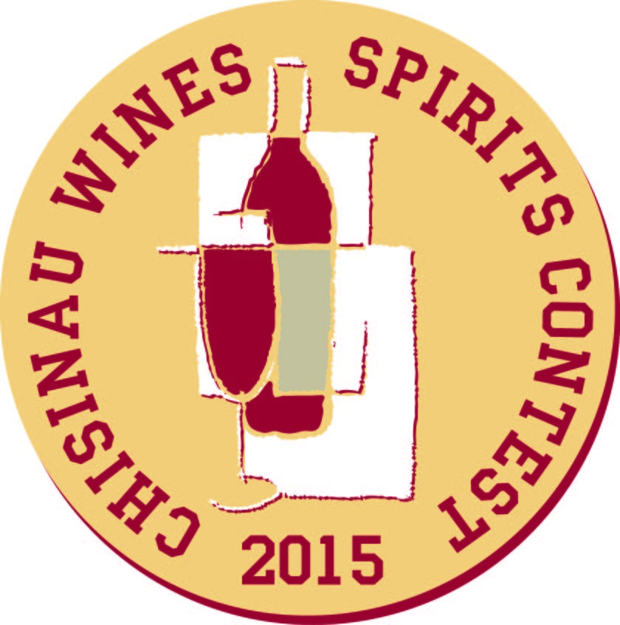
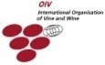
CHISINAU WINES&SPIRITS CONTEST’ 2015
Concursul Internaţional de Vinuri şi Băuturi Alcoolice, ediţia a XXIV-a
XXIV Международный конкурс вин и спиртных напитков
The 24th International Wines&Spirits Competition

GRAND PRIX
BARZA ALBA S.A., Moldova | Divin XXO DRAGOŞ VOIEVOD, 40 ani
MAREA MEDALIE DE AUR, БОЛЬШАЯ ЗОЛОТАЯ МЕДАЛЬ, BIG GOLD MEDAL
VINSKA KLET PRUS, Slovenia | Sauvignon, Ledeno vino (Sauvignon Blanc, Ice Wine), Vina Prus, 2003
IM CVSM “VISMOS” S.A., Moldova | Divin de categoria DVV Vismos, 10 ani
YEREVAN BRANDY COMPANY, Armenia | VASPURAKAN, ARARAT, 15 years old
MEDALIE DE AUR, ЗОЛОТАЯ МЕДАЛЬ, GOLD MEDAL
ЗАО ТВКЗ KVINT, Moldova | KVINT DVS, 8 ani
BARZA ALBA S.A., Moldova | Divin XO BUCURIA, 10 ani
BERHORD VIN S.R.L., Moldova | Pinot Gris, Molda, 2014, vin roz demisec de calitate
BERHORD VIN S.R.L., Moldova | Pinot Noir, Molda, 2012, vin roşu matur rezervă
IM CHATEAU VARTELY S.R.L., Moldova | Chardonnay, 2013, vin de desert
IM CHATEAU VARTELY S.R.L., Moldova | Taraboste Cabernet Sauvignon, 2011
CV "CRICOVA" S.A., Moldova | ZEUS, 2008, vin alb de desert, licoros
CRAMA DOMNEASCĂ S.R.L., Moldova | 5 Elemente, Equinox, 2012
DAVINUS s.r.o., Czech Republic | Palava 2013, Sommelier Select, pozdni sber
DAVINUS s.r.o., Czech Republic | Tramin cerveny, 2012, pozdni sber
FAUTOR S.R.L., Moldova | ILLUSTRO, 2012
FAUTOR S.R.L., Moldova | Sauvignon Blanc, F'AUTOR, 2014
ICS RENAISSANCE-PERFECT S.R.L., Moldova | Lichior de desert AMARETTO, DESERT PERFECT
ICS RENAISSANCE-PERFECT S.R.L., Moldova | Vodca PERFECT, PERFECT
ICS SUVOROV-VIN S.R.L., Moldova | Chardonnay, 2014
ICS SUVOROV-VIN S.R.L., Moldova | Cabernet Sauvignon, 2012
IM BASARABIA-LWIN INVEST S.R.L., Moldova | Kagor, Pastoral, 2011
IM KAZAYAK-VIN S.A., Moldova | Cabernet Sauvignon, roşu matur, 2011
IM KAZAYAK-VIN S.A., Moldova | Muscat Ottonel, 2014
IM KAZAYAK-VIN S.A., Moldova | Sauvignon, 2014
IM ZERNOFF S.R.L., Moldova | Vodka MENDELEEV
IM ZERNOFF S.R.L., Moldova | Vodka SECARICA, ZERNOFF
J&J OSTROZOVIC, Slovakia | Furmint, Slovak Tokaj, 2013
IM LION-GRI S.R.L., Moldova | Lion-Gri, 2004, spumant classic demisec roşu
IM LION-GRI S.R.L., Moldova | Saperavi, 2011
MAURT S.R.L., Moldova | Cahor Bisericesc, 2011
VINIA DENOVI S.R.L., Moldova | Merlot, Reserve, Denovi, 2011
NATURA S.R.L., Romania | Feteasca Neagră, Domeniile Panciu, 2012
SC CASA DE VINURI COTNARI S.A., Romania | Busuioaca, Domenii, 2014
SC Agro Industrial "CERES" S.R.L., Romania | Sauvignon Blanc, Hermeziu 2014
VINARIA DIN VALE S.A., Moldova | Cabernet Sauvignon, 2013
VINARSKE ZAVODY TOPOL'CIANKY s.r.o., Slovakia | Cabernet Sauvignon rose, neskory zber, 2014, L619
VINARSKE ZAVODY TOPOL'CIANKY s.r.o., | SEKT 1933 brut, 2011, L561, sparkling wine
VINARSKE ZAVODY TOPOL'CIANKY s.r.o., | Muller Thurgau, 2014, L609
VINARSKE ZAVODY TOPOL'CIANKY s.r.o., | Alibernet, slamove vino, 2012, L329
VINARSTVI STEPAN MANAK, Czech Republic | SAUVIGNON BLANC 2013 Ice wine oak aged, MORAVA Slovacka, dessert wine
VINSKA KLET PRUS, Slovenia | Rumeni Muskat Suhi Jagodni Izbor, 2006, dessert
VINURI DE COMRAT S.A., Moldova | Мuscat, 2010
VINURI DE COMRAT S.A., Moldova | Roşu de Comrat, 2013
VINURI DE COMRAT S.A., Moldova | Feteasca, 2014
VINURI DE COMRAT S.A., Moldova | Pastoral (Cahor), 2010
ZGUREAN WINERY, Moldova | Lacrima lui Kristi, 2009
БУКЕТ МОЛДАВИИ ЗАО, Moldova | Вермут, Букет Молдавии, 2013
БУКЕТ МОЛДАВИИ ЗАО, Moldova | Космический, Букет Молдавии, 2013, бальзам
ОАО Витебский ликеро-водочный завод “ПРИДВИНЬЕ”, Беларусь | бальзам Черный Рыцарь
MEDALIE DE ARGINT, СЕРЕБРЯНАЯ МЕДАЛЬ, SILVER MEDAL
AES AMBELIS WINERY LTD, Cyprus | EKTOR SHIRAZ, T.O. Nicosia, 2012
ASCONI S.R.L., Moldova | Cabernet Sauvignon, 2014
BERHORD VIN S.R.L., Moldova | Cabernet-Sauvignon, Molda, 2011
BERHORD VIN S.R.L., Moldova | Chardonnay, Molda, 2012
IM CHATEAU VARTELY S.R.L., Moldova | Traminer, 2014
CV "CRICOVA" S.A., Moldova | LACRIMA DULCE, spumant demidulce alb
CRAMA DOMNEASCĂ S.R.L., Moldova | 5 Elemente, Equinox, Merlot, 2012
HUBERT J.E. s.r.o., Slovakia | Karpatske brandy special
HUBERT J.E. s.r.o., Slovakia | Hubert de Luxe, sparkling white wine
HUSARCIUC I.I., Romania | Muscat Ottonel, D.O.C.-C.M.D. Banat, 2014
HUSARCIUC I.I., Romania | Merlot, D.O.C.-C.M.D. Banat, 2013
ICS SUVOROV-VIN S.R.L., Moldova | Merlot, 2012
ICS SUVOROV-VIN S.R.L., Moldova | Aligote, 2014
ICS SUVOROV-VIN S.R.L., Moldova | Sauvignon, 2014
IM VINIA TRAIAN S.A., Moldova | Merlot roze, 2014, vin natural demidulce
IM VINIA TRAIAN S.A., Moldova | Cabernet Sauvignon, 2013
INVINPROM S.R.L., Moldova | Chirsova, 2012, spumant original roşu demidulce
MALOKARPATSKA VINOHRADNICKA SPOLOCNOST a.s., Slovakia | Cabernet Sauvignon rose, 2014, Juznoslovenska vinohradnicka oblast'
MAURT S.R.L., Moldova | Bacio di Bolle Grande Cuvee Brut, 2013, spumant
MAURT S.R.L., Moldova | Casa Amati, 2013, vin roz demidulce
SC CASA DE VINURI COTNARI S.A., Romania | Grasa, Colocviu, 2014
SC Agro Industrial "CERES" S.R.L., Romania | Chardonnay, Hermeziu, 2014
SCOALA PROFESIONALA NISPORENI, Moldova | Cabernet Sauvignon, Crescendo, 2012
STAATSWEINGUT MIT JOHANNITERGUT, Germany | Weissburgunder Spatlese, trocken, Haardter Herrenletten, 2013
VINARIA DIN VALE S.A., Moldova | Sauvignon, 2014
VINARSTVI STEPAN MANAK, Czech Republic | Ruzlink Vlassku, 2013 Terroir, MORAVA Mikulovska
VINURI DE COMRAT S.A., Moldova | Riesling, 2014
VINURI DE COMRAT S.A., Moldova | Cabernet, 2010
VINURI DE COMRAT S.A., Moldova | Alb de Comrat, 2013

