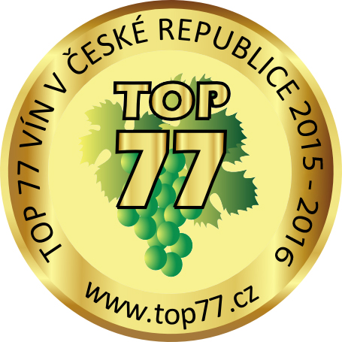

Dear Friends – Wine Producers

I would like to invite you to XVIIth Year of Competition TOP 77 wine in the Czech Republic 2015/2016 and XIVth Year of Competition TOP DESIGN wine in the Czech Republic 2015/2016.
This year, for the first time we will evaluate also foreign wines which would like to appear in Czech market or are already part of it.

The Competition TOP 77 will be under the patronage of the Minister of Agriculture of the Czech Republic Ing. Marian Jurečka and Mayor of Statutory City Brno Ing. Petr Vokřál.
The specialized guarantee of the competition is Ústřední kontrolní a zkušební ústav zemědělský v Brně a FaVU VUT Brno.
The professional evaluation will take place in Brno on 3rd June 2015 from 9:30AM in Hotel Slavia. The Closing Ceremony with the official announcement of the results will take place on 10th September 2015 in Adam Gallery in Brno.

TOP 77 has received excellent responses from you, the public, wine producers and wine dealers.
The publication Wine Guide TOP 77 was printed in 5 000 pieces last year. Recently all the publications have been sold out. The distribution of this publication is ensured not only for the special wine shops but also for all the libraries in the Czech Republic.

This year the Ceremony was organized the way you can use the honoured wines for marketingpurposes from the beginning of September. This way you can start promoting your wines as soon as possible. Also The Wine Guide TOP 77 2015/2016 will be available from September.

To ensure the best objectivity of the competition, we still insist on the complete independency of the members of the committee from the wine producers. The head of the evaluation committee will be an independent expert doc., Ing. Eduard Postbiegl and Bc. Jaroslav Suský from Czech Agriculture and Food Inspection Authority. Another members of the committee will be experts from different wine shops, members of Association of Sommeliers, guests from Slovakia and Austria which are very close to the Moravian production of wines. All the tasters have valid taster exams as per the European Union requirements. The evaluation of wine will take place in Brno on 3rd of June 2015.
From our experience we know that the wine lovers are looking for the wines with the TOP 77 label. These labels and the Wine Guide TOP 77 will be prepared by the date of the Closing Ceremony 10th of September 2015.

This year 2015/2016 these will be honoured:
- 77 wines and sparkling wines in category white dry wines and sparkling wines
(category A, G)
- 77 wines and sparkling wines in category Rosé wines, dry red wines & still and sparkling wines
(category E, C, G)
- 77 wines and sparkling wines in category other wines and sparkling wines
(category B, D, F, H)
- 77 wines and sparkling wines in category foreign wines
(category I)

Your application including the appendix and 6 samples of the appointed wine needs to be send till 20th of May 2015 as last.

Address for the samples:
1. VINDOM, Smetanova 17, BRNO phone: 541 241 193- or arrange the delivery of the samples with our colleague Ms. Irena Hejlova, phone: 775 740 680 or Ms. Gazdova 775 238 716.
- Vinotéka Znovín Znojmo, Loucký klášter, phone: 515 267 237
- Velkoobchod VICOM v Praze, Jankovcova 6, port Holešovice-east,
phone: 224 816232
- České vinařské závody, Hlavní 666, Velké Pavlovice- reception, phone.: 519403164- Mr. Prokš

Cartons / packages/ with samples please mark them as TOP 77
All appointed wines will be also appointed in the competition TOP DESIGN wines of the Czech Republic. This year will be the XIVth year of this competition.
Producers who send at least 6 samples of wine will be appointed in competition The best collection of wines TOP 77.

We look forward to meeting you in TOP 77 best wines in Czech Republic.

Best Regards & „Cheers“
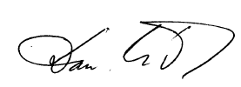
Dan Mádr
Director of competition

