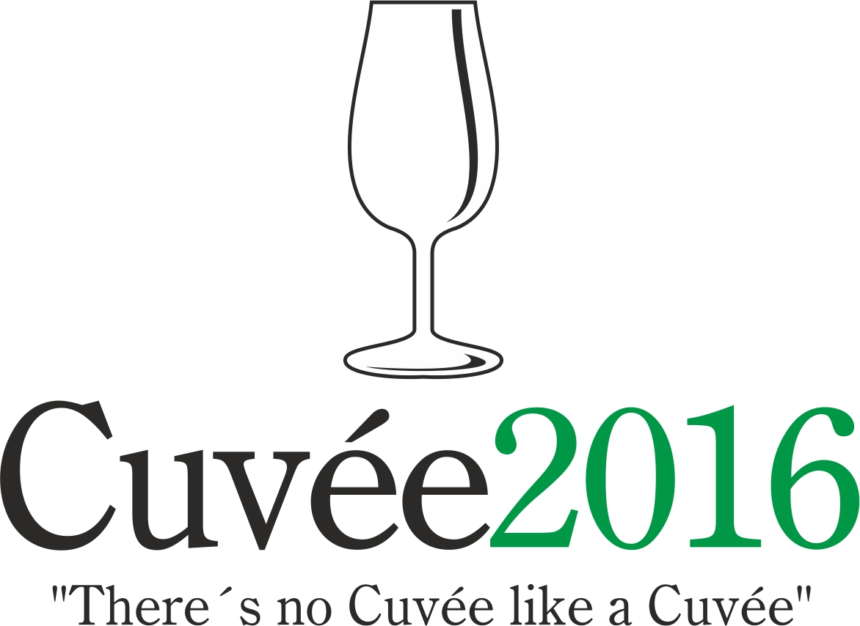

The International Wine Competition of the Moravian-Silesian Region
Cuvée 2016 Ostrava

The 14th edition of this unique international competition of blends and branded wines was held on the 18th and 28th April by the Club of Ostrava’s Amateur Wine Evaluators, K.A.H.A.N, in conjunction with the Zámek Zábřeh Hotel in Ostrava and the National Wine Centre. The event took place with the support of the Wine Fund of the Czech Republic. The initiator and spiritual father of this - the only wine contest taking place in the Moravian-Silesian district - was the guru of Czech and Moravian vini-viticulture, the late Professor Vilém Kraus.

Czech and Moravian wine producers and foreign-wine importers entered into this year’s edition a total of 158 wines in six competition categories: 27 dry white wines (category A1), 31 semi-dry and semi-sweet white wines (A2), 46 red wines (B), 25 rosé wines (C), 15 sparkling wines (D) and 14 sweet and liqueur wines (E). A total of 11 countries sent their samples to this competition: Czech Republic (86 wines), Slovakia (30), Spain (8), Poland (8), France (5), Italy (4), Netherlands (4), Sweden (4), Portugal (3), Bulgaria (3) and Denmark (3). Wines which fulfilled the conditions of the competition statutes were assessed in the tasting room of National Wine Centre in Château Valtice on 18th April using the 100-point evaluation system under the partonage of the National Wine Centre. A hundred-point system was used in accordance with the criteria as defined by the National Standards for Certifying wine competitions of the Czech Republic. Wines receiving 90 points or over were in receipt of a great gold medal, wines achieving between 86 and 89.99 points were awarded a gold medal, wines achieving between 83 and 85.99 points were awarded a silver medal. It was decided by the organisers not to award any bronze medals.
A quartet of specialised committees under the direction of Professor Fedor Malík, Josef Valihrach, Radomil Baloun and Martin Prokeš awarded three great gold medals, 36 gold and 49 silver medals. Local Moravian wines were honoured with 1 great gold, 17 gold and 32 silver medals. Most successful among the foreign participants were wines emanating from Slovakia (1 great gold, 9 gold, 7 silver) followed by Spain (3 gold, 1 silver), Italy (2 gold, 2 silver), France (1 gold, 2 silver) and Portugal (1 gold, 1 silver). sensational were the wines of the “polar“ winemakers from Sweden (1 great gold, 2 silver), Poland (2 gold), Denmark (1 gold, 1 silver) and the Netherlands (1 silver).

Champion of the category of dry white wines was the blend of Riesling and Pinot Blanc Cuvée Thomas 2015 (Víno Hruška, Czech Republic) from the Slovácko wine sub-region. The red-wine champion was Acinipo Reserva 2006 (Bodega F. Schatz, Spain) made on the basis of the Lemberger grape variety coming from a vineyard not far from Málaga. The prize for the best-rated red wine of local provenance went to a cuvée of Dornfelder and Frankovka (Blaufränkisch) Element Ignis 2015 (Bojanovský sklep Uherek, Czech Republic).

The victor in the category of semi-dry and semi-sweet white wines and holder of a historic first great gold medal for Sweden was the branded wine Nordic Light 2014 (Vingården i Klagshamn, Sweden) from the varieties Solaris and hailing from the Skåne region. The winner in the category of rosé wines was Leontýnka 2015 (Marek Štýbl – Vitis Moravia, Czech Republic). The winner in the sparkling-wine category was Crémant de Spielberg 2012 (Spielberg CZ, Czech Republic), an assemblage of Welschriesling, Riesling and Pinot Blanc. The winner among the sweet and liqueur wines was the Tokaj selection 5-puttonyos 1999 (Tokaj & Co, Slovakia), produced from the dried berries of Furmint, Hárslevelü and Yellow Muscadelle, which at the same time became the winner of the award for the best overall collection of wines for the third time running.

Concurrently with this contest was, for the ninth time, the PRIX FIJEV CZ (Special Prize of the International Federation of Journalists and Writers on Wine and Spirits). Jurors who are also FIJEV members nominate for this award those wines that drew attention as much through their exceptional vinous qualities as by their showing the true path winemaking should be taking. The laurels for the 2016 edition were shared by the the Swedish wine Klagshamn Rosé 2015 (Vingarden i Klagshamn, Sweden) from Rondo, a grape variety created by none other than Professor Vilém Kraus, alongside another wine from grapes well known in this country, Grüner Sylvaner / Blauer Sylvaner 2015 (Vinařství Fasora, Czech Republic).

Notional medals and Champion titles were also handed out at Zámek Zábřeh Hotel on 28th April 2016 by the Committee of the Lay Public. These results permit wine producers and importers to compare the opinions of the specialists with those of wine aficionados. The lay public's Champion was the cuvée of Yellow Muscadelle, Traminer and Riesling Pátý Element 2014 (Bojanovský sklep Uherek, Czech Republic), in tandem and in agreement with the specialists' choice Acinipo Reserva 2006 (Bodega F. Schatz, Spain). The highest rated red wine of local provenance was the cuvée of Cabernet Sauvignon, Merlot and Saint Laurent Skale Family Reserva 2011 (Vinařství Springer, Czech Republic). Victors in their individual categories were semi-dry cuvée of Pinot gris, Traminer and Pálava Kienberg 2015 (Vican rodinné vinařství, Czech Republic), followed by the blend of Cabernet Colonjes and Regent Rosé Frederique 2015 (Wijnhoeve de Colonjes, Netherlands), Champagne Bernard Rémy Carte Blanche (Bernard Rémy, France) and once again in agreement with those of the specialised committees Tokajský výber 5-putňový 1999 (Tokaj & Co., Slovakia). The best overall collection of wines was also the firm Tokaj & Co.

The results from this - the one and only international wine competion taking place in Northern Moravia - were made public on 28th April 2016 at the Cuvée Ostrava Wine Exhibition in Zábřeh Castle. Professor Fedor Malík inaugurated the accompanying programme with his traditional tutored tasting of "Slovak wines at 5 o‘clock". Thereafter the wine exhibition was made freely accessible to the general public to the plangent sounds of Moravian dulcimer music, while visitors could sample not only the wines from the competition, but also varietal wines from those Moravian winemakers and importers of foreign wines who were present. The accompanying programme culminated with a presentation by the New Zealand winery Saint Clair Family Estate titled “There’s no Kiwi like a Kiwi“.

The presumptuous aim of the organisers of the Cuvée Ostrava competition is to witness a renaissance of the good name of blends or brands and their return to the forefront of the products on offer from Czech and Moravian winemakers, as is customary in other major wine-producing countries. In the words of the spiritual father of the competition Professor Vilém Kraus: "There's no Cuvée like a Cuvée" meaning that each and every blend is different.

Contact:
Dr. Martin Křístek, +420 603 240 661, info@cuvee.cz, www.cuvee.cz, @CuveeOstrava

