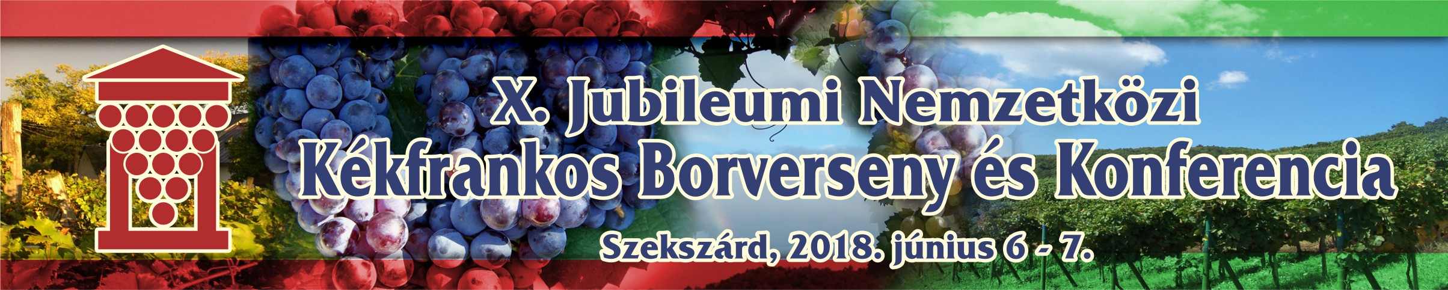
NEVEZÉSI LAP

REGISTRATION FORM

Name of the winery:………………………………………………………………………………………………

Direction of the winery:………………………………………………………………………………………….

Telefon: +……………………………… E-mail:…………………………………………………………………

Homepage/Facebook:…………………………………………………………………………………………..

The wine to be registered: _______________________________
_________________________________________Vintage: _______

Category (indicate with an X):
- Rosé ___
- Siller/Schilcher ___
- Single Variety ___
- Blend (minimum content of the Kékfrankos: 50%) __
Indicate with an X if it is barrel sample:_____

NO REGISTRATION FEE!!!

The samples (4 bottles/0,75 l) must be shipped to this address: Hegyközség, Szekszárd, Táncsics u. 3. Hungary 7100

Please, send this form duly filled in to this e-mail address: hegykozsegszekszard@gmail.com

Deadline for registration: May 25, 2018

