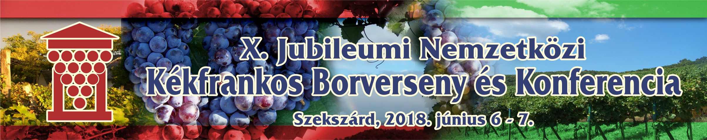
MEGHÍVÓ

INVITATION
The 10th International Kékfrankos Competition to be held in Szekszárd on June 6, 2018 is now accepting entries.

In Hungary the Ministry of Agriculture (FM) declared 2018 as the Year of Kékfrankos which is the most widely planted red grape variety int he country and stands out for its versatility. It has the potential to make exceptionally high-quality wines as well that can nowadays compete on the international stage with the most prestigious ones from other countries.

The main objective of the competition is to bring together the best wines of local and foreign producers and showcase their diversity (Kékfrankos, Blaufränkisch, Lemberger, Frankovka Modrá, Modra Frankinja) and, of course, to find the best ones which can enhance the image of the variety towards the consumers.

The wineries interested in participation are kindly asked to send the registration form and the samples (4 bottles/0,75 liter) to the organizers not later than May 25, 2018.

Additional information: Dr. József Kosárka
Tel.: +36-204825433
E-mail: kosarkadr@yahoo.com

