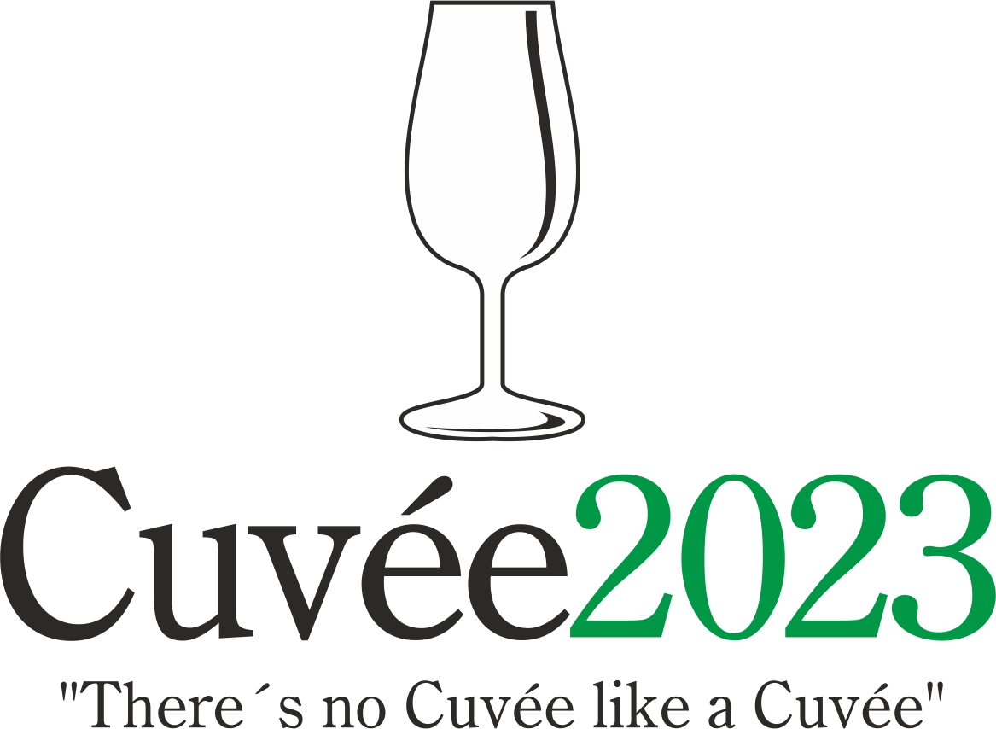

The 21th edition of this unique international competition of blends and branded wines will be held on the 17th April and 4th May by the Club of Ostrava’s Wine Aficionados, K.A.H.A.N. in conjunction with the Zábřeh Castle Hotel in Ostrava and the National Wine Centre which is based in Valtice.

The presumptuous aim of the organisers of Cuvée Ostrava competition is to witness a renaissance of the good name of blends or brands and their return to the forefront of the products on offer from Czech and Moravian winemakers, as is customary in other major wine-producing countries. In the words of the spiritual father of the competition Professor Vilém Kraus: "There's no Cuvée like a Cuvée", meaning that each and every blend is different.

President of Jury: Prof. Fedor Malík
Competition Oenologist: Prof. Josef Balík

Statutes: www.cuvee.cz/en/statutes-of-wine-competition/

Application: www.elwis.cz/en

Collection of Samples: April 12, 2023. Competition participants are exempt from paying any fees.

Collection Points: National Wine Center (Národní vinařské centrum), building Centrum Excelence, Sobotní 1029, Valtice, Jan Slunský, tel. +420 602 142 490; Martin Křístek, Na Pořadí 1002, 735 41 Petřvald, Czech Republic, tel. +420 603 240 661 (only to this collection point competition samples may be delivered by post anytime, but not to arrive later then April 14. 2023); Fedor Malík, Kalinčiakova 21, Modra, Slovakia, tel. +421 907 890 988.

Evaluation of Wines: April 17, 2023, National Wine Center, building Centrum Excelence, Valtice

Exhibition for Public: May 4, 2023, Zábřeh Castle, U Zámku 42/1, Ostrava

Contact: Dr. Martin Křístek, tel. +420 603 240 661, martinkristek@cuvee.cz

