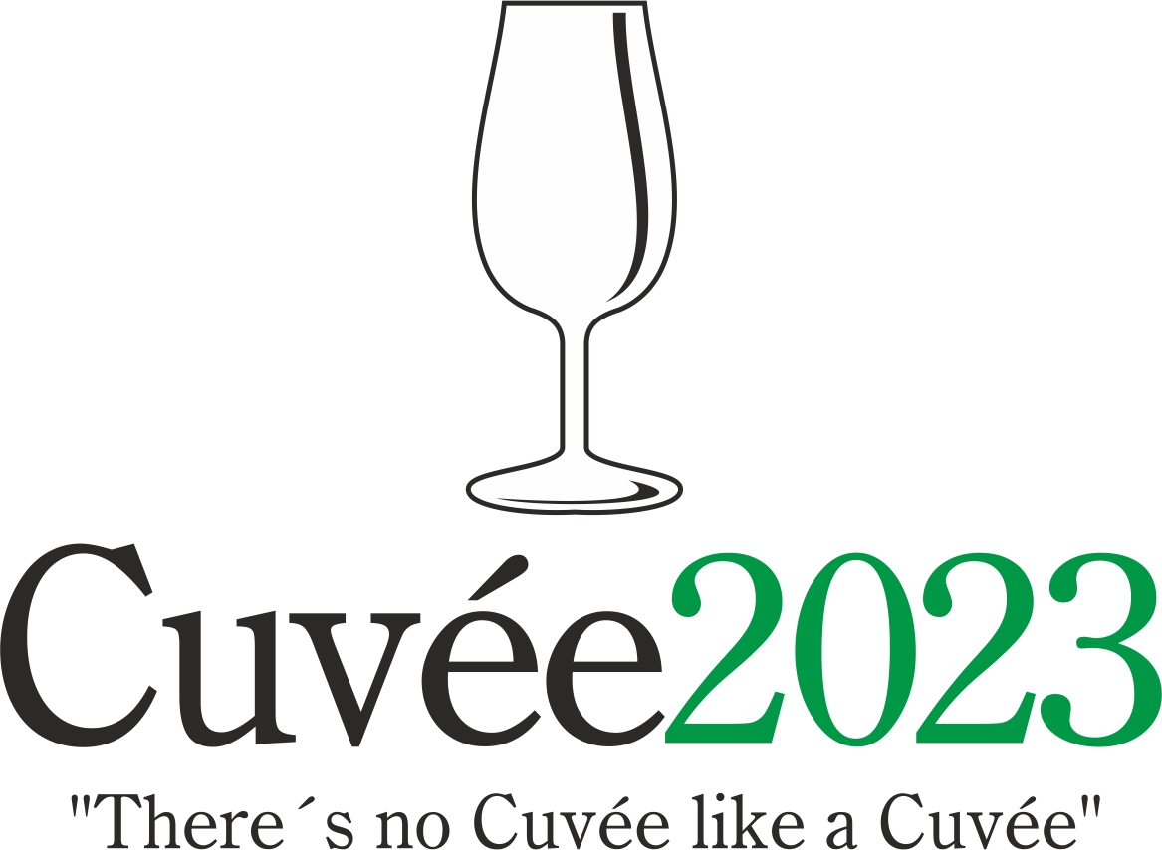

The International Wine Competition of the Moravian-Silesian Region

The 21th edition of this unique international competition of blends and branded wines was held by the Club of Ostrava’s Amateur Wine Evaluators, K.A.H.A.N, in conjunction with the Castle Zábřeh Hotel in Ostrava and the National Wine Centre. The event took place with the support of the Wine Fund of the Czech Republic. The initiator and spiritual father of this - the only wine contest taking place in the Moravian-Silesian district - was the guru of Czech and Moravian vini-viticulture, the late Professor Vilém Kraus.

Czech and Moravian wine producers and foreign-wine importers entered into this year’s edition a total of 136 wines in six competition categories: 32 dry white wines (category A1), 28 semi-dry and semi-sweet white wines (A2), 45 red wines (B), 10 rosé wines (C), 16 sparkling wines (D) and 5 sweet and liqueur wines (E). A total of eight countries sent their samples to this competition: Czech Republic (106 wines), Slovakia (10), France (6), Bulgaria (4), Denmark (4), Austria (2), Spain (2) and South Africa (2). Wines which fulfilled the conditions of the competition statutes were assessed in the tasting room of National Wine Centre in Valtice on 17th April using the 100-point evaluation system under the patronage of the National Wine Centre. A hundred-point system was used in accordance with the criteria as defined by the National Standards for Certifying wine competitions of the Czech Republic. Wines receiving 90 points or over were in receipt of a double gold medal, wines achieving between 87 and 89.99 points were awarded a gold medal, wines achieving between 84 and 86.99 points were awarded a silver medal. It was decided by the organizers not to award any bronze medals.

A trio of specialised committees under the direction of Fedor Malík, Josef Balík and Martin Prokeš awarded 7 double gold medals, 21 gold and 71 silver medals. Local Moravian wines were honoured with 5 double gold, 14 gold and 53 silver medals. Most successful among the foreign participants were wines emanating from Slovakia (2 gold, 5 silver), France (3 gold, 3 silver), Bulgaria (2 gold, 2 silver), followed by Denmark (4 silver), Spain (1 double gold, 1 silver), South Africa (1 double gold, 1 silver) and Austria (2 silver).

The title of Champion in the category of dry white wines was awarded to coupage of Sauvignon and Sémillon Coastal Creative Block 2020 (Spier Wines, South Africa; imported by Zebra Wines). The title of National Winner for the best-rated dry white wine of local provenance went to assemblage of Riesling, Chardonnay and Pinot blanc Starák 2021 (Zámecké vinařství Bzenec). The red-wine champion was Cuvée Strážnice 2021 (Žerotín, Czech Republic) made from Cabernet Cortis, Merlot and Lemberger. The winner in the category of semi-dry and semi-sweet white wines was cuvée Aubere Rezerva 2015 (Vinařství Dvořáček LTM, Czech Republic) produced from the Chardonnay, Sauvignon and Pinot gris. Sweet and liquer wines category was dominated by cuvée of Grüner Veltliner, Welschriesling, Sauvignon and Moravian Muscat Bobulky 70 2017 straw-wine (Oldřich Drápal, Czech Republic). The victor in the Rosé and/or Blanc de Noirs category was coupage of Grolleau gris, Grolleau noir and Cabernet franc Rosé de Loire 2022 (Domaine de la Haute Coudraie, France; imported by Winaři store). The winner in the sparkling-wine category was Cava Jan Vidal Honor Reserva Brut 2021 (Jan Vidal, Spain; imported by Winaři store), assemblage of Xarello, Macabeo and Parellada. The award for the Best Collection of Wines was defended in the closest battle in the history of the competition (Trakia Wine fell behind by a hundredth of a point) by domestic producer Zámecké vinařství Bzenec.

Champion titles were also handed out in the frame of Cuvée Ostrava Wine Exhibition at Castle Zábřeh Hotel on 4th May by the Committee of the Lay Public. These results permit wine producers and importers to compare the opinions of the specialists with those of wine aficionados. With the Jaroslav Kozel Award, in the shape of an original work by glassmaker Ricardo Hoineff, the organisers are paying tribute to the late wine lover from South Moravia without whom the Cuvée Ostrava Wine Competition would never even have seen the light of day. The Champions as chosen by the lay public were Klíňák 2021 (Zámecké vinařství Bzenec, Czech Republic) made of Pinot blanc and Chardonnay, as well as French blend of Merlot, Cabernet Sauvignon, Cabernet franc and Malbec Bordeaux Château Marjosse 2018 (Château Marjosse, France; imported by L9). National winner in the red wines category was Manuscript Merlot / Pinot noir 2018 (Vinařství Baloun, Czech Republic). The winners in the individual categories were assamblage of Grüner Veltliner, Welschriesling, Sauvignon and Moravian Muscat Bobulky 69 2016 straw-wine (Oldřich Drápal, Czech Republic), then Sekt Mikrosvín Brut 2019 (Vinařství Mikrosvín Mikulov, Czech Republic), coupage of Welschriesling, Pinot blanc and Riesling, and in accordance with specialised jury Rosé de Loire 2022 (Domaine de la Haute Coudraie, France; imported by Winaři store). In view of the huge number of entries with a higher residual sugar content in the submissions by local wine producers, the Ostrava wine aficianodes have arrived at the conclusion not to judge the categories of off-dry and semi-sweet wines. The award for the Best Collection of Wines according to the lay public went to the importer Trakia Wine. Klíňák 2021 (Zámecké vinařství Bzenec, Czech Republic) was then honored by the Jaroslav Kozel Award.

The results from this – the one and only international wine competition taking place in Northern Moravia – were made public on the same day at the Cuvée Ostrava Wine Exhibition in Zábřeh Castle. Professor Fedor Malík inaugurated the accompanying programme with his traditional tutored tasting of "Slovak wines at 5 o‘clock". Thereafter the wine exhibition will be freely accessible to the general public to the plangent sounds of Moravian dulcimer music, while visitors could sample not only the wines from the competition, but also varietal wines from those Moravian winemakers and importers of foreign wines who were present. The accompanying programme culminated with a presentation by Tomáš Dominec titled "Wines of France Vol. 6."

The presumptuous aim of the organisers of the Cuvée Ostrava competition is to witness a renaissance of the good name of blends or brands and their return to the forefront of the products on offer from Czech and Moravian winemakers, as is customary in other major wine-producing countries. In the words of the spiritual father of the competition Professor Vilém Kraus: "There's no Cuvée like a Cuvée" meaning that each and every blend is different.

Dr. Martin Křístek, +420 603 240 661, info@cuvee.cz, www.cuvee.cz, @CuveeOstrava

