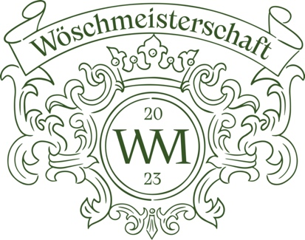

Wöschmeisterschaft 2023 - Welschriesling is back on the big stage!

Dear winegrowers!

The long wait is over - finally there will be a continuation of the Wösch Championship!
After the great success in 2021, mastermind Gerhard Retter, host René Kollegger and organiser Claudia Genner-Schauer are pleased to invite you to the Wösch Championship 2023.

What is new?
Welschrieslings can be entered in the already known categories "Klassik", "Rieden" and "Prädikate ab Beerenauslese".
The category "Nouvelle Wösch" is for high-quality wines that do not bear a vineyard designation.
We have reserved this category for wines that can clearly be assigned to the "Natural/Orange/Amphora" categories.
Encouraged by many requests, the category "sparkling wine" has been added - the majority of the sparkling wines must be vinified from Welschriesling.

A very special cooperation
We are pleased to announce that there will be a special treat for the winning wines of each category: in cooperation with
Alexander Koblinger MS and the wine trading house Döllerer, a limited Wösch Championship box will be created, which will then be sold by Döllerer.
which will then be put on sale by Döllerer.
We are very happy about the opportunity to draw even more attention to the Welschriesling variety!

Who is the jury
Once again this year we have spared neither effort nor expense and invited the best of the best to taste the Wöschmeister.
The tasting panel includes wine luminaries such as Alexander Koblinger MS (Döllerer's Weinhandelshaus & Genusswelten), Stefan Neumann MS (Wine Director by Heston Blumenthal UK), Marco Franzelin (Sommelier 3* Schloss Schauenstein), Harald Scholl (Editor-in-Chief Vinum), Daniela Dejnega (Gault Millau Austria), Willi Balanjuk (A la Carte), Peter Moser (Falstaff), Maximilian Zankl (Sommelier Restaurant Obauer), André Drechsel (Sommelier Tian) and many other renowned wine experts.
The wines will be tasted and evaluated in a masked tasting according to the internationally established 100-point scheme. The results will be announced after the tasting in a press release and in the social media.

When will the Wösch Championship take place?
The semi-final tasting will take place on 25 June and the final tasting on 26 June. The venue will again be the winery Wolfgang Maitz
in Ehrenhausen/South Styria.
For details on delivery, please see the registration link.

How to register now
Under the link https://forms.office.com/e/SNcTeNYkv7Sie you can register your wines easily and paperless for the Wösch Championship.
If you have any problems with the registration, please contact Claudia Genner-Schauer at info@brutundedel.at.
Registration should take place by 16 June 2023 at the latest.
Deliveries can be made from now until 20 June 2023 at the latest.
We need 3 bottles per wine please!
What the wine submission costs
We are pleased to announce that we have kept the costs for the wines entered from 2021.

Cost per wine entered:
for the first wine 95,00 Euro
for the second wine 85,00 Euro
for the third wine 65,00 Euro
from the fourth wine 55,00 Euro

We are looking forward to a successful Wösch Championship 2023, exciting wines and ask for numerous participation and support.

#makewöschgreatagain #wöschwm2023

In this spirit sincerely
Gerhard Retter, René Kollegger and Claudia Genner-Schauer

