United Nations
of Blaufränkisch
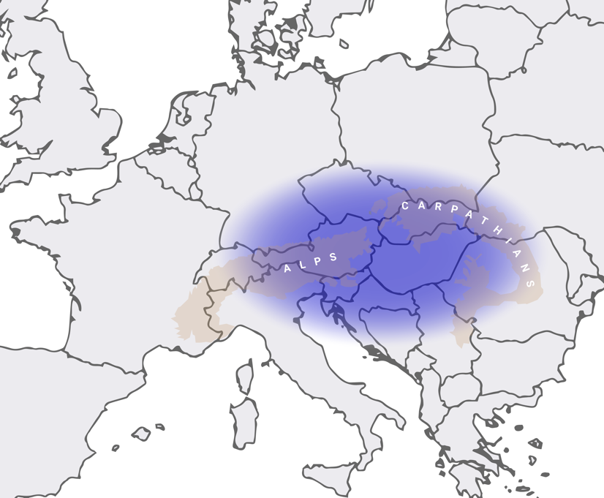
Kekfrankos / Blaufränkisch / Frankovka has earnt gaining interest from international media and sommeliers in the last time. The grape may be considered as a central European roof, that links several states and many regions: all of them marked by continental climate. At the same time, the grape has the talent to clearly reflect the kind of soil and therefore produces many different expressions of wines.

To showcase the diversity of the grape and the common ground of the central European region at the same time, a joint event during VieVinum 2024 in Vienna is planned. It will be an ongoing tasting bar through all three days of the event (25, 26, 27 May), on which 100 wines from Hungary, Croatia, Slovenia, Slovakia, Czechia, and Austria may be tasted.

This is a perfect tool to show the greatness of the grape (as discussed by experts during the Blaufränkisch Summit in Lech). At the same time, it is a smart and cost-effective opportunity for producers to attend VieVinum without paying a full stand.

VieVinum is an interesting place to talk about “United Nations of Blaufränkisch” as Austrian Wine Marketing Board will fly in 400 VIP experts from around the world. The mornings are reserved for professionals only. In the afternoon, private consumers may attend the fair.

The conditions for attending:
- Each country does its own selection of wines to be shown.
We suggest the following amount for each country:
- Hungary 50
- Croatia 10
- Slovenia 10
- Slovakia 10
- Czechia 10
- Austria 10
- Cost of attending is 310 Euros per wine.
- Every producer can show a maximum of three wines. All 100% Blaufränkisch, no blends
- Producers don’t necessarily need to be present personally. But every country must organize at least one person to pour the wines.
- We suggest having one and the same vintage for all wines: 2021
- Every country organizes delivery of the wines individually

Wine+Partners takes care of communicating the tasting bar of “United Nations of Blaufränkisch” to press, trade and international guests and prepares the tasting catalogue.
Of each wine we need information on:
- Region/appellation/single vineyard
- Soil
- age of vines

Vienna, December 8 2023
d.muhr@wine-partners.at

