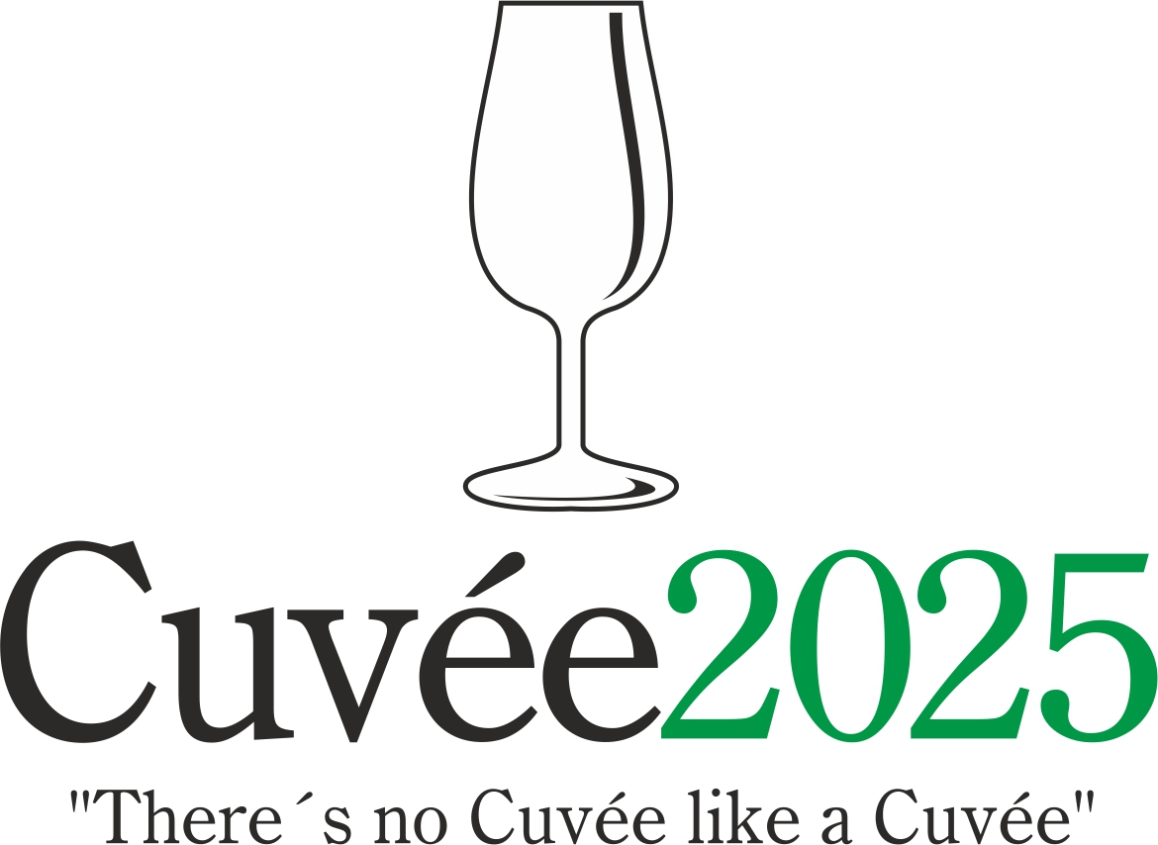

The International Wine Competition of the Moravian-Silesian Region

The 23rd edition of this unique international competition of blends and branded wines was held by the Club of Ostrava’s Amateur Wine Evaluators, K.A.H.A.N, in conjunction with the Castle Zábřeh Hotel in Ostrava and the National Wine Centre. The event took place without the support of the Wine Fund of the Czech Republic. The initiator and spiritual father of this - the only wine contest taking place in the Moravian-Silesian district - was the guru of Czech and Moravian vini-viticulture, the late Professor Vilém Kraus.

Czech and Moravian wine producers and foreign-wine importers entered into this year’s edition a total of 101 wines in six competition categories: 21 dry white wines (category A1), 24 semi-dry and semi-sweet white wines (A2), 36 red wines (B), 6 rosé wines (C), 12 sparkling wines (D) and 2 sweet and liqueur wines (E). A total of seven countries sent their samples to this competition: Czech Republic (71 wines), Slovakia (12), South Africa (6), Spain (5), France (4), Portugal (2) and Bulgaria (1), Wines which fulfilled the conditions of the competition statutes were assessed in the tasting room of National Wine Centre in Valtice on 7th April using the 100-point evaluation system under the patronage of the National Wine Centre. A hundred-point system was used in accordance with the criteria as defined by the National Standards for Certifying wine competitions of the Czech Republic. Wines receiving 90 points or over were in receipt of a double gold medal, wines achieving between 87 and 89.99 points were awarded a gold medal, wines achieving between 84 and 86.99 points were awarded a silver medal. It was decided by the organizers not to award any bronze medals.

A trio of specialised committees under the direction of Fedor Malík, Radomil Baloun and Evžen Kašpárek awarded 6 double gold medals, 24 gold and 46 silver medals. Local Moravian wines were honoured with 2 double gold, 14 gold and 35 silver medals. Most successful among the foreign participants were wines emanating from Slovakia (2 double gold, 3 gold, 4 silver), South Africa (4 gold, 2 silver), Spain (2 double gold, 1 silver), Portugal (2 gold), followed by France (1 gold, 3 silver) and Bulgaria (1 silver).
The title of Champion in the category of dry white wines was awarded to coupage of Feteascǎ regalǎ, Pinot blanc, Sylvaner, Frühroter Veltliner and Feteascǎ alba Naše Cuvée 2023 (Víno Dudo – VMD, Slovakia). The red-wine champion was assemblage of Cabernet Sauvignon, Merlot, Lemberger, Pinot noir, Alibernet and Dunaj Pavon 2021 (Zámocké vinárstvo Pezinok, Slovakia). The title of National Winner for the best-rated dry white and red wine of local provenance went to cuvée Kliňák 2023 (Zámecké vinařství Bzenec, Czech Republic), produced from Chardonnay and Pinot blanc, and to Pinos Dědě Frantě barrique 2022 (Eurona Mutěnice, Czech Republic) on the base of Pinot noir. The winner in the merged category of semi-dry and semi-sweet white wines and the sweet and liqueur wines was field blend Amálie 2014 (Vinařství Fučík, Czech Republic). The victor in the Rosé and/or Blanc de Noirs category was Cuvée Martínka 2024 (Moravčíkova vína, Czech Republic) made from André, Cabernet Moravia, Zweigelt and St. Laurent. Sparkling-wine category was dominated by Cava Honor Reserva Brut (Jan Vidal, Spain; imported by Winaři store), coupage of Macabeo, Xarello and Parellada. The domestic company Winaři store has received an award for the Best Overall Collection of Wines.

Champion titles were also handed out in the frame of Cuvée Ostrava Wine Exhibition at Castle Zábřeh Hotel on 30th April by the Committee of the Lay Public. These results permit wine producers and importers to compare the opinions of the specialists with those of wine aficionados. With the Jaroslav Kozel Award, in the shape of an original work by glassmaker Ricardo Hoineff, the organisers are paying tribute to the late wine lover from South Moravia without whom the Cuvée Ostrava Wine Competition would never even have seen the light of day. The Champions as chosen by the lay public were Pavon 2022 (Zámocké vinárstvo Pezinok, Slovakia) made of Welschriesling, Pinot blanc, Pinot gris, and Riesling, as well as Portoguese blend of Touriga Nacional, Tinta Roriz and Touriga Franca Douro Claudia´s Reserve 2021 (Vinhos Quevedo, Portugal; imported by Winaři store. National winners were assamblage of Chardonnay and Pinot gris Velká bílá slípka 2021 (Vinařství Vladimír Tetur, Czech Republic) and Traditional Line Cabernet Sauvignon / Merlot 2023 (Vinařství Mikrosvín Mikulov, Czech Republic). The winners in the individual categories were in accordance with specialised jury Cuvée Martínka 2024 (Moravčíkova vína, Czech Republic) and Cava Honor Reserva Brut NV (Jan Vidal, Spain; imported by Winaři store). In view of the huge number of entries with a higher residual sugar content in the submissions by local wine producers, the Ostrava wine aficionados have arrived at the conclusion not to judge the categories of off-dry and semi-sweet wines. The award for the Best Collection of Wines according to the lay public went to the importer Winaři store. Bordeaux Superieur Chȃteau Jalousie Beaulieu 2020 (Vignobles Jalousie Beaulieu, France; imported by Dominec a spol.) on the base of Merlot was then honored by the Jaroslav Kozel Award.

The results from this – the one and only international wine competition taking place in Northern Moravia – were made public on the same day at the Cuvée Ostrava Wine Exhibition in Zábřeh Castle. Professor Fedor Malík inaugurated the accompanying programme with his traditional tutored tasting of "Slovak wines at 5 o‘clock". Thereafter the wine exhibition will be freely accessible to the general public, while visitors could sample not only the wines from the competition, but also varietal wines from those Moravian winemakers and importers of foreign wines who were present. The accompanying programme culminated with a presentation by Tomáš Dominec titled "Wines of France Vol. 8."

The presumptuous aim of the organisers of the Cuvée Ostrava competition is to witness a renaissance of the good name of blends or brands and their return to the forefront of the products on offer from Czech and Moravian winemakers, as is customary in other major wine-producing countries. In the words of the spiritual father of the competition Professor Vilém Kraus: "There's no Cuvée like a Cuvée" meaning that each and every blend is different.

Dr. Martin Křístek, +420 603 240 661, info@cuvee.cz, www.cuvee.cz, @CuveeOstrava

