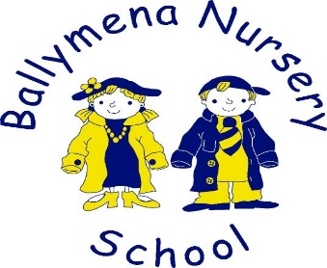 COVID 19 KEY WORKERS

21st Mar 2020
Dear Parents and Carers,
The Education Minister issued a letter to schools which outlined that all schools will be open from Monday 23rd March 2020 only to the children of parents whose jobs are critical to the Covid-19 response and who would otherwise have no option but to stay at home to ensure safe supervision of their children.
That will mean children of key workers can come for their normal allocated class time slot of either 8.45 – 11.15 am or 12.30 – 3pm.
It is imperative that children travel to and from as few settings as possible. Therefore, the guidance we have received is that it would be unproductive and not advised that children are transported from home; child minder; day care and nursery. We would ask that all parents respond responsibly.
The full list of keyworkers has been published by the Minister. We are also expecting further guidance on the provision for and vulnerable children. l am attaching a copy of Mr Weir's letter to this email.
Where possible, alternative childcare arrangements for your child should be sought first as this will help keep the number of adults and children to a minimum and enable us to adhere to the recent guidance on social distancing.
The following outlines the broad categories of what would currently be defined as a key worker;
• Health and Social Care. This includes doctors, nurses, midwives, paramedics, social workers, home carers and staff required to maintain our health and social care sector
• Education and childcare. This includes nursery and teaching staff, social workers and those specialist education professionals who will remain active during the Covid-19 response
• Public safety and national security. This includes civilians and officers in the police (including key contractors), Fire and Rescue Service, prison service and other national security roles
• Transport. This will include those keeping air, water, road and rail transport modes operating during the Covid-19 response
• Utilities and Communication. This includes staff needed for oil, gas, electricity and water (including sewage) and primary industry supplies, to continue during the Covid-19 response, as well as key staff in telecommunications, post and delivery, services and waste disposal
• Food and other necessary goods. This includes those involved in food production, processing, distribution and sale, as well as those essential to the provision of other key goods (e.g hygiene, medical etc)
• Other workers essential to delivering key public services
• Key national and local government including those administrative occupations essential to the effective delivery of the Covid-19 response
Please e-mail:- info@ballymenans.ballymena.ni.sch.uk to request 2.5 hours of supervision ONLY if your job is listed as a key worker; you wish to send your child and you have no other form of childcare for your child.
Please note that we will consider each case individually and will respond to parents over the weekend to inform them if a place can be made available in nursery for their child, beginning on Monday 23rd March.
These are very uncertain and emotional times for us all.
Wishing you all continued good health and God’s blessing
Keep safe,

Mrs. Coulter

