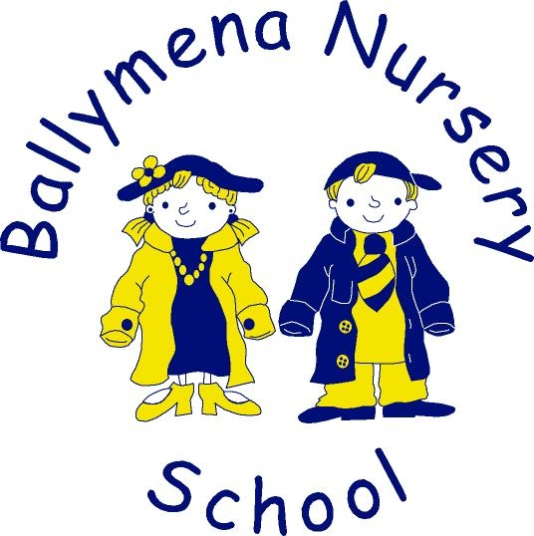

Community Relations, Equality and
Diversity in Education Policy

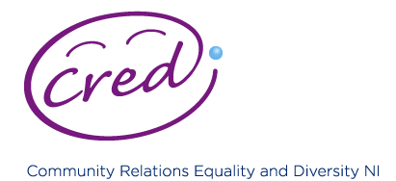

Rationale

In order to place CRED within the context of the overall school improvement agenda, four main characteristics of Every School a Good School play a key part in promoting CRED through their approach to:

1. Child Centred Provision
2. High Quality Teaching and Learning
3. Effective Leadership
4. A School Connected to its Local Community

These in turn link clearly with School Development Planning and the central role of the school’s ethos in underpinning the life and work of the school. The embedding of CRED into teaching and learning is a key focus within the School’s Development Plan for 2015-2018.

Definitions of Community Relations, Equality and Diversity

Community Relations is to encourage greater cross-community contact and co-operation; to support encourage and develop mutual understanding; and to promote recognition of and respect for cultural diversity.

Equality is about creating an equal society, where everyone can participate and has the opportunity to fulfil their potential.

Diversity is about recognising individual as well as group differences, treating people as individuals, and placing positive value on diversity in the community.

Ballymena Nursery School’s Ethos:

The pastoral dimension of our Nursery naturally permeates every aspect of school life. In recognition of this, our School Development Plan includes areas for focus and development through curriculum, teaching and learning, staff development, parental and Board of Governors involvement in the day to day smooth running of our school community. The children, staff, parents, outside agencies and Board of Governors work together to ensure that CRED is embedded into all areas of learning in Ballymena Nursery School.

Community Relations in Schools includes using;
The DENI Community relations, Equality and Diversity Policy, 2011.

“Northern Ireland is emerging from the period of conflict into a new and hopeful phase, and we become more diverse in our communities, I want to ensure our children and young people have the skills and attitudes to ensure a society where equality and diversity are valued and relations within and between communities are strong.”

There is for example, a greater representation of children from different cultural or ethnic groups in our nursery and increasingly there are children for whom English may not be their first language (EAL).

The Good Friday (Belfast) Agreement, including Section 75* and Schedule 9 to the NI Act 1998, place a statutory obligation on public authorities in carrying out their various functions relating to the north of Ireland, to have due regard to the need to promote equality of opportunity:
• Between persons of different religious belief, political opinion, racial group, age, marital status or sexual orientation;
• Between men and women generally;
• Between persons with a disability and persons without; and
• Between persons with dependants and persons without

The Promotion of Section 75 in Ballymena Nursery School:

The policy, and its delivery, must recognise the influences, both positive and negative, that peers, parents, guardians and the media have on the views, perceptions and stereotypical images of young people. The views of children and young people need to inform the delivery of community relations, equality and diversity in education settings, both within and outside school. The changing nature of curriculum delivery in both formal and non-formal settings provides the dynamic backdrop and context for the policy review with the focus on the needs of the learner and on equipping children and young people with the key skills to be successful learners and participative citizens.
In order to articulate more effectively the wider scope of the new policy, it has been renamed’ The Community Relations, Equality and Diversity in Education’ (CRED) Policy.

The United Nations Convention on the Rights of the Child (CRC) is at the heart of a school’s planning, policies, practice and ethos. A rights-respecting school not only teaches about children’s rights but also models rights and respect in all its relationships: between pupils and adults, between adults and between pupils.

The proposed aim of the policy is to:

• Contribute to improving relations between communities by educating children and young people to develop self-respect and respect for others, promote equality and work to eliminate discrimination, and by providing formal and non-formal education opportunities for them to build relationships with those of different backgrounds and traditions within the resources available.

The objectives of the policy will be to:

• Promote a developmentally appropriate understanding of and respect for the rights, equality and diversity of all without discrimination; and
• Educate children to live and participate in a changing world, so that they value and respect difference and engage positively with it, taking account of the on-going intercommunity divisions arising from conflict and increasing diversity within our society; and
• Equip children with the skills, positive attitudes and acceptable behaviours needed to develop mutual understanding and recognition of, and respect for, difference.

Role of Pre-School Education and the Early Years Curriculum

There is recognition of the role that nurseries can play in laying the foundations for young children to become personally, socially and emotionally more aware of themselves and others (Personal Social and Emotional Development) and their early experiences and interaction with their environment (World Around Us).

In Ballymena Nursery we value:-

Honesty: We will promote a culture of honesty; speaking and acting in the best interest of everyone.
Acknowledgement: We will recognise the achievements and efforts of ourselves and others.
Inclusiveness: We will promote a welcoming environment were respect for all
is paramount and evident.
Trust: We will build trust through our actions, our experiences and our openness.
Respect: We will promote positive relationships between all members of the
school community.

Dissemination of the Policy

The contents of this policy will be made available to all members of staff and the Board of Governors. It will also be available to all parents, students, volunteers and visitors on request and they will be encouraged to adhere to and follow its aims and objectives.

