BALLYMENA NURSERY SCHOOL
SEPTEMBER 2020 NEWSLETTER
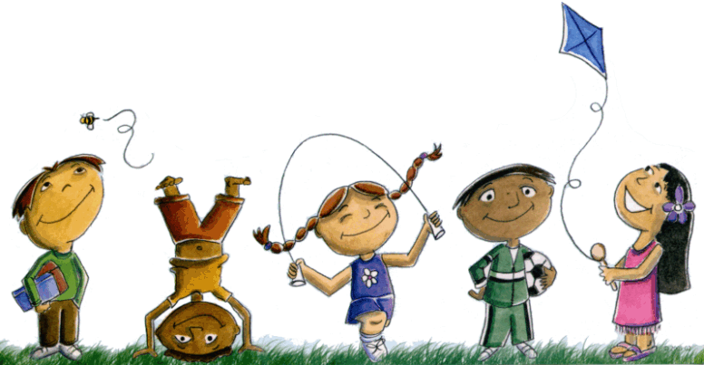

Welcome, and thank you for choosing Ballymena Nursery School and for your patience during months of uncertainty due to the Covid Pandemic. (Education Restart Pre-School Education Guidance for reopening Version 2, issued on 17/8/20 Department of Education.) We trust that the time you and your child spends with us will be enjoyable, educational and most importantly embedded within a “safe and caring nursery school environment”.

SETTLING IN MID COVID 19 PANDEMIC
We appreciate that often the transition into Nursery can be emotional for both children and parents. This new school year understandably will raise unprecedented challenges which will require flexibility, resilience and a united approach between nursery staff and parents. Together, our aim will be to settle your children into a safe, secure and happy Nursery routine.
As a staff team we are not comfortable with many of the Covid 19 restriction imposed on us for example to; exercise social distance with our colleagues and parents; to have segregated pods/groups of children, to limit our play based resources and to reduce our timetable to carry out extensive cleaning between sessions to name but a few. We are hopeful these restrictions will be temporary and will be reviewed and relaxed. For now, please adhere to Social Distancing, use of designated school gates and all hand sanitising/washing and respiratory hygiene measures. (Catch it, Bin it and Kill it).
PARKING
When dropping off/collecting children at Nursery School, can I please emphasise that it a parking offence to park outside the school on Trostan Avenue on the double yellow lines. Please use the Leisure centre public car-park, adjacent to the school. Please do not use the disabled parking spaces, unless you are entitled to use them. Also, please do not use the staff parking spaces and keep the yellow emergency box clear at all times. Do not put your child and other children in danger by obstructing the emergency yellow box, even for a moment.
PARENTS’ INFORMATION
It is important that parents keep up-to-date with everything which is going on in school. A monthly newsletter is posted on our web-site on the first school day of each month, giving all details of important dates and special events to celebrate. PLEASE NOTE THAT WE ARE AN ECO SCHOOL AND NO FURTHER PAPER COPIES WILL BE DISTRIBUTED TO PARENTS. THIS IS THE ONLY PAPER COPY OF THE NEWSLETTER WHICH YOU WILL RECEIVE. It is the responsibility of every parent to access the monthly newsletter via the school web-site. www.ballymenanursery.co.uk. The web-site will also keep you up to date and informed with regularly up-dated photographs of activities going on in nursery. The web-site also has a Google Translate facility for a range of languages. We apologise for the inability to access our school web site over the past weeks due to essential and necessary updates being required.
TAPESTRY
Please ensure that you have all completed your ICT forms and signed up to Tapestry Online Learning Journal by sending your e-mail address to Mrs. McMullan at smcmullan206@c2kni.net
SCHOOL TEXTING SERVICE
We operate a texting service. It is essential that you inform us of any changes to your mobile number so that you can be contacted, particularly in the case of an emergency situation. We will be sending out a test message to all parents within the next couple of weeks – please save the number to your contact list. Please note you cannot contact the school using this number – it is only for you to receive messages.
SICKNESS/ABSENCES
Please contact the school (02825652011) if your child is unwell or will be absent for another reason. This is particularly important for Tract and Trace during this current Covid Pandemic.
DROP-OFF AND COLLECTION OF CHILDREN
Please do not plan to arrive in Nursery before session times or congregate in the nursery gardens. Please remain in your car and ensure that your child is picked up on time. Staff need time to carry out additional hygiene measures to clean and rotate resources in the classrooms between sessions. The classroom doors will remain closed until the commencement of nursery sessions.
SCHOOL FUND MONEY
In your Welcome Pack, you are offered different payment options for school fund. This money should be paid in advance, on the first school day of the year/term or month, depending on your choice. Please place in a sealed envelope, clearly marked with your child’s full name and class teacher. All envelopes should be given to your child to bring into their teachers.
Cheques should be made payable to “Ballymena Nursery School”; - if sending cash, please send correct money only. Change will not be given. Money pouches can be purchased from your class teacher for £2 per pack.
If you opted to pay monthly, the amount now due is £20, termly £80 and for a one –off payment £200
Additional expenses will occur due to Covid 19. Therefore, school fees will not be returned if your child is required to self isolate or the nursery needs to close for deep cleaning etc.
SCHOOL SWEAT-SHIRTS
School sweatshirts are available throughout the school year (£10). Please remember to label these and any other removable items of clothing – e.g. outdoor coats, with your child’s name. You may order name labels directly from www.MyNametags.com, quoting our school ID – 976. Nursery school will benefit from all sales.
BIRTHDAYS
Every child in Nursery will receive a card and gift on his/her birthday from the staff and children from nursery.
Due to current Covid restrictions and rigorous health and safety risk assessments unfortunately, we will not be permitted to distribute birthday invitations, party bags, cup-cakes or birthday cake to the children’s friends in nursery. Such safety measures will be reviewed regularly.
ITEMS TO BRING
Please send a box of tissues and a packet of baby wipes with your child, a pair of wellington boots and a complete change of clothes including underwear and socks for any unexpected accidents is also essential. All clothes clearly labelled with their name.
HOME/SCHOOLBOX
Each child has their own home/school box located on a trolley in their classroom.
This offers the children opportunities to take ownership of their personal belongings, prompt notes, and their art work. During current Covid restrictions your child will be encouraged to check their home time box on a regular basis.
ALLERGIES
With an increasing number of allergies present and to minimise risk, we ask that children do not bring any foods/drinks to school unless to meet medical/allergen requirements. Please make sure your class teacher is aware of any allergies which your child may have. If your child has asthma and may need to use a “reliever inhaler” during school, please leave a spare inhaler in school and speak to your class teacher. You must complete an administration of medicine permission slip.
LEARNING FOCUS FOR THIS MONTH
Our focus for learning throughout the nursery year will be on a “recovery curriculum”. Working in partnership with you, together we will strive to bolster your child’s Personal, social and emotional development within a caring and educational environment. (Professor Barry Carpenter, www.ssatuk.co.uk.com)
Please make us aware if your child has experienced any Adverse Childhood Experiences due to Covid. (ACE’s)
This month’s focus for learning is SETTLING IN, ALL ABOUT ME, MY FAMILY, MY FRIENDS, MY NURSERY, EXPLORING EMOTIONS, RAINBOWS, COLOURS and TRADITIONAL NURSERY RHYMES AND STORIES. The children will be learning to recognise, name, express their emotions and be taught strategies, techniques to ‘Self-Regulate’ their emotions in Nursery by ‘Smelling imaginary flowers/ strawberries and blowing out imaginary candles. This deeper, regular, controlled breathing works for the staff too!!!!
We trust you will encourage emotional literacy and these techniques at home too.
The children will also be learning about the 5 Golden Rules in Nursery School:-
- We are gentle
- We are honest
- We are kind
- We listen
- We look after property
- And to develop good attention and listening skills by giving 5, good looking, good listening, hands on knees, closed lips and steady feet.
We look forward to an exciting and enjoyable “New Normal” nursery year” as we work together for the education and care of your children. (Educare).
Due to Covid restrictions staff will not be permitted to engage in any lengthy conversations, so please e-mail or telephone.

.

CHILD PROTECTION
If you have any concerns, please ring the school and contact the Designated Teacher for Child Protection
– Mrs. McGall
Or the Deputy Designated Teacher for Child Protection
– Mrs. Coulter
We would remind you to look again at the summary of Child proection policy which was included in your Parents’ Welcome Pack or our school web-site (www.ballymenanursery.co.uk). For further information regarding this area please use the
School telephone number: 028 25652011

** Please note that all adults responsible for dropping off and collecting children must be 18 and over.

