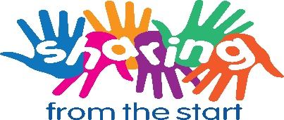

Parental Consent Form

I understand that Ballymena Nursery School is participating in the Sharing from the Start Programme which involves keeping a record of activities and developing a portfolio of evidence.
Please place a tick beside each statement.
I give consent for my child(ren) to participate in this programme.
Please name your child (ren)

I give consent for this setting to include the views of myself and my child (ren) within their Portfolio of evidence such as recordings (audio or visual), photographs, written material and records and other information which may be deemed eligible by the setting to be used as part of the settings engagement in the Sharing from the Start Programme. I understand the portfolio of evidence will be accessible by the project partners, Early Years, Fermanagh Trust and National Childhood Network.

I give consent for the portfolio of evidence to be used for supporting the project monitoring and evaluation, training, media promotion, showcasing practice or for conference purposes worldwide.

Sharing from the Start will be carrying out a series of publicity initiatives throughout the programme including publishing photographs and news stories on the project website, E-newsletter, social media and newspapers.

I give consent for my child(ren) to participate in this publicity.

I give consent for all the above permissions to be used beyond the lifetime of the project, where appropriate.

I understand that my participation in this process is voluntary and I have the right to withdraw from the programme and/or withdraw my personal documentation or perspectives at any point should I wish to do so.

I have been informed that any personal data I or my child(ren) contribute to the Sharing from the Start Programme will be treated with the strictest of conﬁdence. The setting staﬀ and staﬀ involved in the administration of the Sharing from the Start Programme will have access to this information for monitoring and evaluation.

Signature of Parent:
Date:
Principal: | Mrs. Coulter

